Final Report

Service Delivery and Privacy Public Opinion Research

Prepared for: Treasury Board of Canada Secretariat

ZZPEAALP@tbs-sct.gc.ca

May 2018

Ce rapport est aussi disponible en français.

Phoenix SPI is a Gold Seal Certified Corporate Member of the MRIA



Table of contents

Executive summary 1

Detailed Findings 8
1. Online Activities 9
2. Use of Online Government Services 12
3. Service Channels for Contacting the Government of Canada 17
4. Reaction to “Tell Us Once” and Related Issues 21
5. Trust in Protection of Personal Information 30
6. Profile of Survey Respondents 32

Appendix 33
Annex 1: Methodological Details 35
Annex 2: Quantitative Research Instruments 38
Annex 3: Qualitative Research Instruments 47
Annex 4: Phone vs. Online Sample Comparison on Key Issues 60
Annex 5: Tabulated Survey Data 69

Table of Figures

Figure 1: Internet Use 9
Figure 2: Online Activities 10
Figure 3: Use of Online Government Services 12
Figure 4: Reasons for not using online government services 13
Figure 5: Motivations to use online government services 14
Figure 6: Use of GC services via an online account 15
Figure 7: Preferred method of signing into a GC online account 16
Figure 8: Preferred service channel for contacting the Government of Canada 17
Figure 9: Reasons for using the phone to contact the GC 18
Figure 10: Reasons for using the Internet to contact the GC 19
Figure 11: Reasons for visiting a GC office 19
Figure 12: Knowledge of GC's sharing of personal information 21
Figure 13: Support for "Tell Us Once" 22
Figure 14: Comfort with GC sharing of personal information 24
Figure 15: Preferred approach to providing consent for information sharing 26
Figure 16: Advantages of information sharing between federal and P/T governments 28
Figure 17: Disadvantages of information sharing between federal and P/T governments 29
Figure 18: Trust in protection of personal information by organization 30
Figure 19: Online Activities [comparison] 60
Figure 20: Use of online government services [comparison] 61
Figure 21: Use of GC services via an online account [comparison] 61
Figure 22: Preferred channel for contacting the GC [comparison] 62
Figure 23: Knowledge of GC's sharing of information within federal govt. [comparison] 62
Figure 24: Knowledge of GC's sharing of information with P/T govts. [comparison] 63
Figure 25: Support for "Tell Us Once" [comparison] 63
Figure 26: Comfort with sharing of personal information within GC [comparison] 64
Figure 27: Comfort with sharing of personal information between govts. [comparison] 65
Figure 28: Preferred approach to providing consent [comparison] 66
Figure 29: Trust in protection of personal information by GC [comparison] 66

Executive summary
Phoenix Strategic Perspectives (Phoenix SPI) was commissioned by the Treasury Board of Canada Secretariat (TBS) to conduct public opinion research with Canadians on service delivery and privacy.

Background and Objectives
The mandate of the President of the Treasury Board includes the development of “a new service strategy that aims to create a single online window for all government services.” During the development of the strategy, service departments have cited legislation, including the Privacy Act and select departmental acts, as one of the barriers to providing innovative services to the public. A review of legislative obstacles to providing seamless services is a key enabler for the Government of Canada Service Strategy and has received broad support from Ministers.

The Minister of Justice has committed to reviewing the Privacy Act. Some departments have also tried to amend their Acts in an effort to improve services. For example, Employment and Social Development Canada (ESDC) is exploring amendments to the Department of Employment and Social Development Act to improve its ability to deliver services on behalf of other departments, and therefore improve the overall client journey.
To help inform its contribution to the review of the Privacy Act by Justice Canada and to help prioritize potential amendments to service legislation, TBS wanted to gain a better understanding of public perceptions, expectations, and concerns with regards to the sharing of government-held personal information in the context of the delivery of government services. TBS seeks to strike the right balance between privacy and efficient and effective service delivery.
This research was conducted to explore Canadians’ opinions on how government should collect, use, and disclose Canadians’ personal information in the specific context of information sharing and a “Tell Us Once” approach for better, more efficient government services. The results will guide TBS’ prioritization of efforts to modernize service legislation, including anticipated impact on the modernization of the Privacy Act. In addition to informing TBS’ input for the Privacy Act review, the collected data will be used to support analysis of other legislative barriers and prioritization of legislative changes to improve services. Finally, the research will provide a baseline for continuous public consultation around how users want service to evolve over time.

Methodology
To meet the research objectives, qualitative and quantitative research was conducted with Canadians. This included a series of 12 in-person focus groups in six locations across Canada, a 12-minute random digit dial (RDD) telephone survey of 2,500 Canadians, 18 years of age or older, and an online survey of 1,033 Canadians who are members of an online panel. All steps of the project complied with market research industry standards, including those of the Marketing Research Intelligence Association (MRIA), The Standards for the Conduct of Government of Canada Public Opinion Research, as well as the standards and privacy requirements outlined in the Statement of Work.

Qualitative Research
Twelve in-person focus groups were conducted between March 1st and March 7th, 2018. Two sessions were conducted in each of the following cities: Toronto, Halifax, Quebec City (French), Kelowna, Calgary and Moose Jaw. Participants were Canadians between 18 and 74 years of age. The groups were segmented by age. One group in each city was conducted with Canadians under 35 years of age and the second group was conducted with Canadians 35 years of age and older. Eight to 10 participants took part in each group. In all, 99 Canadians attended the two-hour focus groups. In appreciation of their time, participants received an $100 honorarium. This phase of the research was qualitative in nature and, as such, the results provide an indication of participants’ views about the issues explored, but they cannot be generalized to the full population of members of the general public.
Quantitative Research
A 12-minute random digit dial (RDD) telephone survey was conducted with 2,500 adult Canadians from March 1st to 25th, 2018. An overlapping dual-frame (landline and cell phone) sample was used to minimize coverage error. Interviewing was conducted by Elemental Data Collection (EDCI) using computer aided telephone interviewing (CATI) technology. The margin of error for this sample is ±1.9%, at a 95% confidence level (adjusted for stratified sampling). The survey data has been weighted by region, age and gender to ensure results that are representative of the Canadian population. Population figures from Statistics Canada 2016 Census were used to construct the weights.

In addition, an online survey of 1,033 Canadians who are members of Research Now’s online panel. The objective of the online survey was to explore differences in online Canadians’ views of digital service delivery compared to Canadians surveyed as part of a representative telephone survey. The online fieldwork was conducted March 15th to 27th, 2018. The results of the online survey cannot be generalized to the population because the survey sample is a non-probability sample. They can only be considered reflective of the views of online adult Canadians. Survey data has been weighted by region, age and gender to ensure results that are reflective of the Canadian population. Population figures from Statistics Canada 2016 Census were used to construct the weights.

More information about the qualitative and quantitative methodologies can be found in Annex 1.

Key Findings

Online Activities
Internet use is pervasive, with nine in 10 survey respondents reporting they use it. Among Canadians who use the Internet, large proportions use it to conduct their banking (80%), to get news (79%), to buy products or services (79%), to use social networking sites (77%), and to stream services for TV or movies (63%).

Among focus group participants, virtually everyone said they bank and shop online. The most frequently identified advantage of both was convenience. Convenience was routinely seen to include the ease and speed with which transactions can be performed, 24/7 accessibility, and not having to leave one’s home. The most frequently identified disadvantage of both online banking and online shopping was possible hacking resulting in illicit access to one’s private information and potentially fraudulent financial activity and identity theft.

Use of Government Services Online
Canadians accessing government services online do so for a variety of purposes, including to download forms (60%), file taxes (39%), apply for or renew a license (34%), apply for programs or benefits (29%), or pay a fine (29%). In addition, 58% of online Canadians have accessed Government of Canada services through an online account, such as My Service Canada Account or Canada Revenue Agency’s My Account. The plurality of Canadians who use these online services (45%) prefer to sign-in via a GCKey, while just over one-quarter (28%) prefer to use a sign-in partner.

Lack of need (37%) is the main reason online Canadians have not used government services online. In terms of what would encourage or motivate online Canadians to start using, or use more, online government services, three in 10 pointed to improving ease of access or making the user experience easier.

Virtually all focus group participants said they are aware that the Government of Canada offers online services, and most had used such services. Participants collectively identified a range of things they have done, including, for example, filing taxes and tax-related reporting, Canada Pension Plan-related activities, applying for/renewing a passport, using jobs.ca, and Employment Insurance-related reporting. Many participants also said they interact with the Government of Canada through My Service Canada Account and Canada Revenue Agency’s My Account.

Service Channels for Contacting the Government of Canada
More Canadians prefer using the phone (46%) and Internet (33%) when they need to contact the Government of Canada than visiting an office (18%). When asked why they prefer the phone or Internet, Canadians pointed to convenience factors. Specifically, those who expressed a preference for the phone were most likely to say they prefer dealing with a real person (44%), while those who prefer using the Internet said it is more convenient than other channels (59%), easier (43%), and less time consuming (28%).

Among focus group participants, the most frequently identified advantage of using Government of Canada online services was convenience with a focus on speed and efficiency. Other frequently identified advantages tended to focus on accessibility. This included 24/7 access to service, the ability to access and track one’s data, access to online forms, and access to information that is detailed and accurate. Potential disadvantages to using Government of Canada online services identified most often included technical problems or glitches and the possibility of hacking.

Reaction to “Tell Us Once” and Related Issues
Two-thirds of Canadians agree strongly (33%) or somewhat (34%) with “Tell Us Once”, while a smaller majority is comfortable with the information sharing that would be necessary to support this approach to service delivery. Almost six in 10 (58%) Canadians are very or somewhat comfortable with their personal information being shared automatically with other federal services as part of a single account approach for accessing government programs and with the Government of Canada linking the single account to their provincial or territorial government.

Support for information sharing is not surprising given that Canadians believe their personal information is currently being shared by government as part of service delivery. Specifically, 72% believe that their personal information is definitely or probably shared between federal departments and agencies and 67% believe that the Government of Canada is definitely or probably sharing their personal information with their provincial or territorial government.

Convenience factors were most often cited by Canadians as possible advantages of the provincial/territorial and federal governments sharing citizens’ personal information as part of service delivery. One in five believe that they would receive faster (21%) and easier access to (20%) service as a result of information sharing, while 18% said it would simply make access more convenient all the way around and 9% pointed to shorter wait times for service. Data security-related issues topped the possible disadvantages of the sharing of citizens’ personal information. This included the security of their personal information (21%), privacy breaches (20%) and identity theft (7%), as well as other unspecified privacy concerns (15%).

Among focus group participants, there was widespread, though not unconditional, receptivity to “Tell us Once”, including the sharing of information it implies. The most frequently identified qualifiers were that Canadians should have the choice to accept or decline such information sharing, that their acceptance would depend on knowing what information was being shared, with whom, and for what purpose, and that adequate security measures and systems would be in place. The main concerns about information sharing related to security and functionality. Many participants shared an impression that the more information is being shared, the greater the potential risk of both technical problems and security issues.

Trust in Protection of Personal Information
Almost eight in 10 Canadians said they have at least some level of trust in the federal government when it comes to protecting their personal information. Specifically, 27% have a great deal of trust (a score of 5 on a 5-point scale) and 51% have moderate levels of trust (scores of 3 and 4). Conversely, one in five said they trust the federal government very little (9%) or not at all (12%). Canadians reported similar levels of trust when asked about banks and provincial/territorial governments. Retail companies were least likely to be trusted to protect the personal information that is shared with them. Just over two-thirds of Canadians said they have very little (25%) or no (43%) trust in retail companies.

Among focus group participants, most trust the Government of Canada to protect their personal information and keep it confidential, though reasons for such trust varied. Some made it clear that this is a hope or expectation that they have, while others said they trust the Government of Canada because they are unaware of any major problems so far. Finally, some said they trust the government because they believe it has policies, procedures, systems, and expertise to ensure the security of information. To the extent that there is lack of trust, it has less to do with any shortcomings of the Government of Canada per se and more to do with a perception that government, like any organization, is subject to breaches on the part of sophisticated hackers.

Conclusions and Implications
Findings from this research suggest receptivity among Canadians to a single online window for government service delivery that facilitates citizens’ experience across different government programs and services. The research points to a population that is predisposed to accessing services online. Specifically, nine in 10 Canadians are online, and high numbers use the Internet for leisure, such as streaming TV and movies, as well as for financial transactions, such as banking, paying bills, and purchasing products or services. In addition, nearly six in 10 online Canadians have accessed Government of Canada services through an online account, and many focus group participants said they interact with the Government of Canada through a My Service Canada Account or Canada Revenue Agency’s My Account.

Convenience is a key factor driving the service channels used by Canadians. Whether Canadians expressed a preference for contacting the Government of Canada by phone, online or in-person, a top reason for their preference was convenience, with a focus on speed and efficiency. When asked what would encourage or motivate online Canadians to start using, or use more, online government services, a significant minority pointed to improving ease of access or making the user experience easier. Indeed, the reason offered most frequently—by nearly four in 10 online Canadians— for not using government services online was lack of need. This was followed by the impression that online government services are too difficult to use or time consuming—in other words, neither quick nor easy to use. This reinforces the importance of online government services being easy to access and use.

Considering a key objective of applying a “Tell Us Once” principle to government services is more efficient delivery of programs and services, it is not surprising that there was widespread, though not unconditional, support for “Tell Us Once”. The likelihood of positively assessing the approach was higher among younger Canadians, which suggests that openness to a single online window for government service delivery will likely increase with time.

Support for “Tell Us Once” appears motivated by a desire for easy access to government services. The main advantage Canadians associate with the approach is convenience, a benefit clearly in line with the overall objective of the initiative. Among focus group participants, the most frequently-identified advantage was increased convenience to Canadians by eliminating redundancy. Underpinning this was the advantage of relieving individuals from having to ensure that every relevant federal and provincial department has been contacted with updated information. Since convenience factors drive service channel preferences, if “Tell Us Once” places any additional burden on Canadians or makes access to government services and programs seemingly more difficult, receptiveness could be expected to be negatively affected.

Not only are Canadians supportive of “Tell Us Once”, they are largely comfortable with the information sharing needed to facilitate an integrated single online window for government service delivery. In fact, two-thirds of Canadians believe the Government of Canada already shares the personal information it collects from citizens, both between federal departments/agencies and with their provincial or territorial governments. When asked about the main advantages of information sharing, survey respondents pointed to faster and more efficient service. “Tell Us Once” may require changes to existing legislation. The findings suggest that Canadians would be supportive of changes to legislation, provided there is a clear benefit to them—fast, more efficient government services.

Receptivity notwithstanding, focus group participants often qualified their support for information sharing saying that Canadians should have the choice to accept or decline. For some, acceptance would depend on knowing what information was being shared, with whom, and for what purpose, and on knowing that adequate security measures and systems would be in place to protect it. Related to this, Canadians are well aware that security and privacy issues accompany online service delivery and information sharing. When potential disadvantages of information sharing between the federal and provincial/territorial governments were offered, security topped the list, following by privacy breaches and privacy in general. Notably, though, one in five Canadians said there are no disadvantages of governments sharing this type of information

Canadians, moreover, generally trust the Government of Canada to protect their personal information and keep it confidential. The majority of survey respondents have trust in the Government of Canada, placing the federal government alongside banks when it comes to privacy protection, well ahead of retail companies. Among focus group participants, to the extent that there is lack of trust in this regard, it tends to have less to do with any shortcomings of the Government of Canada and more to do with a perception that government, like any organization, is susceptible to hackers. Simply put, in recognition of reality, security and privacy are passive concerns for Canadians, but they do not appear to outweigh Canadians’ desire for convenient service delivery.

While focus group participants indicated that they do not necessarily feel they have much control over their personal information, they want to exercise the control they do have over what happens to their personal information. Canadians want, and expect, to be asked for permission when the Government of Canada wants to share their personal information. Six in 10 Canadians would want to be asked each time the Government of Canada wants to share their personal information with other departments. Conversely, one-third would opt to provide permission once only. Among focus group participants, the main reason for preferring a blanket consent option was convenience, particularly eliminating the need to provide the same information to a number of departments.

Finally, while there is broad support for “Tell Us Once”, the research suggests that a perceived downside of online government services is the lack of human contact. Canadians who expressed a preference for using phone or in-person options when they need to contact the Government of Canada pointed to this as the reason. This desire for human contact should be kept in mind for online government services. One way to deal with this is to offer a chat line or a direct, toll-free telephone number for support or questions when Canadians access online government services.

Note to Readers
- The report is organized by theme, with the results of the telephone survey and focus groups integrated in each section. To help the reader clearly delineate qualitative from quantitative findings, the results of the survey are presented first, followed by the focus group findings.
- Regarding the telephone survey results:
  - All results are expressed as percentages, unless otherwise noted.
  - Percentages may not always add to 100 due to rounding.
  - At times, the number of respondents changes in the report because questions were asked of sub-samples of the survey population. Accordingly, readers should be aware of this and exercise caution when interpreting results based on smaller numbers of respondents.
  - When reporting subgroup variations, only differences that are significant at the 95% confidence level, or indicative of a pattern, are discussed in the report.
- Regarding the focus groups results:
  - This research was qualitative in nature, not quantitative. As such, the results provide an indication of participants’ views about the issues explored, but they cannot be generalized to the full population of Canadians.
- Results for the online survey are presented in Annex 4.

Additional Information

Contract value:

The contract value was $209,862.47 (including applicable taxes).

Statement of Political Neutrality:

I hereby certify as a Senior Officer of Phoenix Strategic Perspectives that the deliverables fully comply with the Government of Canada political neutrality requirements outlined in the Communications Policy of the Government of Canada and Procedures for Planning and Contracting Public Opinion Research. Specifically, the deliverables do not contain any reference to electoral voting intentions, political party preferences, standings with the electorate, or ratings of the performance of a political party or its leader.



Alethea Woods
President
Phoenix Strategic Perspectives Inc.

Detailed Findings

1. Online Activities

Almost all Canadians use the internet and they do so for a variety of reasons
Internet use among respondents is pervasive, with nine in 10 reporting they use it. This is in line with findings from Statistics Canada’s General Social Survey – Canadians at Work and Home (released in November 2017) that reported 91% of Canadians aged 15 or older had used the Internet at least a few times a month during August to December 2016, when that survey was administered.

Figure 1: Internet Use

Q1. Do you use the Internet, whether on a computer, tablet or smart phone? Base: All respondents; n=2,500

The likelihood of using the Internet was higher among respondents from Ontario (92%) compared to those from Atlantic Canada (87%), 18-34 year olds (99%) and 35-54 year olds (97%) compared to Canadians aged 55 and older (82%), as well as university graduates (97%) and college-educated Canadians (96%) compared to those with high school or less (80%).

Among those who use the Internet (n=2,228), large proportions reported using it for a wide range of activities, including to conduct their banking (80%), to get news (79%), to buy products or services (79%), to use social networking sites (77%), and to stream services for TV or movies (63%).

Regional differences were pronounced when it came to the types of things Canadians do online. Among online Canadians, the likelihood of using the Internet to get news was lower in Quebec (73%) than it was in the Prairies (79%), Atlantic Canada (80%), and Ontario (81%). Canadians in Ontario (83%) and British Columbia (82%) were more likely to shop online than those in Quebec (70%) and Atlantic Canada (75%), while use of social networking sites was higher in Atlantic Canada (85%) than elsewhere in the country. The likelihood of using the Internet to stream TV or movies was higher in Ontario (68%) and British Columbia (67%).

Notably, there were no significant differences among the regions when it came to online banking—regardless of location, Canadians were similarly likely to use the Internet for banking.

The likelihood of using the Internet for all of these types of activities generally increased as age decreased and was lower among Canadians with a high school education or less. In addition, use of the Internet to stream TV or movies was higher among men (65%) and Canadians living in urban areas (64%).

Figure 2: Online Activities
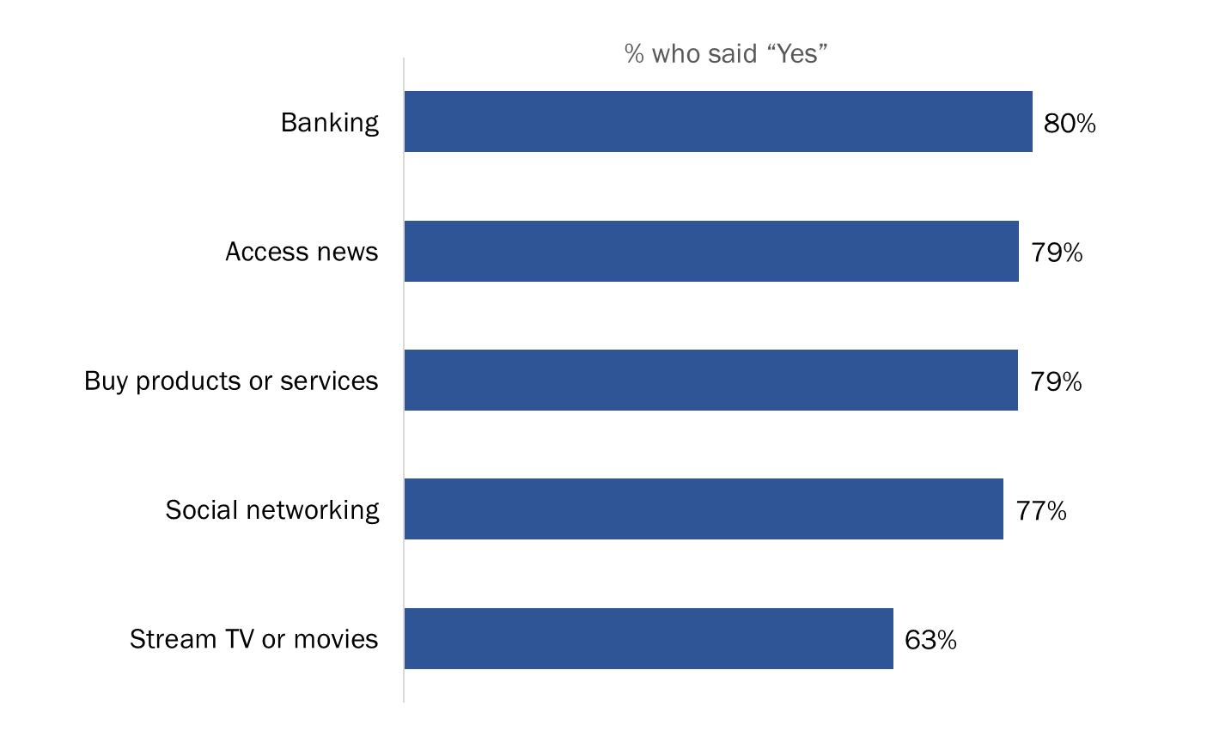
Q2. Please tell me if you ever use the Internet to do any of the following things. How about…?
Base: Respondents who use the Internet; n=2,228. DK/NR: <0.5%

Focus Group Findings:
Virtually all participants engage in both online banking and online shopping.

The most frequently identified advantage of both was convenience. Convenience was routinely seen to include the ease and speed with which transactions can be performed (e.g. bill payments and e-transfers in the case of banking and purchases in the case of shopping), 24/7 accessibility to services or goods from anywhere, and not having to leave one’s home. Many specified that not having to leave one’s home results in savings both in time (e.g. no lines, no waiting) and money (e.g. no transportation or parking costs). Another relatively frequently identified advantage of online banking and shopping was not having to interact with staff/personnel (e.g. being subject to up-selling and sales pressures).

Focus Group Findings (cont’d.):
Other frequently identified advantages of online shopping included better pricing/discounts, and more variety/access to inventories, resulting in greater likelihood of finding what one wants. Another frequently identified advantage of online banking is the ability to track/record one’s transaction history and accounts. An advantage of online banking identified less frequently was the ability to engage in paperless transactions. An advantage of online shopping identified less frequently was the ability to read reviews of products and/or companies.

The most frequently identified disadvantage of both online banking and online shopping was possible hacking resulting in illicit access to one’s private information and potentially fraudulent financial activity and identity theft. The only other frequently identified disadvantage of both was described as loss of the human element (e.g. the inability to speak to someone in the event of a problem or if one has a question). In the case of online shopping, other frequently identified disadvantages were post-transactional. This included waiting time/shipping delays, products not being delivered or being stolen, problems returning items, and uncertainty about the quality of the product such as clothes not fitting.

One less frequently mentioned disadvantage of both online banking and online shopping was the possibility of technical problems (e.g. systems being down). Infrequently identified disadvantages of online shopping included the collection of information for data-mining purposes, inability to get information about the source of products (i.e. where they are produced), having to pay customs/brokerage fees, having to pay the exchange rate on products shipped from the U.S., and the fact that some sites are not mobile device-friendly. An infrequently mentioned disadvantage of banking online is having to remember one more PIN.

2. Use of Online Government Services

Canadians access government services online for a variety of tasks
Canadians accessing government services online – from any level of government – do so for a variety of purposes, including to download government forms (60%), file taxes (39%), apply for or renew a license (34%), apply for government programs or benefits (29%), or pay a fine (29%).

Figure 3: Use of Online Government Services
I use online government services to….
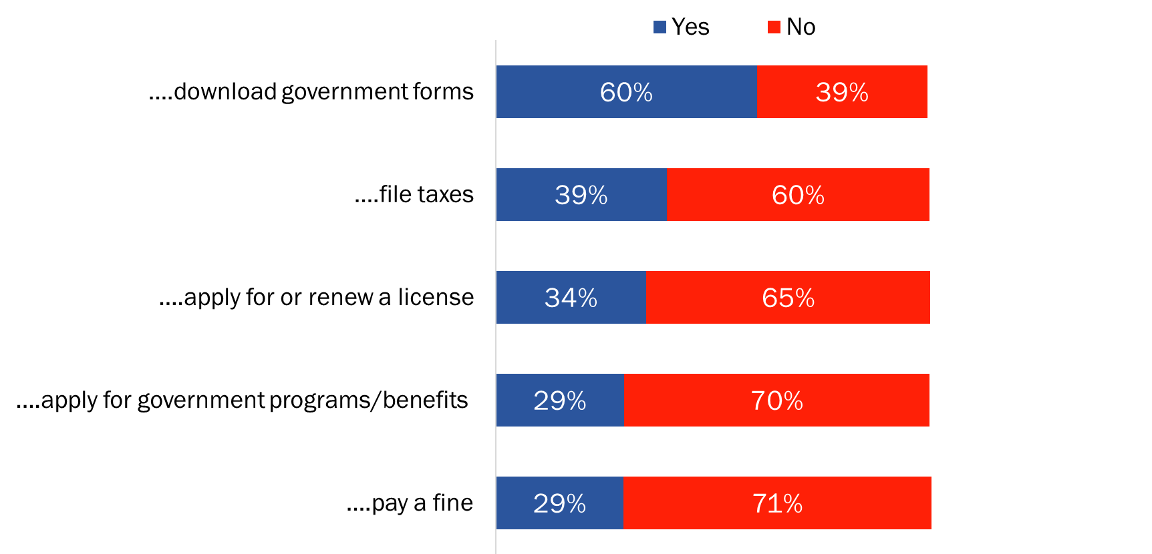
Q3. In the last few years, have you done any of the following online with any level of government in Canada? How about…?
Base: Respondents who use the Internet; n=2,228. DK/NR: <0.5%-1%

The likelihood of doing any of these things online in the last few years was lower among Canadians aged 55 and older and among Canadians with a high school level education or less. Regionally, the following differences were evident:
- Atlantic Canadians (44%) followed by Ontarians (39%) and Quebeckers (36%) were more likely to have applied for or renewed a license online.
- Online tax filing was higher in British Columbia (43%) and Quebec (42%) than it was in Atlantic Canada (34%) and the North (22%).
- Downloading government forms was higher in British Columbia (62%) and Ontario (62%) than it was in Atlantic Canada (54%).
- The likelihood of applying for a government program or service online was lower in the North (13%), while the likelihood of paying a fine online was lower in the North (13%) and in Atlantic Canada (16%).

Among those who have not tried to complete tasks or transactions using online government services, the likelihood of attributing this to lack of need was higher among Canadians under 35 years of age.

Lack of need is the main reason Canadians have not used government services online
For the minority of Canadians who have not accessed government services online in the past few years, nearly four in 10 (37%) reported that they simply have no need to do so. Following this, factors relating to convenience were cited by almost one in five; specifically, 19% pointed to online access being too difficult, slow, or time consuming. In addition, 16% do not use government services online because this service channel is too impersonal, 14% because of security concerns, and 13% because they have no interest in doing so.

Figure 4: Reasons for not using online government services
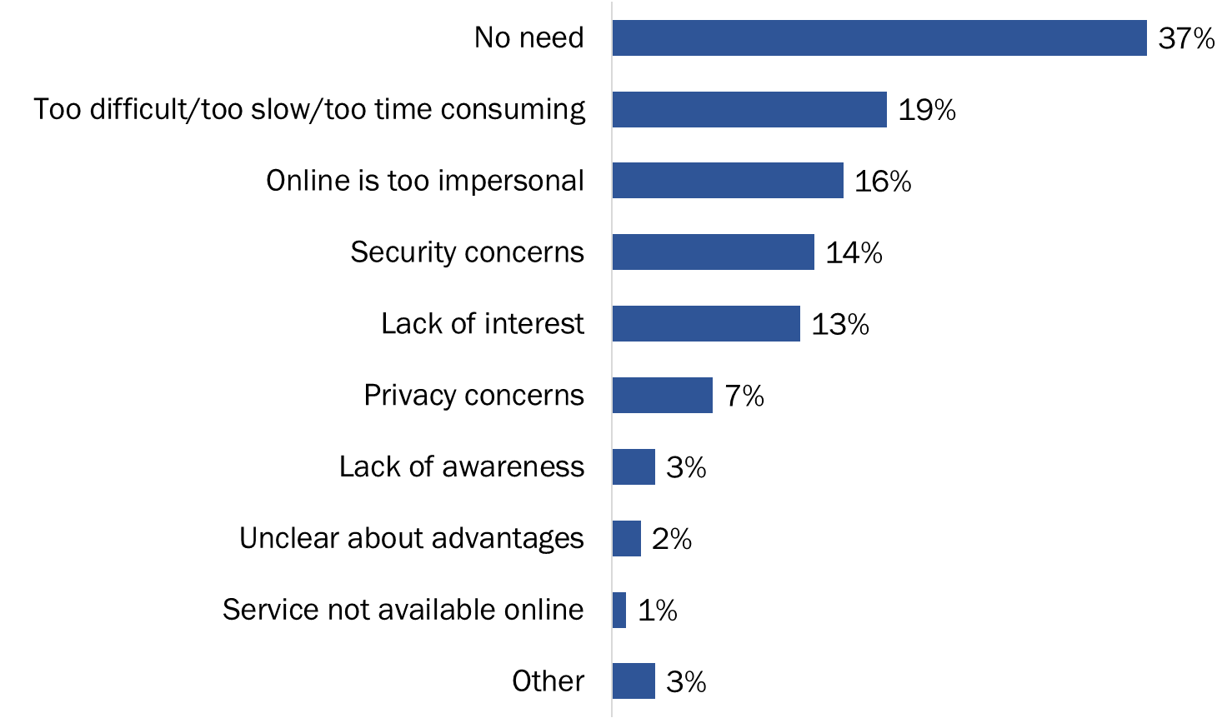
Q4. Why have you not tried to complete tasks or transactions using online government services?
Base: Respondents who do not use government services online; n=484. DK/NR: 5%. [Multiple responses accepted.]

Only a relatively small proportion of Canadians (7%) reported concerns about privacy as reasons for not accessing government services online. However, this survey was in-field before the recent Facebook/Cambridge Analytica issue surfaced as a major topic in the media and public consciousness, so Canadians’ views on privacy may have evolved somewhat in the interim.

Other issues were cited by small numbers, including lack of awareness, uncertainty about the advantages, and the needed services not being available online.

Three in 10 say easier access to online government services would encourage use
In terms of what would encourage or motivate online Canadians to start using, or use more, online government services, three in 10 (30%) pointed to improving ease of access or making the user experience easier. Other motivators include promoting the online services (8%) and instilling confidence that personal information will be kept safe (5%).

Figure 5: Motivations to use online government services
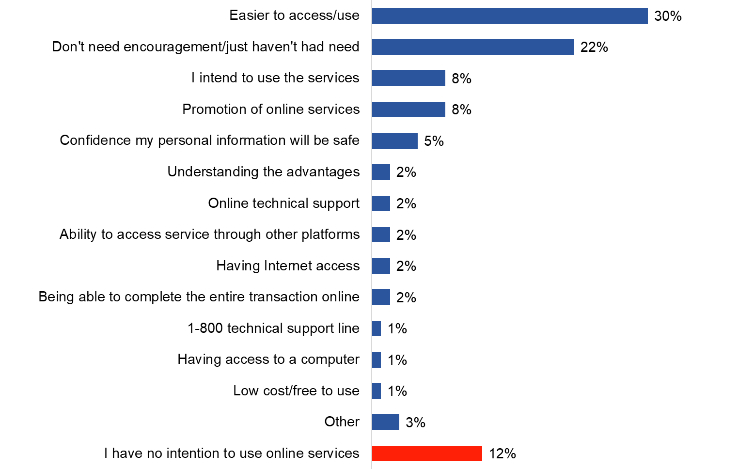

Q5. What would encourage or motivate you to use more/start using online government services? Anything else?
Base: Respondents who use the internet; n=2,228. DK/NR: 10%. [Multiple responses accepted.]

Smaller numbers (2% or less) said that future online use could be motivated by better communicating its advantages, offering access to phone/online technical support, providing online services through alternatives platforms, such as mobile devices, or being able to complete the entire transaction online. Others mentioned that they would be encouraged to use online government services if they had access to the Internet or to a computer, of if the services were low cost or free to use.

For a noteworthy number of Canadians, nothing is needed to encourage online use: 22% simply have not had a need to do so and 8% intend to use government online services. Conversely, 12% of Canadians said they have no intention of using online government services in the future.

The likelihood of pointing to making online government services easier to access or use was higher among those in British Columbia (31%) and Ontario (31%) than among those in Atlantic Canada (24%). As well, it was higher among Canadians living in urban areas (31%), those under 55 (33%), and university graduates (35%). Canadians aged 55 and older (18%), with a high school education or less (19%), and women (14%) were more likely to say they have no intention of using online government services.

Nearly six in 10 online Canadians use GC online services
Almost six in 10 (58%) online Canadians have accessed Government of Canada services through an online account, such as My Service Canada Account or Canada Revenue Agency’s My Account. Four in 10 have not done so.

Figure 6: Use of GC services via an online account
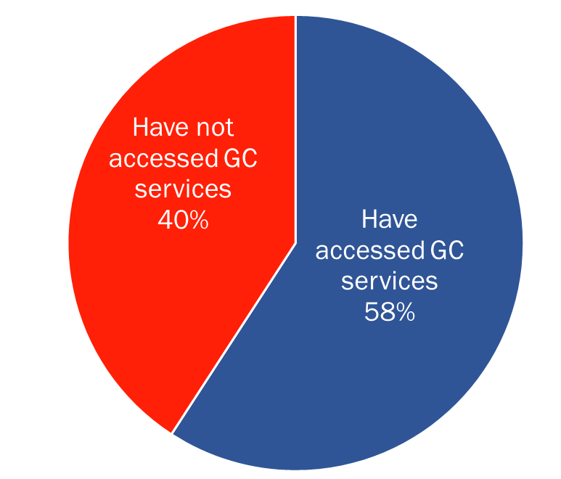
Q8. Have you ever accessed Government of Canada services through an online account, such as My Service Canada Account or Canada Revenue Agency’s My Account?
Base: Respondents who use the Internet; n=2,228. DK/NR: 1%

The likelihood of accessing Government of Canada services through an online account was higher in British Columbia (65%) and the Prairies (61%) than it was in Quebec (54%). It was also higher among Canadians living in urban areas (60%), men (62%), those under 55 years of age (63%), and among college (63%) and university (65%) educated Canadians.

Plurality of Canadians who used online GC services prefer to sign-in via a GCKey
A significant minority (45%) of those who access Government of Canada services through an online account said they prefer to sign-in using their GCKey credentials. Following this, more than one-quarter (28%) prefer to use a sign-in partner. Very few (5%) expressed a preference for using their social media log-in information.

Among the rest, 3% volunteered that they have no preference while 19% said they did not use any of these methods to sign into Government of Canada online services.

The only noteworthy subgroup differences pertained to use of the partner sign-in. Using banking log in information was more likely to be preferred among those living in Quebec (38% versus a high 28% elsewhere in the country), 35-54 year olds (33%), and those with a university degree (31% versus 23% of high school educated Canadians).

Figure 7: Preferred method of signing into a GC online account
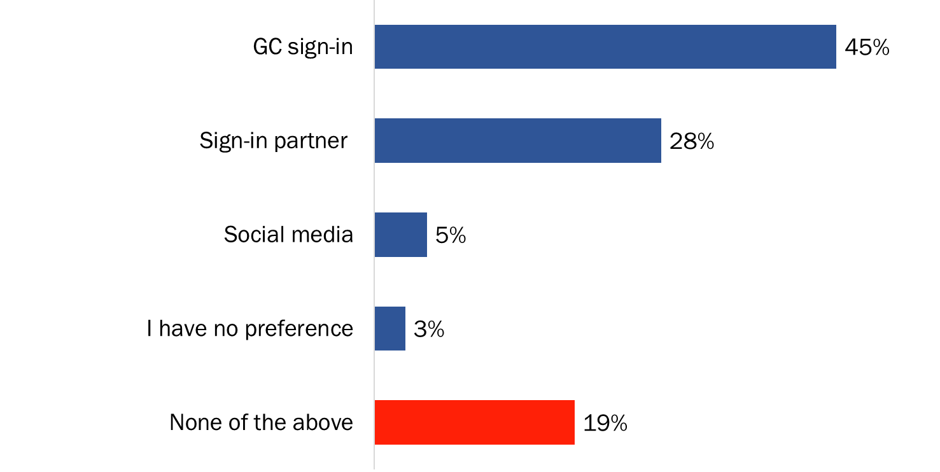
Q9. What is your preferred method of signing into Government of Canada online services?
Base: Respondents who accessed Government of Canada services through an online account; n=1,276.

Focus Group Findings:
Virtually all participants said they are aware that the Government of Canada offers online services. They routinely identified the following types of things that can be done online: filing taxes and tax-related activities, applying for/renewing a passport, filing for Employment Insurance (EI), applying for/managing a student loan, job searches (i.e. jobs.ca). Other things participants identified as capable of being done online included accessing immigration services (e.g. paying immigration fees online), accessing grants and contributions, applying for the Canada Pension Plan (CPP), searching for benefits, updating one’s personal information, accessing records of employment, and accessing and downloading forms.

In addition to being aware of such possibilities most participants have used such services. Participants collectively identified a range of things they have done online and services they have accessed, including the following: filing taxes and tax-related reporting (e.g. filing HST returns), CPP-related activities, applying for/renewing a passport, using jobs.ca, EI-related reporting, checking their Tax Free Savings Account (TFSA) contribution room, Canada Student Loan Program (CSLP) repayment assistance, accessing records of employment, paying citizenship fees, applying for the child tax benefit, applying online for jobs at NavCanada, and purchasing items from GCSurplus. Many participants said they interact with the Government of Canada through online accounts, mainly through a My Service Canada Account and/or the CRA’s My Account.

3. Service Channels for Contacting the Government of Canada

Canadians prefer using the phone and Internet to contact the Government of Canada
When they need to contact the Government of Canada for information or to receive service, Canadians prefer to use the telephone (46%) followed by the Internet (33%). Fewer than one in five (18%) expressed a preference for visiting an office. Two percent volunteered that they do not contact the Government of Canada.

Figure 8: Preferred service channel for contacting the Government of Canada
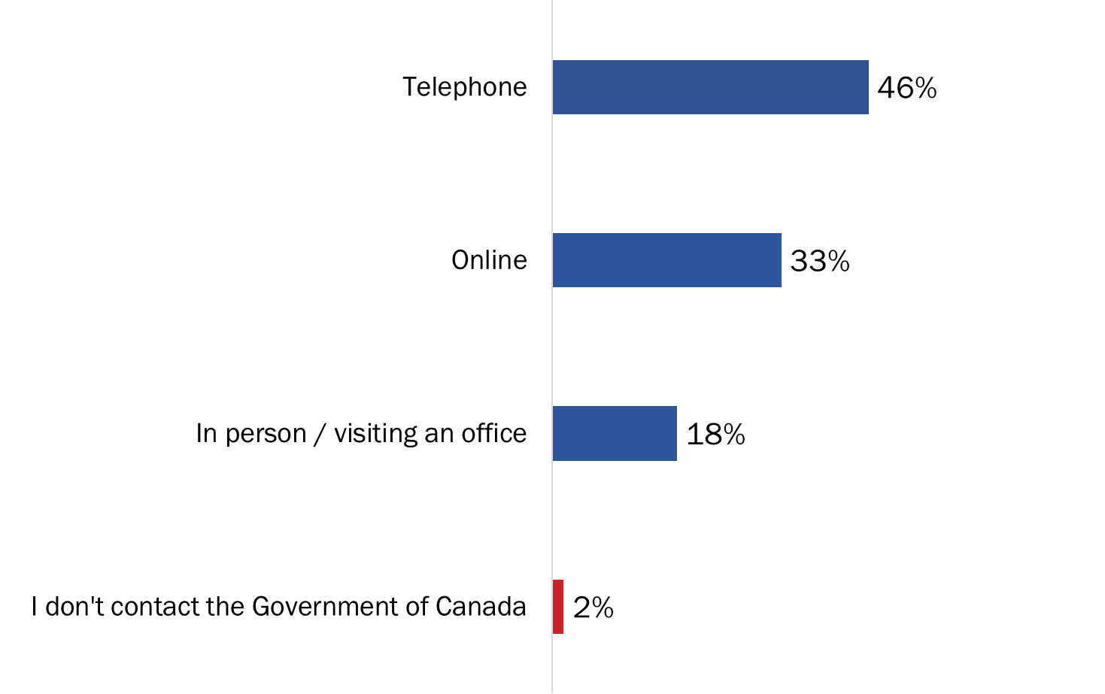
Q6. When you need to contact the Government of Canada for information or to receive service, how do you prefer to do so?
Base: All respondents; n=2,500. DK/NR: 1%

Canadians with a high school or college-level education, as well as those aged 55 and older, were more likely to prefer to use the phone or to visit an office when they need to contact the Government of Canada. Conversely, the likelihood of preferring the Internet increased with Canadians’ level of education and was higher among respondents under 55 years of age. In addition, online Canadians were less likely than Canadians who do not use the Internet to prefer phone.

Regional differences were also evident, and included the following:
- Canadians in the North (62%) and in Quebec (56%) were more likely to prefer the phone.
- Preference for online was higher in Ontario (36%) and British Columbia (34%) than it was in the North (14%).
- Atlantic Canadians (30%) were most, and Quebeckers were least (10%), likely to say they prefer visiting an office.

Reasons for preferred service channels
Convenience factors make the telephone a preferred contact channel with 44% of Canadians saying they prefer to deal with a real person, 36% finding the phone easier than other methods, and about the same proportion (34%) simply saying that convenience is the main reason they prefer using the phone.

Figure 9: Reasons for using the phone to contact the GC
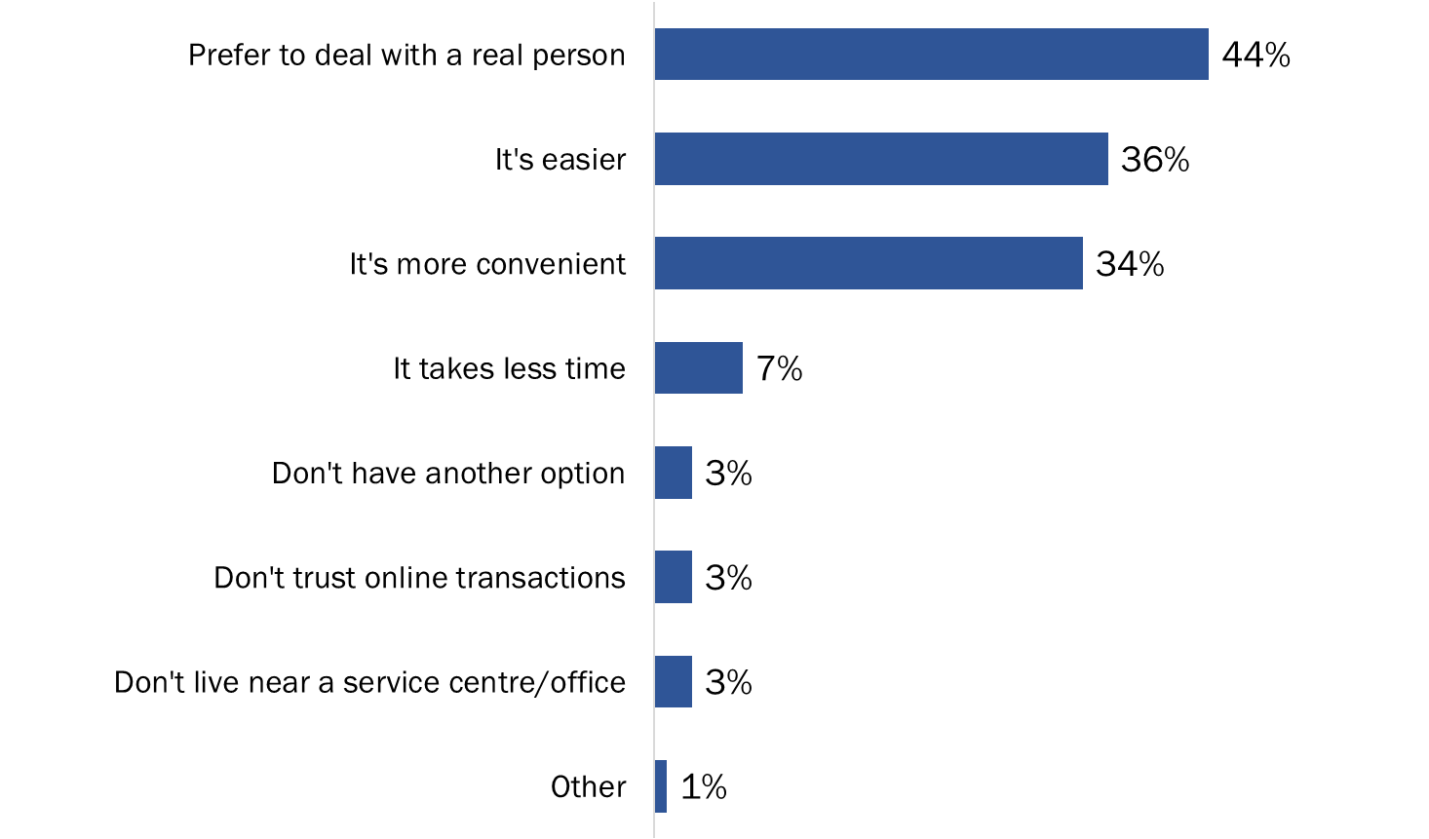
Q7B. Why do you prefer using the phone?
Base: Respondents who use the phone to contact the Government of Canada; n=1,152. DK/NR: 1%. [Multiple responses accepted.]

Other reasons were mentioned by fewer than one in 10 respondents and included the perception that using the phone takes less time, the fact that they do not have another option or do not live near a service centre, and lack of trust of online transactions.

For the one-third of Canadians who prefer the online channel, convenience factors also top the list of reasons offered to explain this preference. Specifically, 59% said they find it more convenient than other methods, 43% find it easier, and 28% reported that it takes less time to use the Internet. Thirteen percent prefer the online channel because they find it takes too long to get through by phone, while very small proportions said they do not live near a service (2%) or they do not have another option (1%).

Similarly, convenience factors motivate Canadians to contact the Government of Canada by visiting an office, with 61% preferring to deal with a real person, 28% finding it more convenient, and 19% reporting that it is easier to visit an office than use other contact methods. A minority (8%) prefer in-person visits because they do not trust the online environment and an almost equal proportion (7%) find it takes too long to get through by telephone. Small proportions pointed to other reasons: visiting an office takes less time (4%), they usually need to visit an office to complete a transaction (2%), and they do not have another option (1%).

Figure 10: Reasons for using the Internet to contact the GC
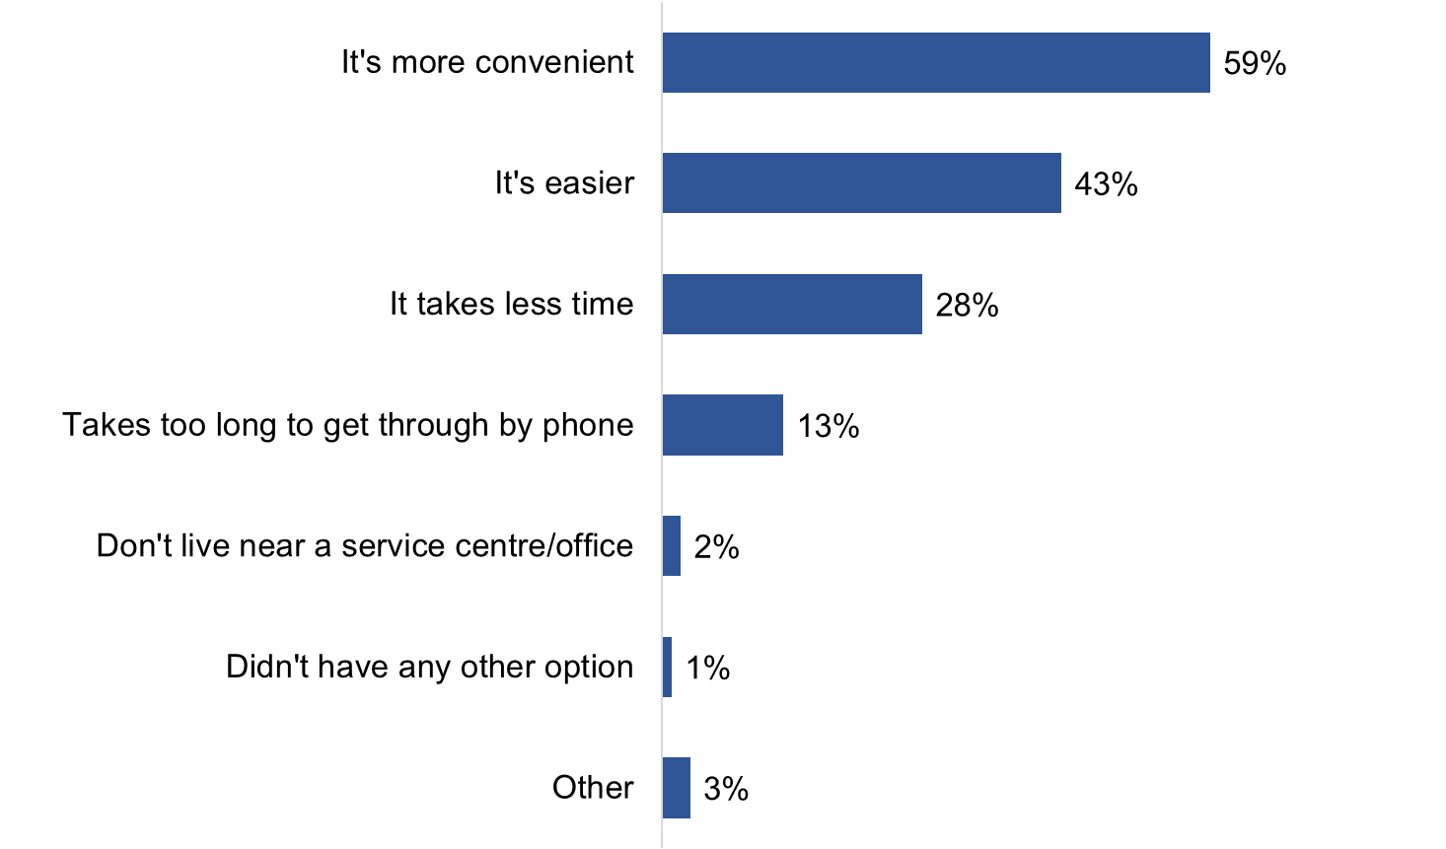
Q7C. Why do you prefer online?
Base: Respondents who prefer to contact the Government of Canada online; n=750. DK/NR: <0.5%. [Multiple responses accepted.]

Figure 11: Reasons for visiting a GC office
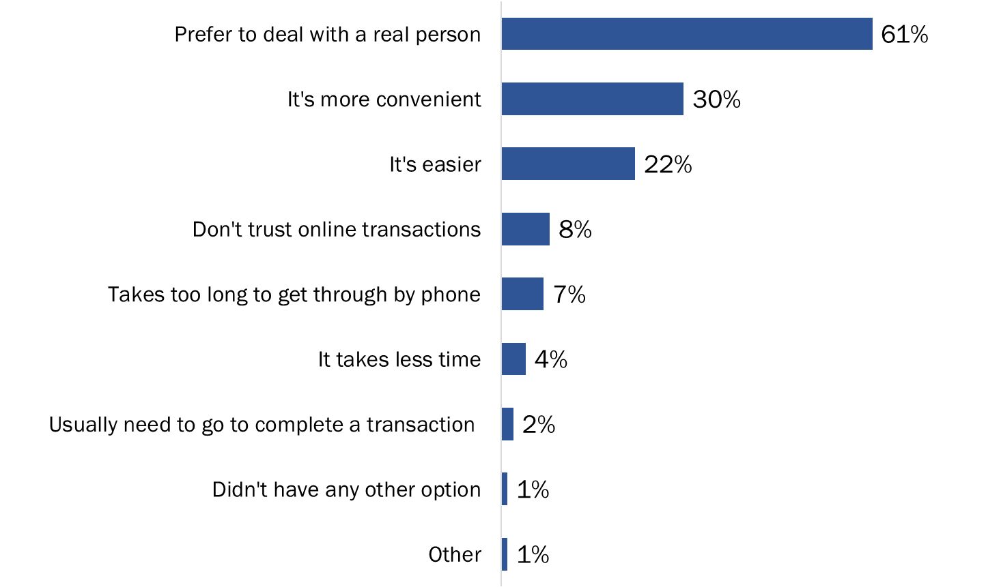

Q7A. Why do you prefer visiting an office?
Base: Respondents who visit Government of Canada office; n=513. DK/NR: 1%. [Multiple responses accepted.]
Focus Group Findings:
The most frequently identified advantage of using Government of Canada online services was convenience with a focus on speed and efficiency. For example, if you need information you can get it without delay (e.g. no need to stand in lines or wait on the phone), and if you are sending/updating information it gets through immediately and directly to the appropriate destination. Other frequently identified advantages tended to focus on accessibility. This included 24/7 access to service, the ability to access and track one’s data, access to online forms, and access to information that is detailed and accurate (i.e. not subject to errors/confusion that can arise through person-to-person interactions). An advantage identified less frequently was the ability to print out information or personal records.

Participants collectively identified a range of potential disadvantages to using Government of Canada online services, but those identified most often included technical problems/glitches (sometimes resulting in the need to try to contact someone by phone), and the possibility of hacking, resulting in unauthorized people having access to one’s information. Other disadvantages identified relatively frequently included the perception that the sign-in process is lengthy (i.e. lots of steps to go through), difficulty moving forward/continuing with what one is doing if there is a problem (e.g. difficulty contacting someone for assistance), lack of user-friendliness on some sites (i.e. they can be difficult to navigate), language/questions at times being complex or unclear, and the need to remember passwords.

Disadvantages identified infrequently included the length of time it takes from some sites to time one out, resulting in the possibility of others seeing one’s information on screen, the possibility of missing/ignoring important information, not being aware of everything that is available or that can be done online, and the potential for two-tiered service that disadvantages those who do not engage in online transactions.

4. Reaction to “Tell Us Once” and Related Issues

Knowledge about current GC information sharing practices is low
While the Government of Canada does not share the personal information it collects from citizens as part of service delivery, almost three-quarters of Canadians (72%) believe it does. Specifically, 24% said it is definitely true that their information is shared between federal departments and agencies as part of current service deliver and 48% believe it is probably true that this happens.

Canadians also believe that the Government of Canada is sharing their personal information with their provincial or territorial government departments, with two-thirds saying that this is definitely (22%) or probably (45%) true.

Figure 12: Knowledge of GC's sharing of personal information
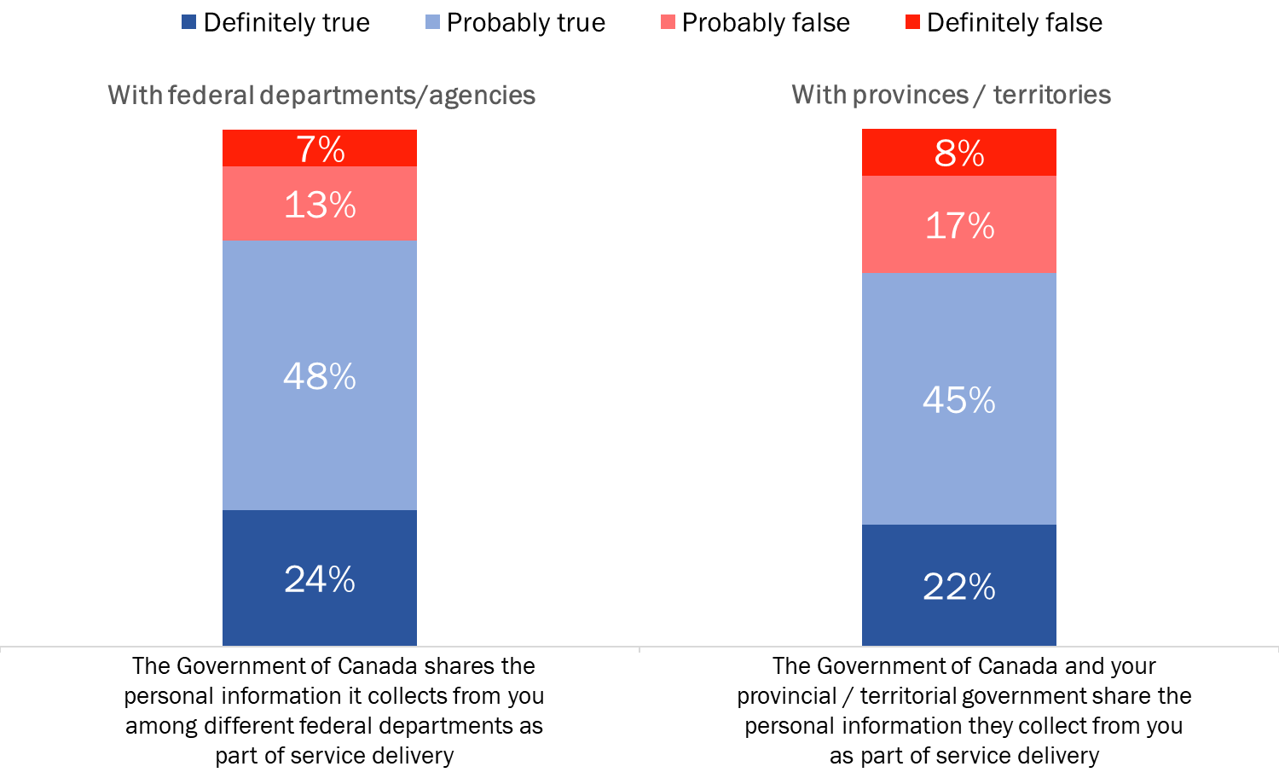
Q10A/B. To the best of your knowledge, are the following statements true or false? Would you say this is definitely true, probably true, probably false, or definitely false? Base: All respondents; n=2,500. DK/NR: 8%

The likelihood of saying it is definitely or probably false that the Government of Canada shares the personal information it collects from Canadians among different federal departments was higher among Atlantic Canadians (21%) and Ontarians (21%) than it was among Quebeckers (16%). It was also higher among Canadians aged 55 and older (22%) than it was among Canadians under 35 years of age (17%). Conversely, the likelihood of believing that this statement is definitely or probably true was higher among university graduates (75% versus 69% of Canadians with high school or less) and Internet users (73% versus 63% of Canadians who do not use the Internet).

When asked whether it is true or false that the Government of Canada shares personal information with provincial and territorial governments, there were fewer subgroup differences. The only differences of note are the following: those in Quebec (25% compared to 19% of respondents from Atlantic Canada and the Prairies and 17% from British Columbia) were more likely to say this is definitely true, as were college (24%) and university (22%) educated Canadians (compared to 18% of those with high school or less).

Two-thirds of Canadians support “Tell Us Once”
Two-thirds of Canadians agree strongly (33%) or somewhat (34%) with the “Tell Us Once” approach to service delivery. Approximately three in 10 strongly (18%) or somewhat (11%) disagree with this approach. These opinions were offered in response to the following question:

In the future, Canadians may have the option of providing their personal information, like phone number, date of birth or home address, only once in order to access services from all Government of Canada departments. Do you agree or disagree with this approach?

Figure 13: Support for "Tell Us Once"
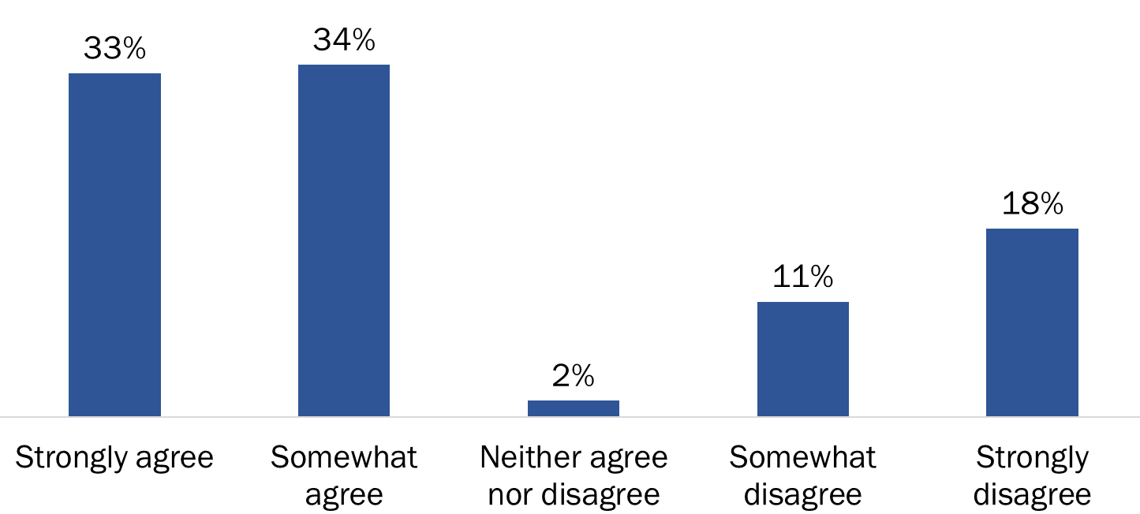

Q11. In the future, Canadians may have the option of providing their personal information, like phone number, date of birth or home address, only once in order to access services from all Government of Canada departments. Do you agree or disagree with this approach? Would that be strongly [agree / disagree] or moderately [agree / disagree]?
Base: All respondents; n=2,500. DK/NR: 2%

The likelihood of agreeing (strongly or somewhat) was higher among those 18-34 years of age (74%), Quebeckers (73%), Canadians living in urban areas (68%), and among Internet users (68%). Canadians with high school or less were less apt to agree with this approach (64% versus 71% of university educated Canadians).

Focus Group Findings:
There was widespread, though not unconditional, receptivity to the “Tell us Once” scenario, including the sharing of information it implies. Participants had no difficulty identifying potential advantages of Government of Canada departments sharing the personal information of Canadians with other federal service-providing departments and provincial governments.

Focus Group Findings (cont’d.):
The most frequently identified advantage was increased convenience to Canadians by eliminating redundancy (i.e. the need to provide the same information to different departments or levels of government). Related to this was the advantage of relieving individuals from having to make sure that every relevant federal and provincial department has been contacted with new/updated information.

Other advantages included consistency of information (i.e. all departments would immediately and automatically have the same information), more efficient/rationalized allocation of government resources (perhaps resulting in cost-savings), more streamlined processes (perhaps resulting in faster service delivery), potential costs savings, the possibility of reducing the number of PINs one must remember to a single one, and the perception that fewer mistakes might be made if information were entered only once instead of by multiple departments.

The idea that such sharing of information could result in people being made aware of benefits they qualify for also resonated with participants, though most said they would not want to be automatically enrolled to receive such benefits. In addition, the idea that this information sharing could result in benefits being terminated did not concern participants, as long as no mistakes are made and there is an appeal process available. Indeed, it was routinely noted that no one should receive benefits to which they are not entitled, with some noting that they would expect the government to intervene in such cases.

While participants were receptive to information sharing, they also routinely added conditions or qualifiers. The most frequently identified qualifiers were that Canadians should have the choice to accept or decline such information sharing, that their acceptance would depend on knowing what information was being shared, with whom, and for what purpose (i.e. full transparency), and that adequate security measures and systems would be in place (e.g. encryption).

Majority of Canadians are comfortable with GC sharing of personal information
While two-thirds of Canadians support “Tell Us Once”, a smaller majority is comfortable with the information sharing that would be necessary to support a single account for the Government of Canada. Almost six in 10 (58%) Canadians are very or somewhat comfortable with their personal information being shared automatically with other federal services as part of a single account approach for accessing government programs and services. One in four Canadians do not share this view: 17% are not at all comfortable and 8% are somewhat uncomfortable.

Canadians appear to have similar levels of comfort with the Government of Canada linking the single account they would have for federal government services and programs to their provincial or territorial government. Respondents were told that any changes they make to their Government of Canada account would be shared automatically with their provincial or territorial government and vise versa.

Figure 14: Comfort with GC sharing of personal information
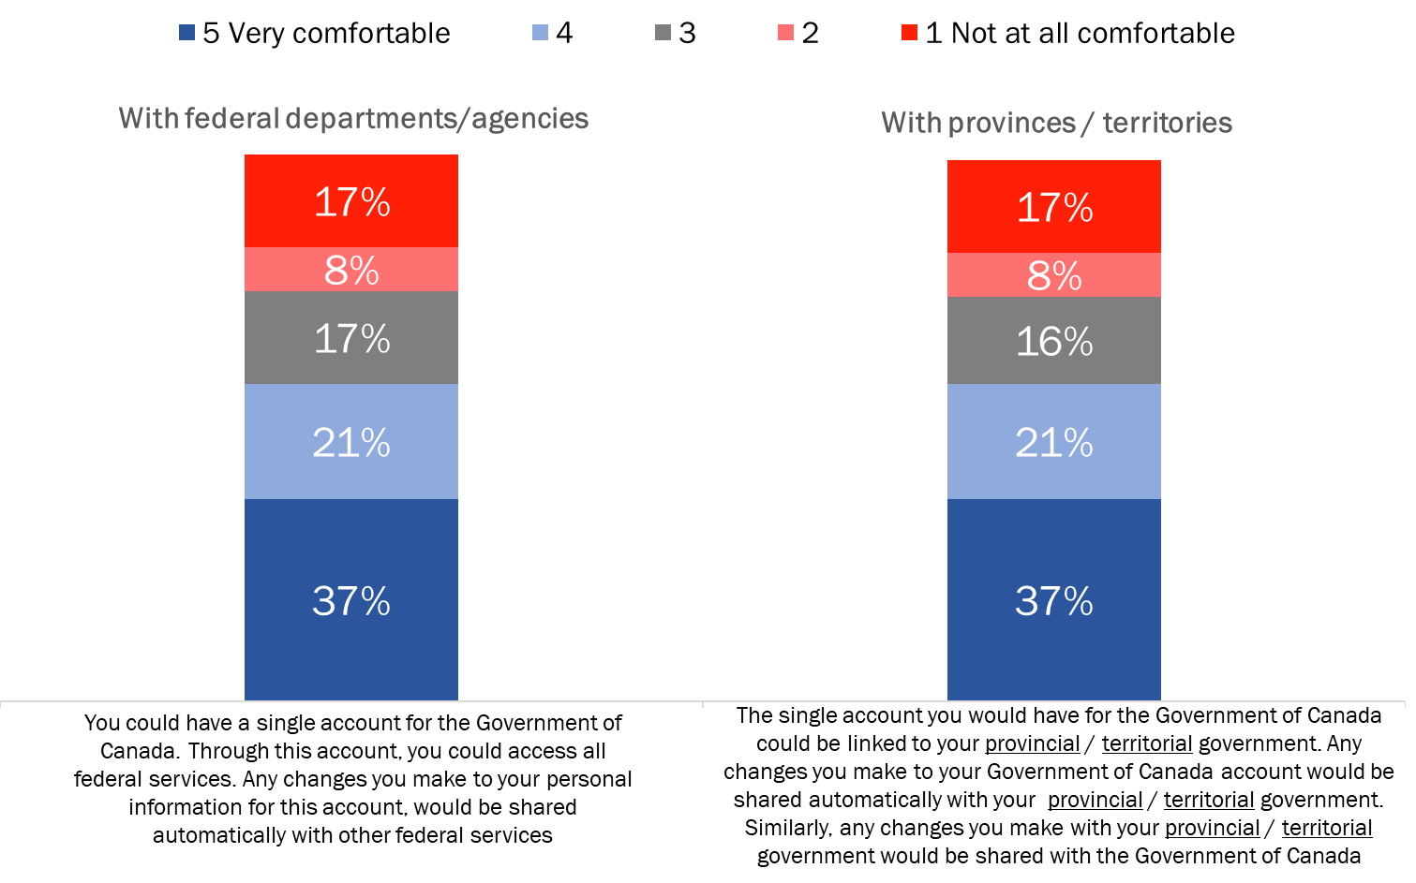
Q12A/B. I’m now going to describe to you two examples of how service delivery could work. For each one, I’d like you to tell me whether or not you are comfortable with the approach, using a scale from 1 to 5, where “1” is not at all comfortable, and “5” is very comfortable.
Base: All respondents; n=2,500. DK/NR: <0.5% - 1%

The following subgroup differences are noteworthy when it came to comfort with the sharing of their personal information among federal departments:
- Quebeckers were most likely to be comfortable (scores of 4-5) with their personal information being shared within the federal government: 69% compared to 57% of Ontarians, 55% of those living in the Prairies, 50% of British Columbians, 48% of Atlantic Canadians, and 42% of those living in the territories.
- Canadians aged 55 and older (48%) were less likely than younger Canadians to be comfortable with this type of information sharing (65% of 35-54 year olds and 67% of 18-34 year olds).
- University graduates (67%) were more likely to be comfortable than were Canadians with high school or less (49%).
- Online Canadians (61%) were more likely to say they are comfortable with this approach than Canadians who do not use the Internet (27%).

The same pattern was reflected in the results when respondents were asked about the sharing of their personal information with provincial and territorial governments.

Focus Group Findings:
The main concerns about information sharing related to security (i.e. is it safe?) and functionality (will it work?). Many participants shared an impression that the more information is being shared, the greater the potential risk of both technical problems (e.g. a system overload caused by too much data) and security issues. Indeed, many noted that a technical problem or security breach in the type of sharing system described would be magnified because it would resonate across departments and levels of government. Similarly, correcting such problems could be more complicated for the same reason (i.e. the fact that it is inter-departmental or inter-governmental). A few participants also expressed concerns in the form of questions. One concerned potential about changes in Government ministries/departments. Specifically, if a ministry or department becomes an agency or a service currently delivered by government gets privatized would anything change regarding the sharing of information. Another concerned the use of sub-contractors, specifically would the government use subcontractors to maintain its system and if so what safeguards would be in place to ensure that the subcontractor does not have access to someone’s information/data.

Most participants think they have little or no control in terms of how their personal information is collected and used by federal departments and agencies for the purpose of service delivery. There were two fundamental assumptions underpinning this impression: one is the impression that once their information is in the hands of government it is out of their control; the other is the impression that if one wants government services one must provide the personal information they demand. In other words, one could exercise control by refusing to provide personal information, but at the cost of being denied service which is not a realistic option. Related to this, it was observed that there are no ‘opt-out’ provisions when it comes to providing information government asks for. Participants who think they retain some degree of control over how their personal information is used usually pointed to the fact that the Government departments and agencies currently ask permission to share personal information (e.g. the CRA asks permission to share information with Elections Canada). It was also suggested that the Privacy Act limits the government’s ability to share information, which amounts to a certain degree of control left in the hands of citizens.

Despite this impression of limited control, participants were virtually unanimous that they would expect to be asked permission when government wants to share their personal information. Reasons included the fact that it is their information (i.e. it belongs to them and it is their right to know who has access to it), in order to be able to confirm/verify that the information is correct, and in order to be able to hold government accountable for what it does with our personal information (i.e. in order to do this one must know what personal information it collects and shares).

Six in 10 Canadians want to be asked for consent for each time their personal information is to be shared
Six in 10 Canadians (60%) want to be asked for their permission each time their personal information is shared with other government departments to deliver different government services to them. Conversely, 34% would prefer to provide their consent for information sharing once only. Among the rest, 3% volunteered that neither option would be acceptable, while 2% expressed no preference, saying that either option would be fine.

Figure 15: Preferred approach to providing consent for information sharing
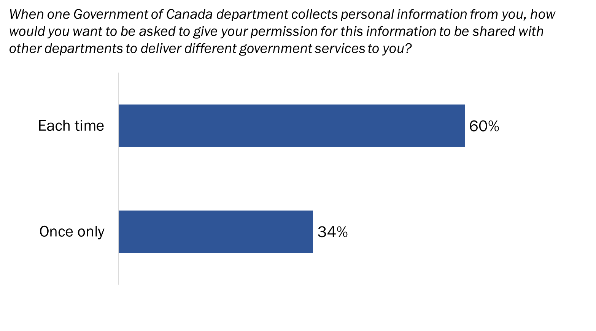
Q13. When one Government of Canada department collects personal information from you, how would you want to be asked to give your permission for this information to be shared with other departments to deliver different government services to you?
Base: All respondents; n=2,500. DK/NR: 1%

When it came to consent, Ontarians (65%) were more likely to want to be asked each time the government wants to share their personal information, while Quebeckers (41%) and Atlantic Canadians (38%) were more likely to prefer to be asked once only. Compared to Canadians aged 55 and older (56%), those 18-34 years of age were more likely to want to be asked each time, as were college-educated Canadians (62% compared to 56% of those with less education) and online Canadians (61% versus 44% of Canadians who do not use the Internet). Men (36%) were more likely than women (31%) to say they would want to give their permission once only.

Focus Group Findings:
Participants held different opinions on how often and how they should be asked to give the Government of Canada permission to share their personal information.

Regarding the frequency with which permission should be granted, most participants said they prefer being asked for permission each time the Government of Canada wants to share their personal information. The main reason for preferring this approach was that it gives a certain amount of control over what happens with one’s information (something they think they lack as noted above). This includes exercising some measure of control over where the information is going and why. Many of those favouring this approach also said that it serves to remind them that information is being shared and in so doing it keeps the issue on their radar screen. By contrast, they felt that giving permission only once may result in forgetting that permission was ever given in the first place.

Focus Group Findings (cont’d):
Other reasons for favouring this approach included the impression that it provides an opportunity to correct mistakes or update personal information proactively, and because policies and procedures regarding the sharing of information might change in such a way that people are no longer comfortable with their information being shared.

On the other hand, at least a few people in most groups said they would prefer giving permission once only. The main reason for preferring this option was convenience, particularly eliminating the need to provide the same information to a number of departments. Regarding the latter point, it was observed that since dealings with other service providing departments will be inevitable, why not provide the information once. Related to this was the observation that there is no reason to distrust one government department more than another when it comes to sharing personal information.

Some said that their choice would depend on factors such as the type of information being shared. The more sensitive the information (e.g. SIN, health-related information), the less likely they would be to give blanket permission once. Some also said they would be willing to grant permission once but for a determinate period of time after which permission would have to be sought again. Some others said they would be comfortable providing permission once if the information sharing was restricted to service-providing departments and agencies.

On the issue of how such permission should be provided, top-of-mind responses included giving permission through one’s tax return, on the census, through e-signatures, and by way of Government of Canada websites or online accounts such as My Account and My Service Canada Account.

When it came to a choice between being asked to complete a formal form authorizing the sharing of information or checking an opt-in box, arguments were presented for each but most favoured a formal approach. The main reason for favouring this approach was that this is a very important decision and it is better to go through the process of completing a form when it comes to making that decision. Many in favour of this option suggested that checking an opt-in box is too unreflective an act and that such a box might even be checked accidentally. By contrast, completing a form engages one in more deliberate reflection on what one is consenting to. It was also suggested that an opt-in box might be easier for someone to ‘hack’ than a formal form.

Those in favour of an opt-in box suggested that as long as the information is the same as on the form and it is clear with whom and for what purposes information will be shared, it is much easier to simply click on a box, especially if this is done on an official Government of Canada site. Some participants also liked the idea of an opt-in box on the assumption that it would allow them to choose which departments their information could be shared with (another example of wanting to exercise some control over use of their personal information).

Convenience is the top perceived advantage of government information sharing
Convenience factors were most often cited by Canadians as possible advantages of the provincial / territorial and federal governments sharing citizens’ personal information as part of service delivery. One in five believe that they would receive faster (21%) and easier access to (20%) service as a result of information sharing, while 18% said it would simply make access more convenient all the way around and 9% pointed to shorter wait times for service.

Following convenience, other perceived advantages mentioned by Canadians tended to focus on greater efficiency and included more efficient, better service (9%), elimination of duplication (7%) and fraud (2%), cost savings (4%), as well as less bureaucracy and paperwork (3%).

Fifteen percent saw no advantages to this kind of information sharing and thirteen percent said they did not know what the main advantage would be if the provincial / territorial and federal governments shared information as part of service delivery.

Figure 16: Advantages of information sharing between federal and P/T governments
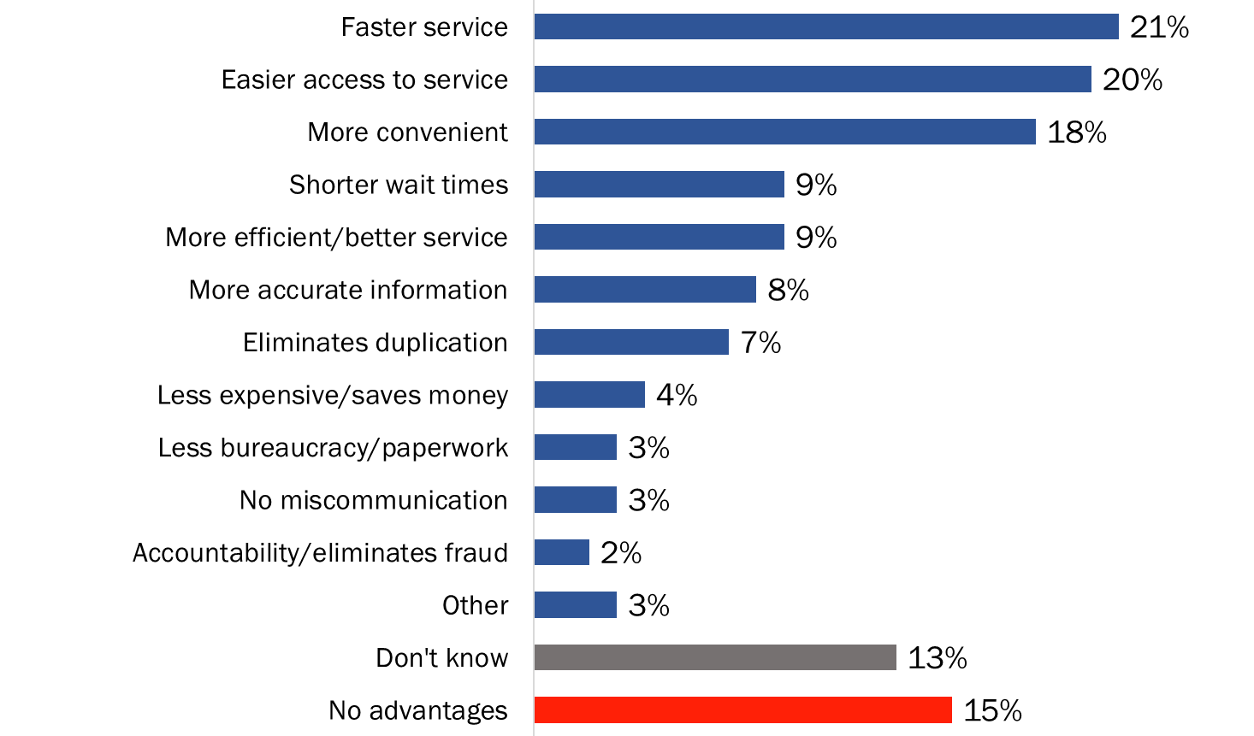
Q14. In your view, what would be the main advantage, if any, of the provincial / territorial and federal governments sharing information as part of service delivery?
Base: All respondents; n=2,500. [Multiple responses accepted.]

Those residing in Quebec were more likely to mention faster service and more convenience as advantages of information sharing. Canadians under 35 years of age, as well as university graduates and online Canadians, were more likely to identify faster service, easier access to service, and more convenience as advantages of information sharing. The likelihood of saying there are no advantages was higher among older Canadians, those with less formal education, and non-Internet users.

Security, privacy are main disadvantages of government information sharing
Security and privacy were most often cited by Canadians as possible disadvantages of the provincial / territorial and federal governments sharing citizens’ personal information as part of service delivery. Data security-related issues topped the list, including the security of their personal information (21%), privacy breaches (20%) and identity theft (7%), as well as other unspecified privacy concerns (15%).

Other possible disadvantages included Canadians’ information being used for unintended purposes (12%) and the perception that errors or mistakes could be made (6%) with this kind of information sharing.

One in five Canadians (21%) have no concerns at all about their personal information being shared with and among federal departments and their provincial or territorial government, while 16% were unable to identify any disadvantages.

Figure 17: Disadvantages of information sharing between federal and P/T governments
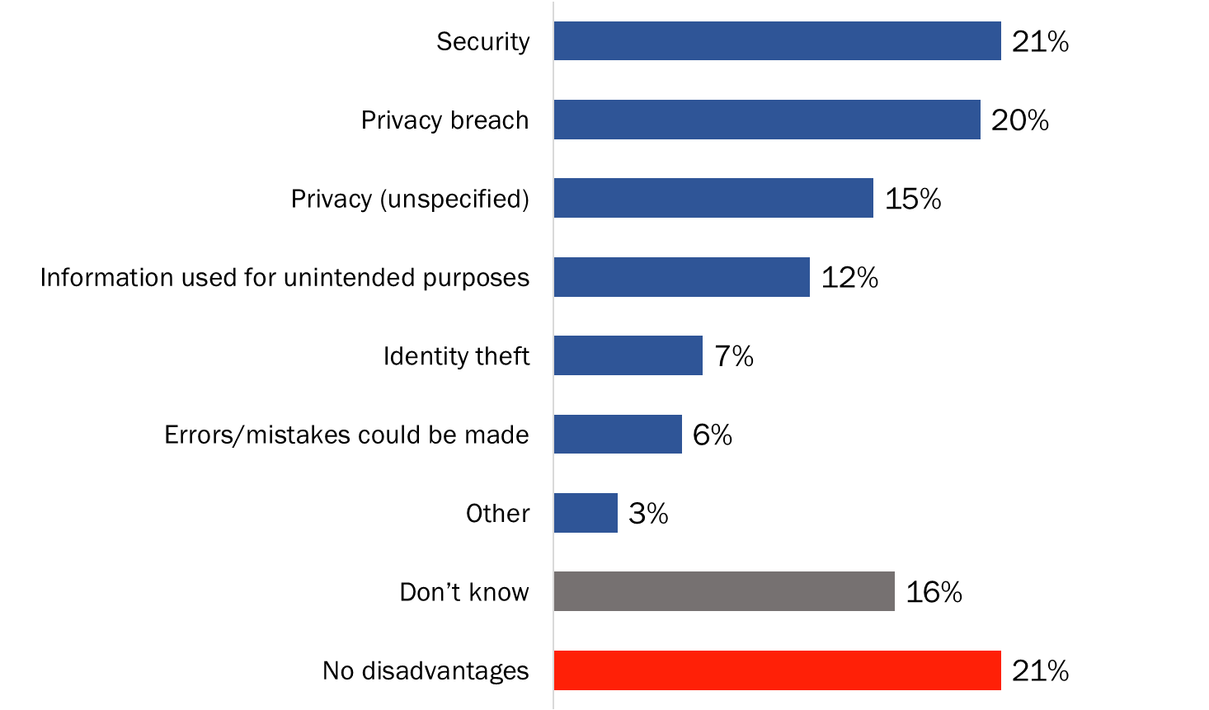

Q15. What would be the main disadvantage, if any, of the provincial / territorial and federal governments sharing this type of information as part of service delivery?
Base: All respondents; n=2,500. [Multiple responses accepted.]

The likelihood of pointing to security or privacy, including a breach, as disadvantages of information sharing was higher among university graduates than it was among those with a high school education or less, and among online Canadians. A privacy breach, as well as privacy in general, was more likely to be mentioned in Ontario, the Prairie provinces and British Columbia. Conversely, those living in Atlantic Canada and Quebec were more likely to say they have no concerns at all about the sharing of information as part of service delivery.

5. Trust in Protection of Personal Information

Canadians trust government to protect their personal information
Almost eight in 10 Canadians said they have at least some level of trust in the federal government when it comes to protecting their personal information. Specifically, 27% have a great deal of trust (a score of 5) and 51% have a moderate level of trust (scores of 3 and 4). Conversely, one in five said they trust the federal government very little (9%) or not at all (12%) to protect their data.

Following the federal government, Canadians reported similar levels of trust in banks and their provincial or territorial government.

Canadians were least likely to trust retail companies to protect the personal information that is shared with them. Just over two-thirds of Canadians said they have very little trust (25%) or no trust at all (43%) in retail companies.

Figure 18: Trust in protection of personal information by organization
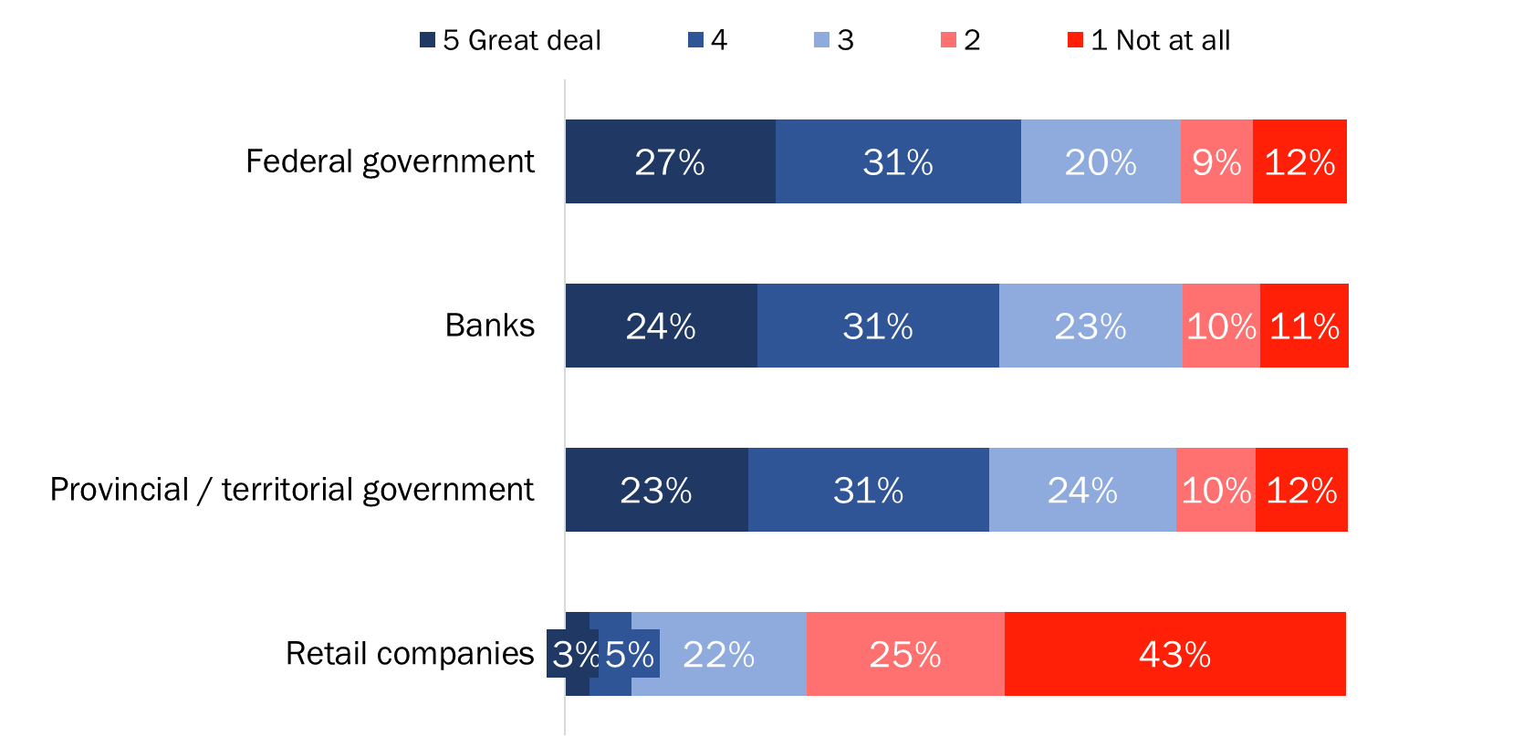
Q16. Finally, to what extent do you trust the following organizations to protect the personal information you share with them? Please use a scale from 1 to 5, where “1” means not at all, and “5” means a great deal. How about ….?
Base: All respondents; n=2,500. DK/NR: <1% - 1%.

The following subgroup differences are noteworthy when it came to trust in various organizations:
- Quebeckers were more likely than Canadians in other regions of the country to trust the federal and provincial governments as well as banks to protect their personal information.
- Canadians aged 55 and older were least likely, and Canadians under 35 years of age were most likely, to trust government and banks. Older Canadians were more likely than Canadians under 35 to not trust retail companies to protect their personal information.
- University graduates were more likely to trust government and banks than were Canadians with high school or less education.
- The likelihood of trusting government and banks was higher among online Canadians.

Focus Group Findings:
Most participants think about privacy and the protection of their personal information, even though it is not a constant top-of-mind concern. The main reasons for such concern include the fact that so much of their information is ‘out there’, shared, or accessible (often through their own willingness to share it), awareness/knowledge of information breaches/hacking, and an impression, through anecdotal or personal experience, that the effects of identity theft can be devastating and take a long time to resolve.

Most participants say they trust the Government of Canada to protect their personal information and keep it confidential, though reasons for such trust varied. Some made it clear that this is a hope or expectation that they have. For example, when asked why they trust the Government of Canada they responded with answers such as ‘If we can’t trust them then who can we trust’, or ‘It’s in their best interest to protect our information’. Others said they trust the Government of Canada because they are unaware of any major problems so far and expect that they would have heard had there been any. Finally, some said they trust the government because they believe it has policies, procedures, systems, and expertise to ensure the security of information. For example, some pointed to the security steps they themselves must go through to access their own information through online accounts. Others pointed to notifications they have received regarding scams such as bogus calls claiming to be from the CRA.

To the extent that there is lack of trust in this regard, it has less to do with any shortcomings of the Government of Canada per se and more to do with a perception that government, like any organization, is subject to breaches on the part of sophisticated hackers, such as the recent one at Equifax.

On the other hand, some do associate their lack of trust to perceived or possible shortcomings on the part of the Government of Canada. Examples included problems with the Government of Canada’s pay system and criticism of the CRA’s handling of enquiries in the most recent report of the Auditor General. A few linked their concerns to the fact that they have no idea who the Government of Canada contracts out to for the systems it uses to protect personal information. Finally, a few said that their lack of trust was due in part to the possibility that ‘rogue’ Government of Canada employees with access to their personal information might use it for fraudulent purposes.

6. Profile of Survey Respondents

Telephone Survey Respondents: Weighted Data

Region | %
Atlantic Canada | 7%
Quebec | 23%
Ontario | 38%
Prairies | 20%
British Columbia | 11%
Territories | <1%

Education | %
Grade 8 or less | 2%
Some high school | 7%
High school diploma or equivalent | 20%
Registered Apprenticeship or other trades certificate or diploma | 7%
College, CEGEP or other non-university certificate or diploma | 23%
University certificate or diploma below bachelor’s level | 10%
Bachelor’s degree | 20%
Post graduate degree above bachelor’s level | 13%
Refused | 1%

Age | %
18-34 years | 26%
35-54 year | 33%
55+ years | 36%
Refused | 5%

Language | %
English | 79%
French | 21%

Sex | %
Woman | 51%
Man | 47%
Other | <1%
Refused | 1%

Appendix

Annex 1: Methodological Details
A more detailed discussion of the methodologies is provided below.

1. Telephone Survey
- A 12-minute telephone survey was administered to 2,500 adult Canadians. The quantitative fieldwork was carried out by Elemental Data Collection Inc. (EDCI), under subcontract to Phoenix SPI, as per our standing offer.
- An overlapping dual-frame (landline and cell phone) sample was used to minimize coverage error.
- The sample was geographically disproportionate in order to improve the accuracy of regional and provincial results. Survey results are weighted by region, age, and gender to reflect the actual population distribution in Canada.
- A telephone pre-test was conducted in English and French, with 10 interviews in each official language.
- All survey respondents were informed that their participation was voluntary, and that information collected was protected under the authority of privacy legislation.
- Sponsorship of the study was revealed (i.e., the Government of Canada).
- The survey was registered with the MRIA’s Research Verification System and included the following phrase in the introduction: “This survey is registered in the National Survey Registration System.”
- The table below presents information about the final call dispositions for this survey, as well as the associated response rates (using the Marketing Research and Intelligence Association [MRIA] formula). The MRIA response rate formula is as follows: [R=R/(U+IS+R)]. This means that the response rate is calculated as the number of responding units [R] divided by the number of unresolved [U] numbers plus in-scope [IS] non-responding households and individuals plus responding units [R].

 | Total | Landline | Cell
Total Numbers Attempted | 65,289 | 29,588 | 64,185
Out-of-scope - Invalid | 22,175 | 7,980 | 42,679
Unresolved (U) | 22,175 | 9,698 | 12,477
No answer/Answering machine | 22,175 | 9,698 | 12,477
In-scope - Non-responding (IS) | 17,993 | 10,308 | 7,685
Language barrier | 518 | 286 | 232
Incapable of completing (ill/deceased) | 247 | 200 | 47
Callback (Respondent not available) | 2,977 | 1,218 | 1,759
Refusal | 13,969 | 8,449 | 5,520
Termination | 282 | 155 | 127
In-scope - Responding units (R) | 2,946 | 1,602 | 1,344
Completed Interview | 2,500 | 1,408 | 1,092
Quota Full | 124 | 71 | 53
NQ - Age | 72 | 0 | 72
NQ - Industry | 250 | 123 | 127
Response Rate | 6.83% | 7.41% | 6.25%

- The overall response rate was 7%. Specifically, the response rate for the cell phone sample was 6% and for the landline sample it was 7%. This is consistent with response rates for similar surveys.
- The potential for non-response bias was assessed by comparing the characteristics of respondents through unweighted and weighted data. The characteristics evaluated were gender and age. As is generally the case, for general population telephone surveys, older individuals (those aged 55+) are overrepresented and younger individuals (those under 35 years of age) are underrepresented in the survey sample. This was corrected through weighting.

2. Online Survey
- In addition to the telephone survey, an online survey was administered to 1,033 Canadians who are members of Research Now’s online panel.
- The questionnaire developed for the telephone survey was also administered to panellists. It was modified only to accommodate self-administered data collection (rather than interviewer-assisted).
- Panellists were invited to participate in the survey through an email invitation which informed them about the survey topic in a very general way and provided a password-protected URL to access the survey.
- All survey respondents were informed that their participation was voluntary, and that information collected was protected under the authority of privacy legislation.
- Sponsorship of the study was revealed (i.e., the Government of Canada).
- The survey was registered with the MRIA’s Research Verification System and included the following phrase in the introduction: “This survey is registered in the National Survey Registration System.”
- The response rate was 15%, calculated using the formula outlined in the Standards for the Conduct of Government of Canada Public Opinion Research (Online Surveys).

Total Sample Used | 33,879
Unresolved (U) | 0 18,964
In-scope non-responding units (IS) | 0
Responding units (R) | 5,188 1,263
Completed survey | 1,033 1,263
Partially completed surveys | 112
Disqualified – quota filled | 3,895
Disqualified – industry | 148
Response Rate = R/(U+IS+R) | 15%

2. Qualitative Research
- A set of 12 two-hour focus groups was conducted with Canadians, 18 years of age and older.
- Two focus groups were conducted in each of the following six locations: Halifax, Quebec City, Toronto, Moose Jaw, Calgary, and Kelowna. The groups in Quebec City were held in French; in all other locations, the groups were conducted in English.
- In each location, one group was conducted with Canadians under 35 years of age, the other with Canadians 35 years of age and older. Each group had a good mix by gender, age (within stated parameters), education, ethnicity, and online activities.
- Participants were paid $100 to participate.
- All sessions were video-recorded. Participants were informed of this during the recruitment interview, asked to sign a consent form upon arrival for the focus group, and were reminded of the recording by the moderator in advance of the discussion.
- The moderators for this study were Alethea Woods and Philippe Azzie. Alethea moderated the groups in Moose Jaw, Calgary, and Kelowna. Philippe moderated the groups in Toronto, Halifax, and Quebec City (French). Both contributed to the final report.
- This research was qualitative in nature, not quantitative. As such, the results provide an indication of participants’ views about the issues explored, but they cannot be generalized to the full population of members of the general public.

Annex 2: Quantitative Research Instruments

2a: Survey

Introduction
Hello, my name is ….. I’m calling on behalf of Phoenix SPI, a public opinion research company. We are conducting a survey for the Government of Canada on current issues of interest to Canadians. Would you prefer to continue in English or French? / Préférez-vous continuer en anglais ou en français?

The survey takes about 12 minutes and is voluntary. Your responses will be kept entirely confidential and anonymous and this survey is registered with the Marketing Research and Intelligence Association.

IF ASKED ABOUT THE REGISTRATION, SAY: The survey is registered with the Market Research and Intelligence Association as per Government of Canada standards. The MRIA project registration number is 20180215-299R. The registration system has been created by the Canadian survey research industry to allow the public to verify that a survey is legitimate, get information about the survey industry or register a complaint. The registration system’s toll-free telephone number is 1-888-602-6742, extension 8728].

[LANDLINE SAMPLE]

- We choose telephone numbers at random and then select one person from each household to be interviewed. To do this, we would like to speak to the person in your household, 18 years of age or older, who has had the most recent birthday. Would that be you?

Yes GO TO E
No ASK TO SPEAK TO ELIGIBLE PERSON; REPEAT INTRO

[CELL SAMPLE]

- Are you 18 years of age or older?

Yes CONTINUE
No THANK/DISCONTINUE

- Are you in a place where you can safely talk on the phone and answer my questions?

Yes GO TO E
No ASK D

- We would like to conduct this interview with you when it is safe and convenient to do. When would it be more convenient for me to call back?

SCHEDULE CALL-BACK IF POSSIBLE (TIME/DAY): _______________

[EVERYONE]

- Do you, or does anyone in your family or household, work in any of the following areas? [READ LIST]

Advertising or Market Research or Public Relations
The media (i.e. TV, radio, newspapers)
Government of Canada

THANK/DISCONTINUE IF ANY OF THE ABOVE

THANK/DISCONTINUE MESSAGE: “Thank you for your willingness to take part in this survey, but you do not meet the eligibility requirements of this study.”

- In which province or territory do you live?

Newfoundland and Labrador
Prince Edward Island
Nova Scotia
New Brunswick
Quebec
Ontario
Manitoba
Saskatchewan
Alberta
British Columbia
Yukon
Northwest Territories
Nunavut

- RECORD GENDER BY OBSERVATION

Male
Female

PROGRAMMING NOTES:

- Accept Don’t know and Refused for all questions if volunteered by a respondent.
- Record Don’t know and Refused separately for all questions.

I. Online Activities
To start,

- Do you use the Internet, whether on a computer, tablet or smart phone?

Yes [INTERNET USER; CONTINUE]
No [NON-INTERNET USER; GO TO Q6]

- Please tell me if you ever use the Internet to do any of the following things. How about…? [READ AND ROTATE]

Get news online
Buy a product or service
Use social networking sites like Facebook
Stream TV or movies
Banking, including paying bills

[READ AND RECORD]

Yes
No

II. Use of Government Services
[ASK INTERNET USERS]
- In the last few years, have you done any of the following online with any level of government in Canada? How about… [INSERT]?

[RANDOMIZE ITEMS]

Applied for or renewed a license
Paid a fine, such as a parking ticket
Filed taxes (Not through an agent)
Downloaded government forms
Applied for a government program or benefits

[READ AND RECORD]

Yes
No

[IF NO TO ALL ITEMS AT Q3 CONTINUE; IF YES TO ANY GO TO Q 5]

- Why have you not tried to complete tasks or transactions using online government services? [DO NOT READ LIST; DO NOT PROBE, BUT ACCEPT MULTIPLE RESPONSES IF OFFERED]

No need
Lack of awareness
Security concerns
Privacy concerns
Unclear about advantages
Service not available online
Lack of interest
Too difficult / too slow / too time consuming
Online too impersonal/prefer to deal with humans/service agents
Other – SPECIFY [TEXT]

- What would encourage or motivate you to [use more/start using*] online government services? Anything else? [DO NOT READ LIST; DO NOT PROBE, BUT ACCEPT MULTIPLE RESPONSES IF OFFERED]

Don’t need encouragement, just haven’t had need
Increased awareness/promote the services
Understanding the advantages
Confidence that my personal information will be safe
Ability to access service through alternative platforms (i.e., mobile/smartphone)
Being able to complete the transaction entirely online
Online technical support
Easier to access / use
1-800 technical support line
Having access to a computer
Having access to the Internet
Nothing – intend to use the services
Nothing – have no intention of using the services
Other – SPECIFY [TEXT]

*MODIFY USING CATI: 1) ‘USE MORE’ – FOR PEOPLE WHO HAVE DONE ONE OR MORE ACTIVITIES AT Q3, 2) ‘START USING’ – FOR PEOPLE WHO SAID NO TO ALL ITEMS AT Q3.

[ASK EVERYONE]

Now I’d like to focus on the Government of Canada,

- When you need to contact the Government of Canada for information or to receive service, how do you prefer to do so? [READ LIST]

In person by visiting an office,
By telephone, or
Online

VOLUNTEERED: DO NOT CONTACT THE GOVERNMENT OF CANADA

- Why do you prefer [INSERT Q7 FROM LIST BELOW]? [DO NOT READ LIST; DO NOT PROBE, BUT ACCEPT MULTIPLE RESPONSES IF OFFERED]

Office
Prefer to deal with humans/service agents
Usually need to go into an office to complete a transaction anyway
It’s easier
It’s more convenient
Didn’t have another option
It takes too long to get through by phone
Don’t trust online transactions
Other – SPECIFY [TEXT]

Phone
Prefer to deal with humans/service agents
It’s easier
It’s more convenient
Didn’t have another option
Don’t live near a service centre/office
Don’t trust online transactions
Other – SPECIFY [TEXT]

Online
It’s easier
It’s more convenient
It takes less time
Didn’t have another option
Don’t live near a service centre/office
It takes too long to get through by phone
Other – SPECIFY [TEXT]

[Q7 LIST]
visiting an office
using the phone
going online

[INTERNET USERS]

- Have you ever accessed Government of Canada services* through an online account, such as My Service Canada Account or Canada Revenue Agency’s My Account?

Yes CONTINUE
No GO TO Q10

*INTERVIEWER NOTE: IF ASKED, THIS INCLUDES PROGRAMS TOO.

[IF YES AT Q8]

- What is your preferred method of signing into Government of Canada online services? [READ LIST; ROTATE ITEMS]

Using a Government of Canada Sign-in like the GCKey*
Using the same login information you use for online banking**
Using social media, such as Facebook, to sign-in
[DO NOT ROTATE] None of the above

VOLUNTEERED: No preference

INTERIVEWER NOTES:

*IF ASKED, SAY: “GCKey is a unique login solution that allows users to communicate securely with online enabled government programs and services.”
**IF ASKED, THIS IS REFERRED TO AS A SIGN-IN PARTNER.

III. Privacy, Personal Information and Service Delivery
[EVERYONE]

The next questions are about privacy and the protection of personal information, which includes things like your name, age, address, and income.

- To the best of your knowledge, are the following statements true or false? [READ] Would you say this is definitely true, probably true, probably false, or definitely false?

[ROTATE]

- The Government of Canada shares the personal information it collects from you among different federal departments as part of service delivery.
- The Government of Canada and your [provincial / territorial]* government share the personal information they collect from you as part of service delivery.

To protect privacy, federal laws sometimes prevent sharing personal information that one Government of Canada department collects with other departments. This can mean that people need to provide the same information again when talking to different federal departments.

- In the future, Canadians may have the option of providing their personal information, like phone number, date of birth or home address, only once in order to access services from all Government of Canada departments. Do you agree or disagree with this approach? Would that be strongly [agree / disagree] or moderately [agree / disagree]? ACCEPT NEITHER IF VOLUNTEERED.

- I’m now going to describe to you two examples of how service delivery could work. For each one, I’d like you to tell me whether or not you are comfortable with the approach, using a scale from 1 to 5, where “1” is not at all comfortable, and “5” is very comfortable. DO NOT ROTATE EXAMPLES

- You could have a single account for the Government of Canada. Through this account, you could access all federal services. Any changes you make to your personal information for this account, would be shared automatically with other federal services.
- The single account you would have for the Government of Canada could be linked to your [provincial / territorial]* government. Any changes you make to your Government of Canada account would be shared automatically with your [provincial / territorial]* government. Similarly, any changes you make with your [provincial / territorial]* government would be shared with the Government of Canada.

*ADJUST IN CATI BASED ON F: PROVINCE/TERRITORY

- When one Government of Canada department collects personal information from you, how would you want to be asked to give your permission for this information to be shared with other departments to deliver different government services to you?

READ AND ROTATE

Each time the government wants to share your information, or
Once only

VOLUNTEERED:
Either option works for me.
Neither option works for me.

- In your view, what would be the main advantage, if any, of the [provincial / territorial]* and federal governments sharing information as part of service delivery? [DO NOT READ LIST; RECORD FIRST RESPONSE; DO NOT PROBE, BUT ACCEPT MULTIPLE RESPONSES IF OFFERED]

No advantages
Faster service
Shorter wait times
Easier access to service
More convenient
Other – SPECIFY [TEXT]

*ADJUST IN CATI BASED ON F: PROVINCE/TERRITORY

- What would be the main disadvantage, if any, of the [provincial / territorial]* and federal governments sharing this type of information as part of service delivery? [DO NOT READ LIST; RECORD FIRST RESPONSE; DO NOT PROBE, BUT ACCEPT MULTIPLE RESPONSES IF OFFERED]

No concerns
Privacy – not specified
Privacy breach
Identity theft
Security
Having to remember a password/access code
Information could be used for unintended purposes
Other – SPECIFY [TEXT]

*ADJUST IN CATI BASED ON F: PROVINCE/TERRITORY

- Finally, to what extent do you trust the following organizations to protect the personal information you share with them? Please use a scale from 1 to 5, where “1” means not at all, and “5” means a great deal. How about ….? [READ; ROTATE ITEMS]

- The federal government
- Your [provincial / territorial]* government
- Banks
- Retail companies

*ADJUST IN CATI BASED ON F: PROVINCE/TERRITORY

Demographics
The last few questions are for classification purposes only.

- In what year were you born?

Record year: ____________

- How do you identify your gender? This may be different from the information noted on your birth certificate or other official documents.

Woman,
Man, or
Please specify: [TEXT]
Prefer not to answer

- What is the highest level of formal education that you have completed? [READ LIST IF HELPFUL]

Grade 8 or less
Some high school
High School diploma or equivalent
Registered Apprenticeship or other trades certificate or diploma
College, CEGEP or other non-university certificate or diploma
University certificate or diploma below bachelor's level
Bachelor’s degree
Post graduate degree above bachelor's level
[DO NOT READ] Refused

- What are the first three digits of your postal code?

RECORD: _________
[DO NOT READ] Refused
[DO NOT READ] Don’t know

That concludes the survey. This survey was conducted on behalf of the Government of Canada. Thank you very much for your thoughtful feedback. It is much appreciated.

Annex 3: Qualitative Research Instruments

3a: Recruitment screener
- Recruit 11 participants.
- Participants to be paid $100.
- In each location, one group will be conducted with Canadians under 35 years of age, the other with Canadians 35 years of age and older.
- In addition, each group will have a good mix by gender, age (within stated parameters), education, employment, ethnicity, and online activities.

Location | Toronto | Halifax | Quebec City
Date | March 1st | March 5th | March 6th
Language | English | English | French
5:30 pm to 7:30 pm | Under 35 years | 35+ years | Under 35 years
7:30 pm to 9:30 pm | 35+ years | Under 35 years | 35+ years

Location | Kelowna | Calgary | Moose Jaw
Date | March 5th | March 6th | March 7th
Language | English | English | English
5:30 pm to 7:30 pm | 35+ years | Under 35 years | 35+ years
7:30 pm to 9:30 pm | Under 35 years | 35+ years | Under 35 years

A. Introduction

Hello/Bonjour, my name is [INSERT]. Would you prefer to continue in English or French? / Préférez-vous continuer en français ou en anglais?

[INTERVIEWER NOTE: FOR ENGLISH GROUPS, IF PARTICIPANT WOULD PREFER TO CONTINUE IN FRENCH, PLEASE RESPOND WITH, "Malheureusement, nous recherchons des gens qui parlent anglais pour participer à ces groupes de discussion. Nous vous remercions de votre intérêt." FOR FRENCH GROUP, IF PARTICIPANT WOULD PREFER TO CONTINUE IN ENGLISH, PLEASE RESPOND WITH, “Unfortunately, we are looking for people who speak French to participate in this discussion group. We thank you for your interest.]

I’m calling from CRC Research, a Canadian research firm. We’re organizing a series of discussion groups on behalf of the Government of Canada to explore current issues of interest to Canadians. The groups will last up to two hours and people who take part will receive a cash gift to thank them for their time.

This research is registered with the Marketing Research and Intelligence Association’s Research Verification Service. To confirm the validity of these focus groups, you may access the Research Verification Service through the following URL www.surveyverification.ca and enter the project registration number: 20180215-299R.

Participation is completely voluntary. We are interested in your opinions. No attempt will be made to sell you anything or change your point of view. The format is a "round table" discussion led by a research professional with up to eight participants. All opinions will remain anonymous and will be used for research purposes only in accordance with laws designed to protect your privacy.

[INTERVIEWER NOTE: IF ASKED ABOUT PRIVACY LAWS, SAY: “The information collected through the research is subject to the provisions of the Privacy Act, legislation of the Government of Canada, and to the provisions of relevant provincial privacy legislation.”]

Before we invite you to attend, we need to ask you a few questions to ensure that we get a good mix of people in each of the groups. This will take 5 minutes. May I continue?

Yes
No THANK/TERMINATE

B. Qualification

- Do you, or any member of your household or immediate family, work in any of the following fields? READ LIST

Marketing research, public relations firm, or advertising agency
The media (i.e., radio, television, newspapers, magazines, etc.)
A federal or provincial government department or agency
A political party
Privacy, data protection or cybersecurity

Yes THANK/TERMINATE
No

- We have been asked to speak to participants from all different ages. May I have your age please? RECORD AND CLASSIFY

Under 18 THANK/TERMINATE
18 to 24 years UNDER 35 GROUP
25 to 34 years UNDER 35 GROUP
35 to 44 years 35+ GROUP
45 to 54 years 35+ GROUP
55 to 64 years 35+ GROUP
65 to 74 years 35+ GROUP
75 years or older THANK/TERMINATE

- Record gender by observation. 50/50 SPLIT

Female
Male

- Do you use the Internet on a mobile device, such as a smartphone or tablet, a computer, or both?
Mobile device
Computer
Both
Neither THANK/TERMINATE

- Which of the following do you do online? READ LIST

Purchase products or services
Use social networking sites like Facebook, Instagram, and Twitter
Stream TV or movies
Check email
Use maps
Use search engines

THANK/TERMINATE IF “NO” TO ALL

- Which of the following best describes your employment situation? CHECK QUOTAS

Working full time (35 hrs. +) 4 minimum; ASK Q7
Working part time (under 35 hrs.) 2 maximum; ASK Q7
Homemaker 1 maximum; SKIP TO Q8
Student 1 maximum; SKIP TO Q8
Retired 2 maximum; SKIP TO Q8
Unemployed 1 maximum; SKIP TO Q8

- What is your current occupation? RECORD:

Type of Job: _____________

IF THE INDIVIDUAL WORKS IN THE INFORMATION-TECHNOLOGY (IT) SECTOR, THANK AND DISCONTINUE. THIS COULD INCLUDE THE FOLLOWING TYPES OF JOBS: SOFTWARE DEVELOPER, DATA PROGRAMMER, CYBERSECURITY SPECIALIST, COMPUTERS AND INFORMATION SYSTEMS, ETC. IF UNSURE, ASK WHETHER THE INDIVIDUAL WOULD CLASSIFY THEIR JOB AS BEING IN THE IT SECTOR.

- Could you please tell me what is the last level of education that you completed? GET MIX

Some High School only
Completed High School
Trade School certificate
Some Post secondary
Completed Post secondary
Graduate degree

- Do you consider yourself to be a member of a visible ethno-cultural group? GET MIX

Yes
No

- Participants in group discussions are asked to voice their opinions and thoughts, how comfortable are you in voicing your opinions in front of others? Are you...

Very comfortable MINIMUM 5 PER GROUP
Fairly comfortable
Not very comfortable THANK/TERMINATE
Very uncomfortable THANK/TERMINATE

- Have you ever attended a discussion group on any topic that was arranged in advance and for which you received money for your participation?

Yes MAXIMUM 3 PER GROUP
No GO Q15

- When did you last attend one of these discussion groups?

Within the last 6 months THANK/TERMINATE
Over 6 months ago

- How many discussion groups have you attended in the past 5 years?

Fewer than 5
5 or more THANK/TERMINATE

- Have you attended a discussion group about privacy or government services within the past two years?

Yes THANK/TERMINATE
No

- Sometimes participants are also asked to write out their answers on a questionnaire. Is there any reason why you could not participate? If you need glasses to read, please remember to bring them.

Yes THANK/TERMINATE
No

- The discussion group will be audio/video-recorded. These recordings are used to help with analyzing the findings and writing the report. The results from the discussions will be grouped together in the research report, which means that individuals will not be identified in anyway. Neither your name nor your specific comments will appear in the research report. Is this acceptable?

Yes
No THANK/TERMINATE

- There may be some people from the Government of Canada who have been involved in this project observing the session. They will not take part in the discussion and they will not know your name. Is this acceptable?

Yes
No THANK/TERMINATE

C. INVITATION TO PARTICIPATE

I would like to invite you to attend the focus group session where you will exchange your opinions in a moderated discussion with other Canadians from your community. The discussion will be led by a researcher from the national public opinion research firm, Phoenix SPI. The group will take place on [DAY OF WEEK], [DATE], at [TIME]. It will last two hours. People who attend will receive $100 to thank them for their time. Would you be willing to attend?

Yes
No THANK/TERMINATE

Do you have a pen handy so that I can give you the address where the group will be held? It will be held at [INSERT FACILITY]. I would like to remind you that the group is at [TIME] on [DATE]. We ask that you arrive 15 minutes early.

At the facility, you will be asked to produce photo identification, so please remember to bring something with you (for example, a driver's license). If you use glasses to read, please remember to bring them with you. Participants may be asked to review some materials in [ENGLISH/FRENCH] during the discussion.

As I mentioned, the session will be audio/video recorded for research purposes and representatives of the Government of Canada research team will be observing from an adjoining room. You will be asked to sign a waiver to acknowledge that you will be video recorded during the session. The recordings will be used only by the Phoenix SPI research team and will not be shared with others. All information collected in the group discussion will remain anonymous and be used for research purposes only in accordance with laws designed to protect your privacy.

As we are only inviting a small number of people to attend, your participation is very important to us. If for some reason you are unable to attend, please call us so that we can get someone to replace you. You can reach us at [INSERT NUMBER] at our office. Please ask for [INSERT NAME].

Someone will call you the day before to remind you about the session.

So that we can call you to remind you about the focus group or contact you should there be any changes, can you please confirm your name and contact information for me?

First name:
Last Name:
Daytime phone number:
Evening phone number:

3b: Moderator’s guide

Introduction (5 minutes)
- Introduce moderator and welcome participants to the focus group.
  - Thanks for attending/value your being here.
  - Tonight, we’re conducting research on behalf of the Government of Canada.
  - We will be seeking your opinion on various aspects of online service delivery and privacy.
  - The discussion will last approximately 2 hours.
  - If you have a cell phone or other electronic device, please turn it off.
- Describe focus group.
  - A discussion group like this is a “round table” discussion.
  - My job is to facilitate the discussion, keeping us on topic and on time.
  - Your job is to offer your opinions.
  - There are no right or wrong answers. This is not a knowledge test.
  - Everyone’s opinion is important. We want you to speak up even if you feel your opinion might be different from others.
- Explanations.
  - Comments treated in confidence.
    - Please note that anything you say during these groups will be held in the strictest confidence. We do not attribute comments to specific people. Our report summarizes the findings from the groups but does not mention anyone by name. Please do not provide any identifiable information about yourself.
  - The session is being audio-video recorded.
    - Recording is for report writing purposes / verify feedback.
  - Observers.
    - There are observers from the Government of Canada who will be watching behind the one-way mirror / from the adjacent room.
    - Purpose: oversee the research process and observe your reactions first-hand.
- Any questions?
- Roundtable introduction: Please tell us your first name and a hobby you have.

Warm-up (5 minutes)
To start, I would like to discuss the types of things you do online.

- How many of you shop or bank online? Why do you shop or bank online?

For those of you who shop or bank online… [ROTATE ORDER OF NEXT TWO QUESTIONS]

- What do you see as the main advantages of shopping/banking online?

- What do you see as the main disadvantages of shopping/banking online?

- For those who don’t shop or bank online, why not?

Use of Online Government Services (15 minutes)
Changing topics, I’d now like to talk about online services offered by the Government of Canada.

- How many of you are aware that the Government of Canada offers online services? [HAND COUNT]

- What types of things have you noticed you can do online with the Government of Canada? Anything else? For those who haven’t noticed anything, what do you think those services might be? [USE FLIP CHART]

- Have any of you used Government of Canada online services? [HAND COUNT] If so, what have you done? Why did you choose to do this online?

ASK USERS OF GC SERVICES ONLINE:

- What was your experience? Did it meet your expectations?

PROBE:
  - Positive/negative and reasons why
  - What were your expectations?

- Has anyone ever accessed Government of Canada programs or services through an online account, such as My Service Canada Account or Canada Revenue Agency’s My Account?

- How did you sign into Government of Canada online services?

ASK NON-USERS OF GC SERVICES ONLINE:

- For those of you who haven’t used Government of Canada online services, why is that? Is it because you haven’t needed to, or are there other reasons?

Everyone,

[ROTATE ORDER OF NEXT TWO QUESTIONS]

- What do you think are the main advantages of using Government of Canada online services? Why is that?

- What do you think are the main disadvantages of using Government of Canada online services? Why is that?

- Do you think the information you* provide to one Government of Canada department is shared with other service delivery departments? Why/why not? And what about being shared with your provincial government? Why do you say that?

Impressions of “Tell Us Once” (60 minutes)
To protect privacy in the context of service delivery, federal laws generally prevent sharing personal information that one Government of Canada department collects from Canadians with other departments and agencies. In terms of service delivery, this can mean that people need to provide the same information again when talking to different federal departments or agencies.

When we talk about personal information, keep in mind that this includes things like your name, age, address, income and email address.

- In the future, Canadians may have the option of providing their personal information, like phone number, date of birth or home address, only once in order to access services from all Government of Canada departments and agencies. You would provide this information only once, whether by phone, in person or online, to be able to access different government services. What do you think about this approach?

PROBE:
  - Positive/negative and reasons why
  - Benefits/concerns

- [AS SOME OF YOU NOTED] For a single sign-in approach to service delivery, the personal information of Canadians would need to be shared between departments within the federal government. What do you think about this? Why do you say that?

[ROTATE NEXT TWO QUESTIONS]

- What if, through this information sharing, someone found out they were eligible to receive a benefit they did not know about or were automatically enrolled to receive the benefit? What do you think of this and why? PROBE EACH SEPARATELY: AWARENESS VS. ENROLLMENT.

- What if this information sharing stops a benefit that someone is currently receiving because it shows that they are not, or are no longer, qualified to receive it… what do you think of this and why? What if this happened to you…what would your reaction be?

Now what if the Government of Canada were to share this personal information with your provincial government, for the purpose of increasing the efficiency of service delivery….

- What do you think of this and why?

What I’m going to do now is pass around a document with two different examples of how service delivery could potentially work. These are possible scenarios only; they may or not be implemented. I’d like you to read the first example only and then we’ll discuss it as a group.

[HAND-OUT DOCUMENT; ALLOW PARTICIPANTS TIME TO READ IT, THEN CONTINUE.]

Let’s start with….

EXAMPLE 1 (moderator reads out)

For services related to different life events, such as birth, marriage, retirement, or death, Canadians would be able to complete only one notification. For instance, if there was a death in your family, you could notify one Government of Canada department only about the passing of your family member and this department would automatically share the death notification with all relevant federal departments and with your provincial government.

First, is this example clear to everyone? [BRIEFLY PROVIDE CLARIFICATIONS, AS NEEDED]

- What do you think about the approach? [USE FLIPCHART]

PROBE:
  - Likes/dislikes
  - Benefits/concerns

In the event of a death in the family, for example, this single notification would automatically cancel any government benefits that your deceased family member was receiving and automatically activate others that might be relevant. This might include cancelling their passport, health card, or driver’s license and activating some type of death benefit or survivors benefit.

- What do you think about this? Anything else?

- Would you expect to be notified if benefits were to be cancelled and new ones activated?

Let’s move to the other example*… I’d like you to read it and then we’ll discuss it as a group.

EXAMPLE 2 (moderator reads out)

Personal information you have shared with the federal government could be used each time you travel outside of Canada to pre-screen you for faster processing at the airport. You would be able to avoid security line-ups unlike those who have not agreed to share their personal information and who would be screened, upon arrival, at the airport.

*THIS ALREADY EXISTS WITH NEXUS. THE DIFFERENCE WOULD BE THE BI-DIRECTIONAL SHARING, WHICH FOLLOWS.

Is this example clear to everyone? [BRIEFLY PROVIDE CLARIFICATIONS, AS NEEDED]

- What do you think about the approach? [USE FLIPCHART]

PROBE:
  - Likes/dislikes
  - Benefits/concerns

What if information being collected about someone’s travel outside of Canada, such as where they are going, the date of their departure, and the date of their return to Canada was shared with Government of Canada departments. It might be used to send them safety alerts or travel advisories when they reach their destination.

- What do you think about this? Anything else?

- What if this information sharing resulted in a correction to the benefits someone is receiving? Let’s say they are receiving employment insurance and their trips outside of Canada result in a reduction to their employment insurance benefit for one reason or another. What do you think about this? What is it happened to you? What would your reaction be?

Attitudes toward Privacy and Personal Information Protection (20 minutes)
Now we’re going to talk about privacy and the protection of personal information.

We’ll start with a very general question…

- How much, if at all, do you think about privacy and the protection of your personal information? Why is that?

- In general, to what extent do you trust the Government of Canada to protect your personal information and keep it confidential? Why/why not?

People interact with the Government of Canada for different reasons, from filing taxes to receiving employment insurance, to applying for a passport or social insurance number, for example. In the course of operating its programs and services, the Government of Canada collects personal information from Canadians.

- In the last year or so, can you think of times you’ve been asked to provide personal information to the Government of Canada? ASK FOR SPECIFIC EXAMPLES; IF PARTICIPANTS STRUGGLE, ASK THEM TO THINK ABOUT THE LAST TIME THEY COMPLETED AND/OR FILED THEIR TAXES. What type of personal information were you asked to provide? Anything else?

[ROTATE NEXT TWO QUESTIONS]

MODERATOR: IF COVERED ALREADY, JUST CHECK-IN WITH PARTICIPANTS AND ASK IF THEY HAVE ANYTHING TO ADD OR IF THE DISCUSSION CHANGED THEIR PERSPECTIVE IN ANY WAY.

- What do you think are the advantages, if any, of a Government of Canada department sharing the personal information it collects from Canadians with other federal departments or agencies? And what about if this information were shared with your provincial government?

PROBE [IF NEEDED]: improved service, faster service

- What do you think are the drawbacks, if any, of a Government of Canada service delivery department sharing the personal information it collects from Canadians with other federal departments or agencies? And what about if this information were shared with your provincial government?

PROBE [IF NEEDED]: potential privacy breach, identity theft

Control of Personal Information (10 minutes)
We’ve been talking about information sharing.

- Thinking about the different ways in which you interact with the Government of Canada, what degree of control do you think you have in terms of how your personal information is collected and used by federal departments and agencies for the purpose of service delivery? MODERATOR: PERMISSION IS NOT REQUIRED FOR ENFORCEMENT ACTIVITIES. IF THIS IS BROUGHT UP, REFOCUS ON INFORMATION SHARING FOR SERVICE DELIVERY.

Now I want to focus a bit more on giving permission to share information.

- First, when you think about your personal information and privacy, what does giving ‘permission’, or ‘consent’, mean to you? WAIT FOR TOP-OF-MIND RESPONSES AND PROVIDE THE FOLLOWING DEFINITION BEFORE PROCEEDING.

Consent is the way that individuals can protect their privacy by exercising control over what personal information organizations can collect, how they can use it, and with whom they can share it.

- Thinking about the examples of service delivery we just talked about, do you expect to be asked for permission when government wants to share your personal information? Why, why not?

PROBES (AS NEEDED):
- Does it depend on the sensitivity of the information being shared?
- Does it depend on the potential/risk for harm to result?

- Would you prefer to be asked for permission each time the Government of Canada wants to share your personal information with a federal department? Why/why not? And, what about with your provincial government? Why/why not?

- What about being asked for permission once only, let’s say when you sign up for your account ... would you prefer this approach? Why/why not?

- For Canadians who want to give permission to the Government of Canada to allow it to share their personal information with different departments for service delivery purposes, how should they be asked to do this? WAIT FOR TOP OF MIND RESPONSES AND THEN CONTINUE. Should they be asked to complete a formal form authorizing the sharing of information or is it sufficient for them to check an opt-in box, for example when they first sign up or apply for a service? ENSURE PARTICIPANTS UNDERSTAND WHAT IS MEANT BY AN ‘OPT-IN BOX’.

Conclusion (5 minutes)
- Do you have any final thoughts on anything we’ve discussed tonight?

THANK PARTICIPANTS. COLLECT ALL MATERIALS.

3c: Handout

EXAMPLE 1

For services related to different life events, such as birth, marriage, retirement, or death, Canadians would be able to complete only one notification. For instance, if there was a death in your family, you could notify one Government of Canada department only about the passing of your family member and this department would automatically share the death notification with all relevant federal departments and with your provincial government.

EXAMPLE 2

Personal information you have shared with the federal government could be used each time you travel outside of Canada to pre-screen you for faster processing at the airport. You would be able to avoid security line-ups unlike those who have not agreed to share their personal information and who would be screened, upon arrival, at the airport.

Annex 4: Phone vs. Online Sample Comparison on Key Issues
An online survey of 1,033 Canadians who are members of Research Now’s online panel was conducted in addition to the telephone survey. The parallel data collection provided an opportunity to investigate differences resulting from a change in survey administration mode (telephone/interviewer-assisted versus online/self-administered) and sampling (a random-digit dialing probability sample versus a non-probability sample).

4.1 Behavioural Measures
When the results of the phone and online surveys are compared, differences are evident in reported online activities and behaviours. Specifically, respondents from the online sample were more likely to conduct transactions online, including banking and tax filing, as well as using a secure online account to interact with the Government of Canada.

Figure 19: Online Activities [comparison]
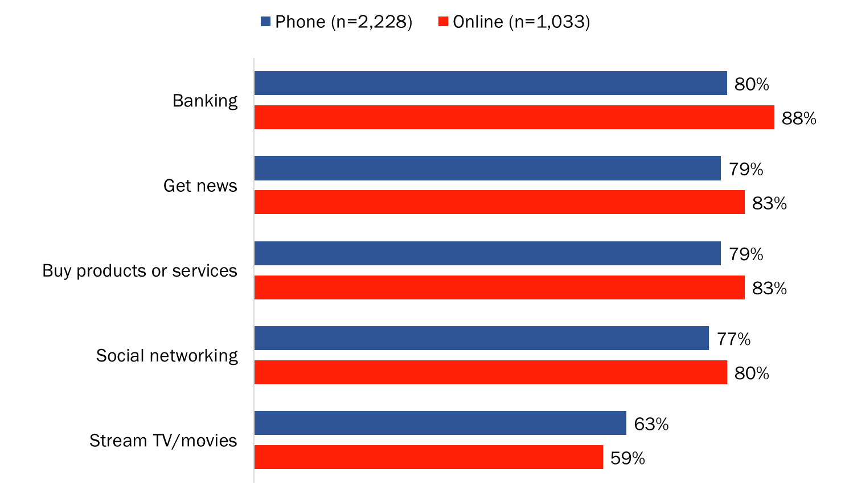

Respondents from the online sample were more likely than online Canadians in the phone sample to get news online, to buy products or services online, and to bank online.

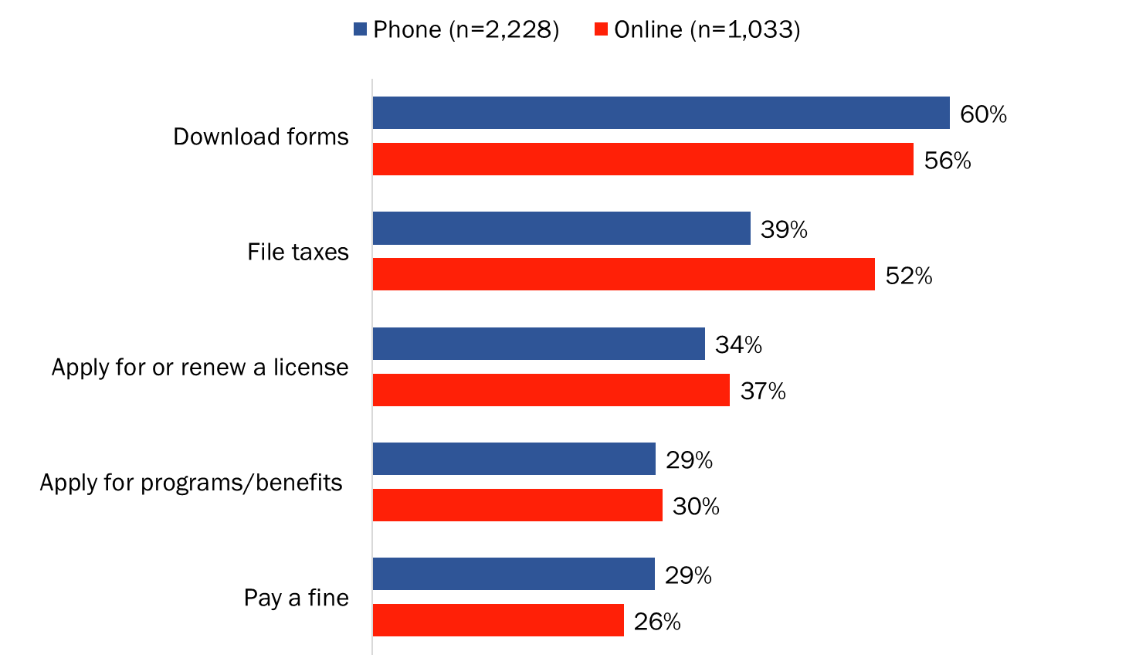
Figure 20: Use of online government services [comparison]

Respondents from the online sample were more likely than online Canadians in the phone sample to say they filed taxes online in the last few years. Conversely, online Canadians in the phone sample were more likely than panellists from the online sample to say they paid a fine online and downloaded government forms.

Figure 21: Use of GC services via an online account [comparison]
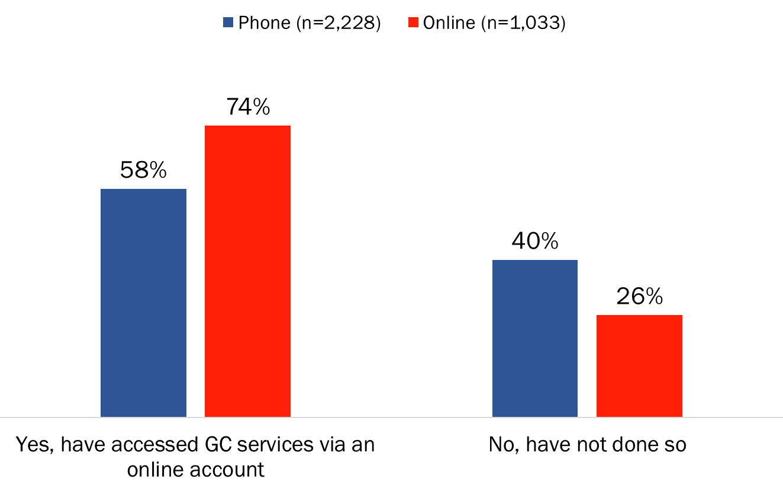
When asked if they have ever accessed Government of Canada services through an online account, such as My Service Canada Account or Canada Revenue Agency’s My Account, respondents from the online sample were more likely than online Canadians in the phone sample to say they have done so.

Figure 22: Preferred channel for contacting the GC [comparison]
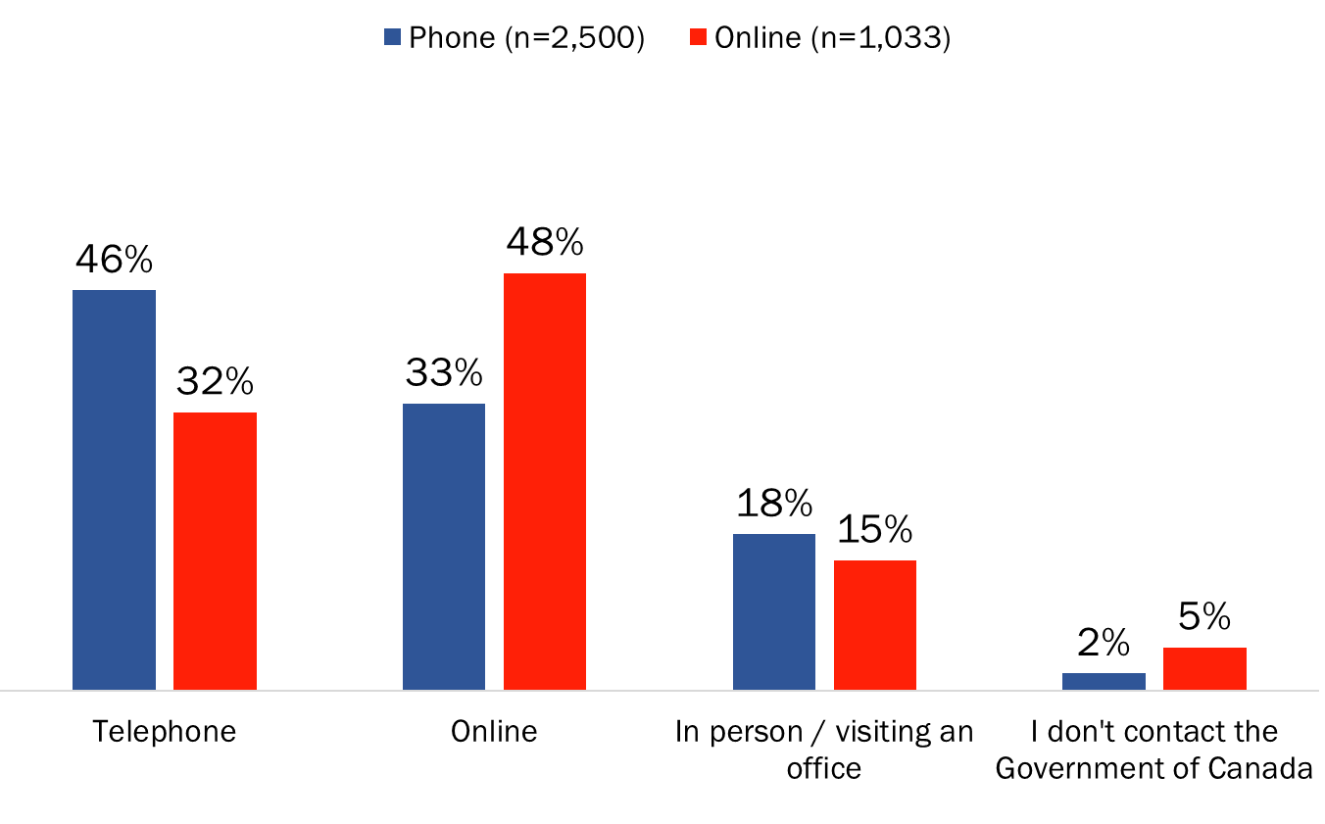
Respondents from the online sample were more likely than Canadians in the phone sample to say they prefer to contact the Government of Canada for information or to receive service via the Internet. Among Canadians in the phone sample, those who use the Internet were less likely than non-Internet users to prefer the phone.

4.2 Knowledge and Attitudinal Measures
The results of the phone and online samples do not differ much overall on the core knowledge and attitudinal measures. Differences can be found in the intensity of the views expressed by respondents in each sample, but not generally in the overall direction of the results.

Figure 23: Knowledge of GC's sharing of information within federal govt. [comparison]
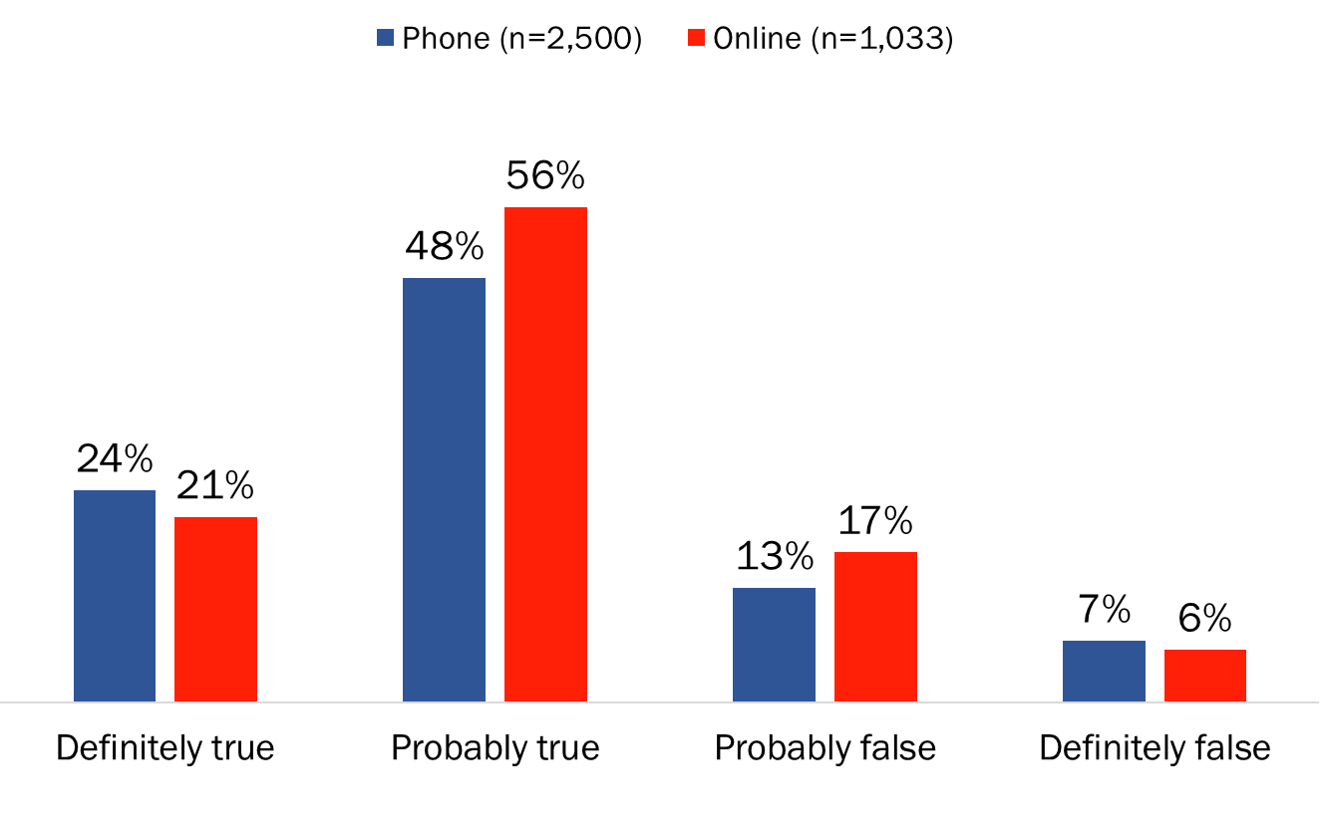
Majorities in both samples (72% phone; 77% online) believe it is definitely or probably true that the Government of Canada shares the personal information it collects from citizens among different federal departments as part of service delivery. That said, respondents from the online sample were more likely than Canadians in the phone sample to believe this.

Figure 24: Knowledge of GC's sharing of information with P/T govts. [comparison]
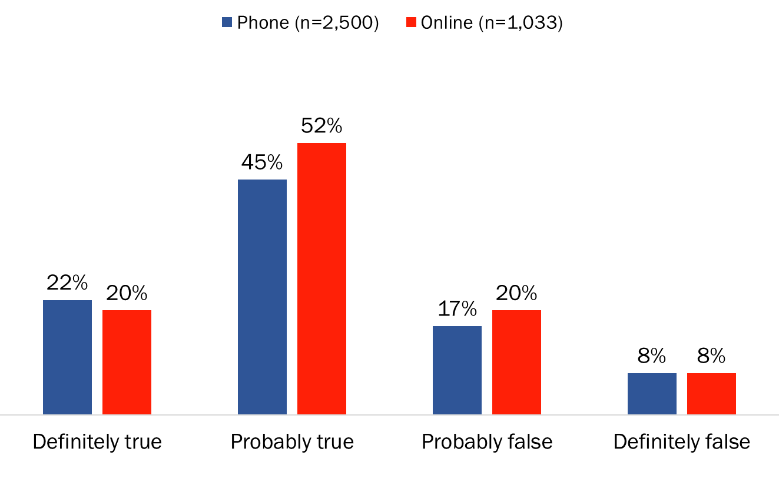
Majorities in both samples (66% phone; 72% online) believe it is definitely or probably true that the Government of Canada and the provincial/territorial governments share the personal information they collect from citizens as part of service delivery. That said, respondents from the online sample were more likely than Canadians in the phone sample to believe this.

Figure 25: Support for "Tell Us Once" [comparison]
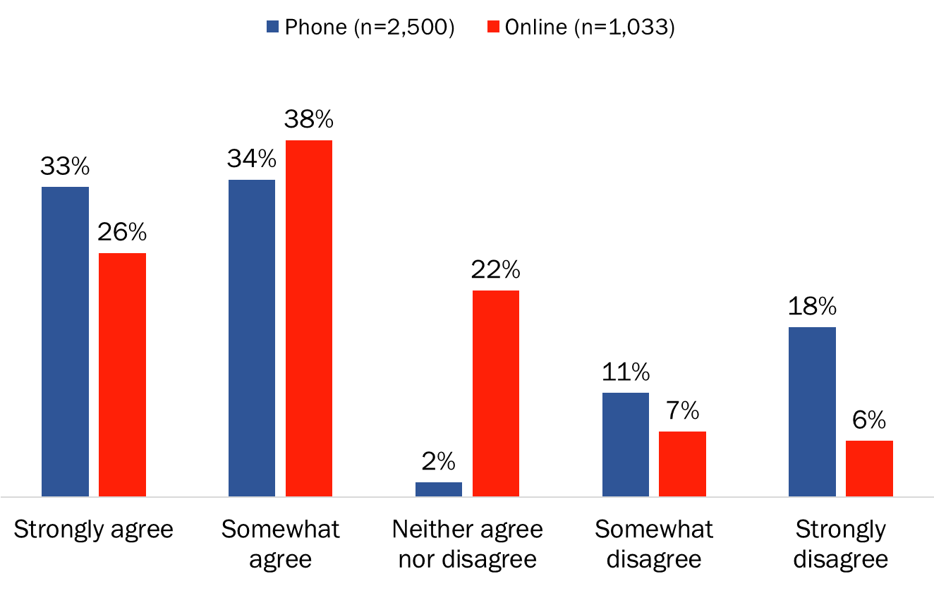

Very similar majorities in both samples (67% phone; 64% online) agreed with the “Tell Us Once” approach in which Canadians would have the option of providing their personal information only once to access services from all Government of Canada departments. That said, respondents from the phone sample were more likely than online panellists to express strong agreement as well as strong disagreement. Online panellists, on the other hand, were more likely to express ambivalence (neither agree nor disagree) and this is undoubtedly attributable to differences in the method of data collection. “Neither” was accepted if volunteered by phone respondents, but it was a visible response option for online respondents.

Figure 26: Comfort with sharing of personal information within GC [comparison]
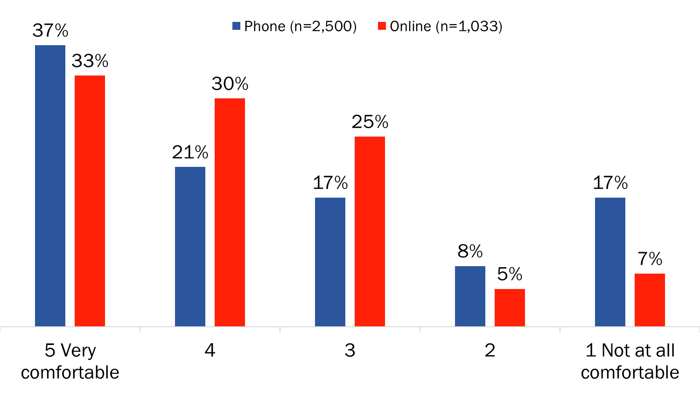

Majorities in both samples (58% phone; 63% online) said they are comfortable with a single account for the Government of Canada where they would access all federal services and changes would be shared automatically with other federal services. Respondents from the online sample, however, were more likely than Canadians in the phone sample to be comfortable with this approach. That said, respondents from the phone sample were more likely to say they would be very comfortable (a score of 5), while online panellists were significantly more likely to express moderate comfort (a score of 4). At the other end of the spectrum, Canadians in the phone sample were more likely than online panellists to say they are not comfortable with a single account and information sharing among federal departments.

Figure 27: Comfort with sharing of personal information between govts. [comparison]
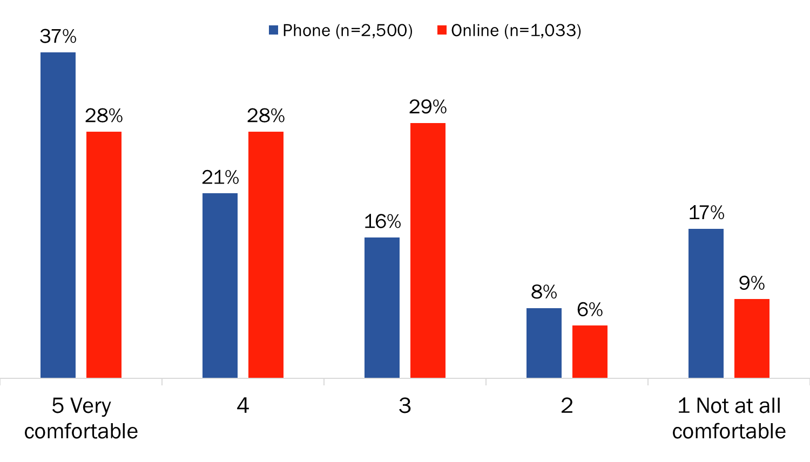
Majorities in both samples (58% phone; 56% online) said they are comfortable with a single account for the Government of Canada linked to their provincial or territorial government in which changes would be shared automatically with each level of government. Respondents from the phone sample, however, were more likely to say they would be very comfortable (a score of 5), while online panellists were significantly more likely to express moderate comfort (a score of 4). At the other end of the spectrum, Canadians in the phone sample were more likely than online panellists to say they are not at all comfortable with this approach.

Figure 28: Preferred approach to providing consent [comparison]
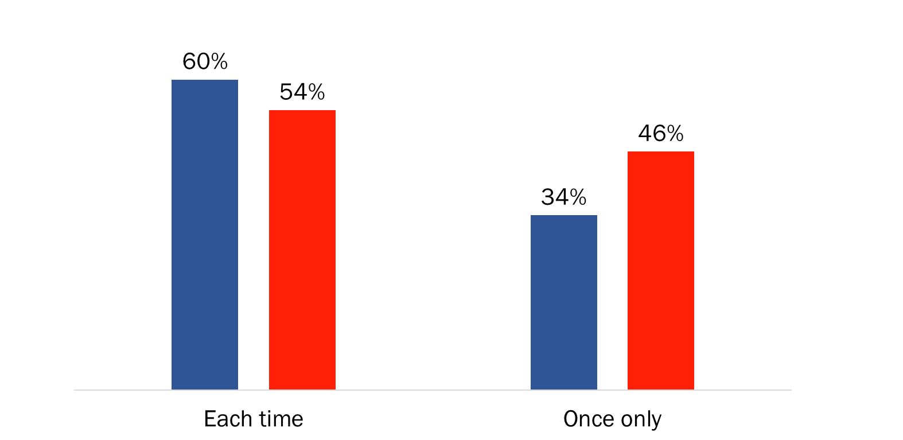
When it comes to providing consent to share their personal information within and among government departments, the majority in both samples said they would prefer to be asked for permission each time the government wants to share their information. That said, Canadians in the phone sample were more likely to want to be asked each time and online panellists were more likely to prefer to give consent once only.

Figure 29: Trust in protection of personal information by GC [comparison]
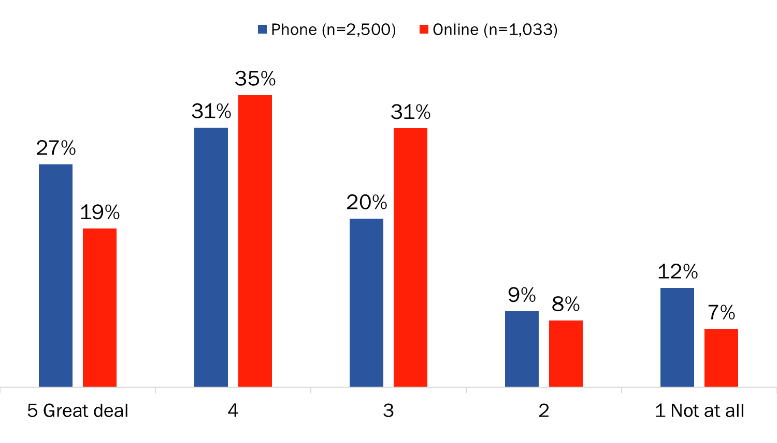

Majorities in both samples (58% phone; 54% online) trust the federal government to protect their personal information. That said, Canadians in the phone sample were more likely to trust the Government of Canada (scores of 4 and 5), and specifically, to say they have a great deal of trust (a score of 5) in the federal government. They also were more likely than online panellists to have no trust at all in the federal government (score of 1). Unlike respondents in the phone who were more apt to place themselves at either end of the scale (a score of 1 or 5), online panellists were more likely to place themselves at the mid-point of the scale (score of 3).

4.3 Conclusions
A comparison of the results from the phone and online samples found differences for some of the survey measures. Focusing first on non-behavioural measures, there were no differences in the overall direction of the results between the phone and online samples. Majorities in both samples agreed with the “Tell Us Once” approach, were comfortable with a single account for accessing federal services, trust the federal government to protect their personal information, and believe the Government of Canada currently shares the personal information it receives from citizens among federal departments and with the provincial and territorial governments.

Where differences were found, they were in the intensity of the views expressed by respondents in each sample. Specifically, respondents from the phone sample were more likely to give extreme responses to scaled questions (scores of 1 or 5 on a five-point scale).
They were more likely than online panellists to express strong agreement (score of 5) and strong disagreement (score of 1) with “Tell Us Once”. When asked about their level of comfort with a single account for accessing all federal services, they were more likely than online panellists to be very comfortable (score of 5) as well as not at all comfortable (score of 1). The same pattern was evident when respondents rated their level of trust in the federal government to protect their personal information.

In contrast, respondents from the online sample were more apt to place themselves at the mid-point of the five-point scales rather than at either end like the respondents from the phone sample. Online panellists were more likely than phone respondents to somewhat agree with “Tell Us Once” (score of 4), to be moderately comfortable with a single account (scores of 3 and 4), and to have a moderate level of trust in the federal government when it comes to protecting their personal information (scores of 3 and 4). The consistent pattern to the observed differences in responses to these rating scale questions suggests a modal influence. In other words, differences in the intensity of respondents’ views may be related more to the method of survey administration than to actual differences in opinion between respondents in the phone and online samples.

To test this suggestion, responses from those in the phone sample representing cellphone-only (CPO) households were compared to responses from online panellists based on the assumption that CPO respondents may be similar to online panellists in terms of their digital profile. When it comes to online activities, CPO respondents did report banking online, getting news online, and buying products or services online in proportions similar to the online panellists. However, CPO respondents’ support for “Tell Us Once”, comfort with a single account, and trust in the federal government did not reflect the propensity of online panellists to use the mid-point of the scales. This finding tends to support the suggestion that observed differences between the phone and online samples in response to rating scale questions are the result of differences in the method of survey administration.

The results of the phone and online samples do differ when it comes to behavioural measures, such as online activities, or views that may be influenced by their online experiences. As mentioned, online panellists were significantly more likely than respondents from the phone sample to bank online, file taxes online, and access Government of Canada services via an online account. These differences ranged from a low of eight-percentage points (banking online) to a high of 16-percentage points (using a GC online account). Such differences are not surprising, however. It is reasonable to expect that panellists are active online given the fact that they volunteered to be a member of an online panel.

There also were differences in service channel preferences, as well as the reasons offered for preferring to use one channel over another to contact the Government of Canada. Among respondents who prefer to visit an office, those in the phone sample were nearly twice as likely as those in the online sample to attribute this to a preference for dealing with people (i.e. human interaction). Among those who prefer the phone channel, respondents in the phone sample were more likely to point to it being easier and those in the online sample to it taking less time. Among respondents who prefer contacting the GC online, those in the phone sample were more likely to mention convenience and the perception that it is easier. Those in the online sample were more apt to attribute their preference to the perception that it takes less time.

In addition, as is typically the case with online surveys, the proportion of respondents not providing a response to these open-ended questions about channel preferences was much higher among respondents from the online sample than the phone sample. While differences in question non-response rates are likely the result of the survey administration modes, differences in the service channels preferred by respondents are more likely the result of substantive differences between the two samples.

The results of this comparison, in summary, reveal differences that can be attributed to the methodology (modal differences) as well as to substantive differences between the two populations (a probability sample of Canadians and non-probability sample of online panellists).

Annex 5: Tabulated Survey Data

Tabulated data (under separate cover)

Those who identified this often indicated that a student loan involves both the federal and provincial governments.
When it came to information sharing, participants did not tend to discriminate between sharing information among departments at the federal level of government and sharing information between levels of government.
INTERVIEWER NOTE: THIS SECTION IS UNAVOIDABLY WORDY, BUT IT CONTAINS KEY INFORMATION FOR RESPONDENTS. READ THROUGH CAREFULLY AND CLEARLY TO ENSURE COMPREHENSION. *ADJUST IN CATI BASED ON F: PROVINCE/TERRITORY
The same questionnaire was used for the phone and online surveys. Only very minor textual changes were made to the questionnaire administered online to address the interviewer-assisted versus self-administered nature of the two modes of data collection.
Banking: 87% CPO versus 88% of online panellists; getting news: (83% for both); and shopping online: 84% CPO versus 83% of online panellists.
There are differences between CPO respondents, phone respondents, and online panellists, but these are outside the scope of this analysis.

