Attitudes Towards Remembrance and Veterans’ Week 2018 – Survey of Canadians

Final Report

Prepared for Veterans Affairs Canada

Supplier Name: Phoenix SPI
Contract Number: 51019-181010-001-CY
Contract Value: $49,478.26 (including HST)
Award Date: 2018-08-30
Delivery Date: 2019-02-05

Registration Number: POR 041-18

For more information on this report, please contact Veterans Affairs Canada at: vac.information.acc@canada.ca

Ce rapport est aussi disponible en français.

Attitudes Towards Remembrance and Veterans’ Week 2018 Survey of Canadians

Final Report

Prepared for Veterans Affairs Canada
Supplier name: Phoenix Strategic Perspectives Inc.
February 2019

This public opinion research report presents the results of a telephone survey of 1,000 Canadians conducted by Phoenix SPI on behalf of Veterans Affairs Canada.

This publication may be reproduced for non-commercial purposes only. Prior written permission must be obtained from Veterans Affairs Canada. For more information on this report, please contact Veterans Affairs Canada at:

vac.information.acc@canada.ca
© Her Majesty the Queen in Right of Canada, as represented by the Minister of Veterans Affairs, 2019

Cat. No.: V32-401/2019E-PDF
ISBN: 978-0-660-29192-5

Aussi offert en français sous le titre Sondage sur les attitudes des Canadiens à l’égard de la commémoration et de la Semaine des vétérans 2018.

Table of Contents

Executive Summary 1
Background and Objectives 1
Methodology 2
Key Findings 2
Notes to Readers 4

Detailed Findings 6
Awareness and Importance of Veterans’ Week 6
Participation in Veterans’ Week and Related Activities 11
Prioritizing Veterans’ Week Activities 20
Attitudes Towards Veterans and Canada’s Military 22
Recognizing Canadian Veterans and Those Who Died in Service 26

Appendix 32
1: Methodological Notes 33
2: Tabulated Data 35
3: Questionnaire 36

Table of Figures

Figure 1: Awareness of Veterans’ Week 6
Figure 2: Importance of Veterans’ Week 7
Figure 3: Reasons Why Veterans’ Week Is Important [By Theme] 8
Figure 4: Reasons Why Veterans’ Week Is Important [Over Time] 8
Figure 5: Reasons Why Veterans’ Week Is Important [All Responses] 9
Figure 6: Top 3 Reasons Why Veterans' Week Is Important 10
Figure 7: Reasons Why Canadians View Veterans' Week Neutrally 10
Figure 8: Participation in Veterans’ Week 11
Figure 9: Reasons for Participating in Veterans’ Week [Honour] 12
Figure 10: Reasons for Participating in Veterans' Week [Personal Connections] 12
Figure 11: Reasons for Participating in Veterans' Week [History] 13
Figure 12: Reasons for Participating in Veterans' Week [Believe] 13
Figure 13: Reasons for Participating in Veterans’ Week [All Responses] 14
Figure 14: Reasons for Not Participating in Veterans’ Week [Practical Reasons] 15
Figure 15: Reasons for Not Participating in Veterans' Week [Lack of Knowledge] 15
Figure 16: Reasons for Not Participating in Veterans' Week [Lack of Opportunity] 16
Figure 17: Reasons for Not Participating in Veterans' Week [Lack of Personal Resonance] 16
Figure 18: Reasons for Not Participating in Veterans' Week [Participated in Other Ways] 17
Figure 19: Reasons for Not Participating in Veterans’ Week [All Responses] 17
Figure 20: Participation in Activities to Commemorate Veterans 18
Figure 21: Participation in Veterans’ Week Activities [Over Time] 18
Figure 22: Participation in Activities Outside of Veterans’ Week [Over Time] 19
Figure 23: Importance of Remembrance Initiatives 20
Figure 24: Importance of Remembrance Initiatives [Over Time] 21
Figure 25: Attitudes Towards Veterans and Commemoration 22
Figure 26: Attitudes Towards Veterans and Commemoration [Over Time] 23
Figure 27: Attitudes Towards Canada’s Military Role 24
Figure 28: Attitudes Towards Canada’s Military Role [Over Time] 25
Figure 29: Attitudes Towards Actions to Recognize Veterans and Those Who Died in Service 26
Figure 30: Attitudes Towards Actions to Recognize Veterans and Those Who Died in Service [Over Time] 27
Figure 31: Attitudes Towards Provision of Funeral and Burial Assistance 28
Figure 32: Attitudes Towards Provision of Funeral and Burial Assistance [Over Time] 29
Figure 33: Awareness and Importance of World War Commemorations 30
Figure 34: Awareness and Importance of World War Commemorations [Over Time] 30

Executive Summary
Phoenix Strategic Perspectives Inc. (Phoenix SPI) was commissioned by Veterans Affairs Canada (VAC) to conduct a telephone survey of Canadians on issues related to Veterans’ Week and the Department’s remembrance programming.

Background and Objectives
A core responsibility of VAC is post-Confederation military commemoration. VAC ensures that Veterans and those who died in service are honoured and that Canadians remember and appreciate Veterans and those who died in service. The Canada Remembers Program and the Funeral and Burial Program support the departmental results for commemoration and promote the following:
- Veterans and those who died in service are publicly acknowledged through ceremonies and events, honours and awards, and the presentation and perpetual care of memorials, cemeteries and grave markers;
- Canadians are aware of, and value, the contributions of those who served through a suite of resources that tell the story of our military history and through the provision of funding for community-led commemorative initiatives;
- the memory of the achievements and sacrifices of Canadian Veterans and those who died in service is preserved; and
- the estates of eligible Veterans have access to financial assistance toward a dignified funeral and burial.

The Attitudes Towards Remembrance and Veterans’ Week survey is a means through which VAC can measure Canadians’ level of participation in remembrance activities, their attitudes toward those who served in Canada’s military and their level of support for VAC's work related to remembrance. The purpose of the quantitative research is to evaluate the effectiveness of the Department’s overall remembrance programming. More specifically, the research was designed to:
- Understand Canadians' attitudes towards and acceptance of the commemoration of Veterans and their sacrifices and achievements;
- Monitor changes in Canadians’ behaviour related to remembrance;
- Assess Canadians’ awareness of and pride in Canadian military contributions and the sacrifices of Canadian Veterans;
- Identify Canadians’ knowledge of Canada’s military contributions;
- Provide VAC with concrete data to assist in performance measurement; and
- Assess Canadians’ level of participation (active and passive) in remembrance.

The research results help guide the Department in its planning and programming for the future. The information obtained allows VAC to continue determining the impact and effectiveness of its remembrance activities, adapt activities to be relevant to Canadians, improve the methods used to inform Canadians about remembrance initiatives, and improve future initiatives.

Methodology
A random digit dialling (RDD) telephone survey was administered to 1,000 Canadian residents, 18 years of age or older, between November 12 and 22, 2018. An overlapping dual-frame (landline and cell phone) sample was used to minimize coverage error. Interviewing was conducted by Elemental Data Collection Inc. (EDCI) using Computer Aided Telephone Interviewing (CATI) technology. A pre-test was conducted in advance of the fieldwork. In all, 20 interviews were conducted during the pre-test, 10 in English and 10 in French. The survey averaged 11 minutes to complete.

Probability sampling was used: a total of 201 interviews were completed with cell phone only (CPO) households from the cell phone sample and 799 interviews with households from the landline sample. The sample frame was geographically disproportionate to improve the accuracy of regional results. The results of the survey can be considered representative of the population of Canadians aged 18 and older. Based on a sample of this size, the overall results can be considered to be accurate within ±3.3%, 19 times out of 20 (adjusted to reflect the geographically disproportionate sampling). The margin of error is greater for results pertaining to subgroups of the total sample.

The survey data has been weighted by region, age and gender to ensure results that are representative of the Canadian population. Population figures from Statistics Canada’s 2016 census data were used to construct the weights.

The table in Annex 1 presents information about the final call dispositions for this survey, as well as the associated response rates. The overall response rate was 6% (8% for the landline sample and 5% for the cell phone sample).

The potential for non-response bias was assessed by comparing the characteristics of respondents through unweighted and weighted data. As is typically the case for general population telephone surveys, older Canadians (those aged 65 and older) were overrepresented in the final survey sample and younger Canadians (those under 30 years of age) were underrepresented. This was corrected with weighting.

Key Findings
Awareness and Importance of Veterans’ Week
Canadians’ awareness of Veterans’ Week and the importance attributed to it remains unchanged from 2017.
Similar to last year, slightly over half (55%) of Canadians said they had heard of Veterans’ Week. This demonstrates no change in awareness since 2016, which is still lower than the high of 66% recorded in 2011. Additionally, the overall importance that Canadians attribute to Veterans’ Week is virtually unchanged from 2017. Nearly nine in 10 Canadians (87%; down from 88% in 2017) think it is important that Veterans’ Week be held each year, with 68% saying that it is very important.

Canadians who said they think it is important that Veterans’ Week be held were asked why they think so. Nearly three-quarters (74%) of Canadians said it is important to honour and show respect to Canadian Veterans and those who died in service. Following this, 39% said it is important to focus on our history or remembrance. Very few (8%) said that Veterans’ Week is important because of a personal connection. These same themes have been Canadians’ top reasons for attributing importance to Veterans’ Week over time.

Participation in Veterans’ Week and Related Activities
Participation in Veterans’ Week has increased steadily since 2011 and reached a record high this year. Wearing a poppy continues to be the most popular way to commemorate Veterans.
Nine in 10 surveyed Canadians (92%) said they or members of their immediate family participated in Veterans’ Week. Since 2011, there has been a steady increase in participation, from 73% in 2011 to this year’s high of 92%. Similar to previous years, practical constraints, such as not having time, were the most common barriers to participating in Veterans’ Week.

Of those who participated in Veterans’ Week activities, almost half (48%) said they did so to honour or show respect to Veterans. Following this, 33% said it was due to personal connections, which includes knowing a Veteran, being a Veteran, or knowing someone who participates in the events. Participating in Veterans’ Week due to personal connection has declined significantly, from 40% in 2017 to 33% in 2018.

The most common form of participation in Veterans’ Week continues to be wearing a poppy, which was cited by 82% of respondents (up from 79% in 2017). Additionally, 72% said they observed a moment of silence (virtually unchanged from 71% last year). Following this, 46% watched a Remembrance Day ceremony on TV, 38% participated in remembrance ceremonies in their communities, and 20% took part in a remembrance-related activity on social media (down from 25% in 2017). Additionally, half of Canadians (52%; up from 2017 in 37%) reported that they or members of their immediate family remembered Canadian Veterans and those who died in service in some way outside of Remembrance Day or Veterans’ Week.

Prioritizing Veterans’ Week Activities
Canadians feel the Government of Canada should prioritize all remembrance initiatives.
Canadians were asked to indicate what priority they feel the Government of Canada should place on various initiatives that recognize the achievements and sacrifices of Canadians during wartime and in peacetime operations. Providing educational materials for schools topped the list at 90% (up from 86% in 2017). This was followed by supporting and leading commemorative events (84%; down from 87% last year) and providing funding for commemorative projects (75%; up from 70% in 2017).

In addition, more than seven in 10 attributed importance to posting remembrance-related content on social media (74%; up from 71% in 2017) and creating remembrance-related ads (72%; down from 76% in 2017). Consistent with previous years, two-thirds (66%) of Canadians attributed importance to the production of promotional materials such as posters and pins.

Attitudes Towards Veterans and Canada’s Military
Canadians’ attitudes towards Veterans and Canada’s military role remain strongly positive.
The vast majority of Canadians think that Canada’s Veterans and those who died in service should be recognized for their service (96%) and that Veterans have made major contributions to our country (93%). Following this, more than four in five (86%) agreed that participation in commemorative activities increases awareness and appreciation for Veterans and those who died in service. Additionally, nearly three-quarters of surveyed Canadians agreed that they make an effort to demonstrate their appreciation to Veterans (74%) and that VAC effectively honours Veterans and those who died in service and preserves the memory of their achievements and sacrifices (73%). With regards to Canada’s military role, roughly four in five (83%) agreed that they are proud of the role that Canada’s military has played in peacekeeping missions and conflicts, while seven in 10 (71%) agreed that they are knowledgeable about the role that Canada’s military has played in the international domain. Canadians’ attitudes towards Veterans and Canada’s military remain strong and virtually unchanged since 2017.

Recognizing Canadian Veterans and Those Who Died in Service
Canadians continue to consider recognizing Veterans and those who died in service as well as commemorating the anniversaries of the World Wars to be important.
Similar to 2017, more than nine in 10 Canadians agreed that it is important that Veterans Affairs Canada recognize and honour Canadian Veterans and those who died in service through the presentation and care of memorials, cemeteries and grave markers (93%) and by providing funeral and burial assistance (91%). In addition, 59% agreed that they are satisfied with VAC’s performance in recognizing and honouring Veterans and those who died in service through the presentation and care of memorials, cemeteries and grave markers, and 52% felt this way about how VAC recognizes and honours deceased Canadian Veterans through the provision of funeral and burial assistance.

With regards to awareness of the anniversaries of the First and Second World Wars, almost two-thirds of Canadians (64%) said they are aware of the 100th anniversary of the First World War. A strong minority (46%) indicated they are aware of the 75th anniversary of the Second World War. Compared to 2017, awareness of the World War anniversaries has increased this year. A clear majority (89%) said they find commemorating the World Wars important, with 69% saying it is very important.

Notes to Readers
- All results are expressed as percentages unless otherwise noted.
- Percentages may not always add to 100 due to rounding.
- In graphs:
  - “DK” stands for “Don’t know” and “NR” for “No response.”
  - Tracking data are presented where available. This survey was not conducted in 2009, 2013, or 2015.
  - Values less than 5% are not labelled in the stacked bar graphs.
- The number of respondents changes throughout the report because questions were asked of sub-samples of survey respondents. Readers should be aware of this and exercise caution when interpreting results based on smaller numbers of respondents.
- Demographic differences are identified in the report. Only differences that are significant at the 95% confidence level and pertain to a sub-group sample size of more than n=30 are discussed in the report.
- The tabulated data is available under separate cover.

The contract value was $49,478.26 (including HST).

I hereby certify as a Senior Officer of Phoenix Strategic Perspectives that the deliverables fully comply with the Government of Canada political neutrality requirements outlined in the Policy on Communications and Federal Identity of the Government of Canada and Procedures for Planning and Contracting Public Opinion Research. Specifically, the deliverables do not contain any reference to electoral voting intentions, political party preferences, standings with the electorate, or ratings of the performance of a political party or its leader.



Alethea Woods
President
Phoenix SPI

Detailed Findings

Awareness and Importance of Veterans’ Week
This section explores Canadians’ awareness of Veterans’ Week, as well as their views on the importance of Veterans’ Week and the reasons why they hold these views.

Awareness of Veterans’ Week is unchanged since 2016
Slightly over half of Canadians (55%) indicated that they had heard of Veterans’ Week. Awareness of Veterans’ Week is unchanged since 2016. However, over time, awareness of Veterans’ Week has fluctuated, from a low of 54% in 2008 to a high of 66% in 2011.

Figure 1: Awareness of Veterans’ Week

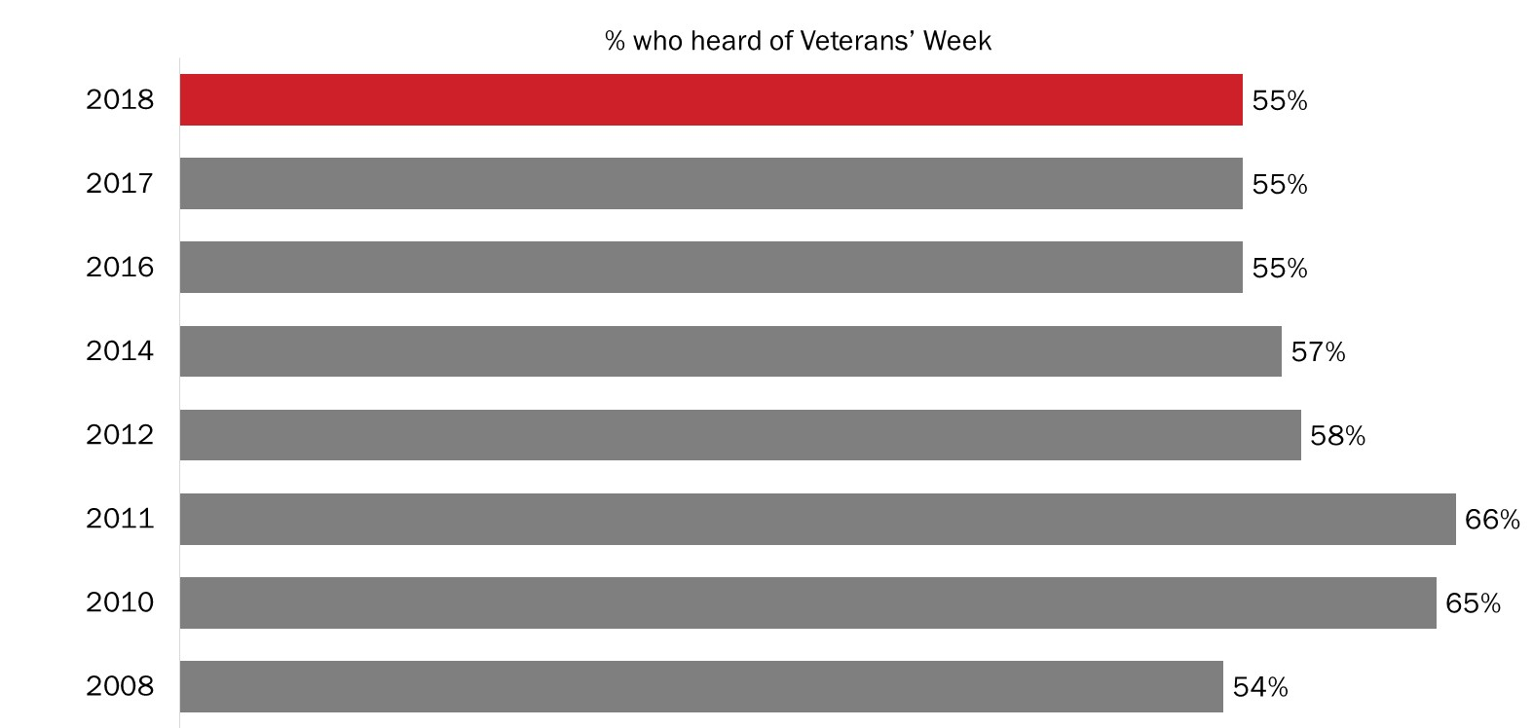

Q1: Have you ever heard of Veterans’ Week? Base: All respondents; 2018 n=1,000

Awareness of Veterans’ Week is higher among residents of Quebec (67%) than among residents of Atlantic Canada (46%) and Ontario (48%). In addition, Canadians aged 45 and older were more likely to have heard of Veterans’ Week than Canadians aged 30 to 44. Specifically, 61% of Canadians aged 65 and older and 57% of Canadians 45 to 64 years of age said they were aware of Veterans’ Week compared to 45% of 30 to 44 year olds.

Majority of Canadians feel Veterans’ Week is important
Eighty-seven percent of Canadians believe that it is important that Veterans’ Week be held each year. Over two-thirds (68%) of Canadians said it is very important. Conversely, very few (3%) Canadians feel that Veterans’ Week is not important.

Respondents were read the following sentence about Veterans’ Week prior to being asked to rate the importance of it:

Veterans’ Week takes place in November each year and ends with Remembrance Day. During this week, commemorative ceremonies and events take place across the country to recognize the achievements of our Veterans and those who died in service. People also take part through things like social media, wearing a poppy, and having discussions with Veterans or military personnel.

The level of importance that Canadians place on Veterans’ Week is virtually unchanged since 2016.

Figure 2: Importance of Veterans’ Week

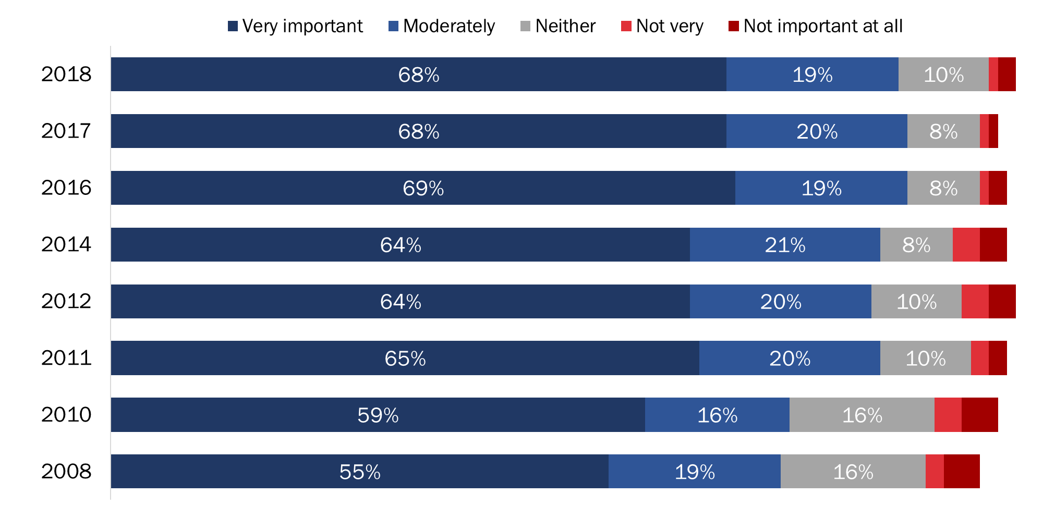

Q2: How important is it that Veterans' Week be held each year? Base: All respondents; 2018 n=1,000. DK/NR: 1%

Atlantic Canadians (94%) were more likely than residents of Ontario (87%), British Columbia (85%) and Quebec (83%) to attribute importance to holding Veterans’ Week each year. The likelihood of thinking Veterans’ Week is very important increased with age, from 59% of Canadians under 30 to 76% of those aged 65 and older, and it was higher among women (72% versus 63% of men) and Canadians who have not completed a university degree (72% of Canadians with some university or college and 70% of Canadians with high school or less versus 60% of university graduates).

Veterans’ Week important to honour and respect Veterans
Canadians who said that Veterans’ Week is moderately or very important were asked to give their reasons. Three-quarters (74%) of the explanations focused on the theme of honouring Veterans, or a sense that Veterans have earned respect. Following this, 39% characterized Veterans’ Week as important because of its focus on our history or remembrance. Few (8%) said that Veterans’ Week is important because of a personal connection, such as having a family member who is a Veteran or in the military.

Figure 3: Reasons Why Veterans’ Week Is Important [By Theme]

Q2B: And why do you say it is important that Veterans' Week be held each year? Base: Those who said it is important; 2018 n=872. (Up to 2 responses accepted)

Compared to 2017, the proportion of Canadians attributing importance to Veterans’ Week because it is important to honour Veterans has increased nine percentage points, from 65% to 74%. Conversely, the proportion of Canadians who said that Veterans’ Week is important because of its focus on our history or remembrance declined, from 52% in 2017 to 39% in 2018.

Figure 4: Reasons Why Veterans’ Week Is Important [Over Time]

Q2B: And why do you say it is important that Veterans' Week be held each year? Base: Those who said it is important; 2018 n=872. (Up to 2 responses accepted)

When looking at specific reasons why Canadians attribute importance to Veterans’ Week, the following three stand out in terms of frequency:
- To honour/respect Veterans/those who died in service (39%);
- To recognize their contribution to our freedom/security/peace (27%); and
- So people will remember their sacrifices (19%).

The table below presents the full range of responses, grouped by the themes presented in Figure 3:

Figure 5: Reasons Why Veterans’ Week Is Important [All Responses]

Honour Veterans / Veterans Have Earned Respect
To honour / to respect the Veterans / those who died in service | 39%
To recognize their contribution to our freedom / security / peace | 27%
Veterans fought for our country / they served our country | 14%
To recognize their service / accomplishments | 13%
We owe them / they deserve recognition | 4%
Canada wouldn't be the country it is today / I wouldn't be here if it weren't for Veterans | 3%
Focus on History / Remembrance
So people will remember their sacrifices | 19%
Part of our heritage / our history | 4%
So children can understand / learn the importance of it | 3%
Good idea / good to remember | 3%
Should not / cannot forget | 2%
So we don't repeat past mistakes | 2%
There are fewer Veterans / their story should be told | 1%
Many soldiers died in past wars | 1%
Focus on Personal Connections
Family member is a Veteran / I am a Veteran | 8%
Other
Believe in it / it's important to do it | 2%
To show support for our troops (past and / or present) | 2%
Forces us to examine war | <1%
Note: Respondents could provide up to two reasons for thinking that Veterans’ Week is important. Therefore, the percentages in the table above for the full range of responses assigned to each theme (e.g., Focus on History / Remembrance) do not necessarily sum to the total percentage for that theme.

There has been one noteworthy change since last year. The proportion of Canadians attributing importance to Veterans’ Week “so people will remember their sacrifices” decreased significantly, from 31% last year to 19% this year. The results for these top responses (over time) are included in Figure 6 below:

Figure 6: Top 3 Reasons Why Veterans' Week Is Important

 | Top Reasons for Importance of Veterans’ Week Over Time
 |  | 2018 | 2017 | 2016 | 2014 | 2012 | 2011 | 2010 | 2008 | 2007 | 2006
To honour / to respect the Veterans |  | 39% | 34% | 34% | 28% | 27% | 23% | 18% | 30% | 33% | 39%
To recognize their contribution |  | 27% | 21% | 19% | 24% | 24% | 22% | 13% | 14% | 37% | 33%
Will remember their sacrifices |  | 19% | 31% | 20% | 25% | 25% | 27% | 14% | 17% | 33% | 39%

Cost-benefit focus is top reason for viewing Veterans’ Week as unimportant
Twenty-eight of 1,000 respondents said they view Veterans’ Week as not very important or not important at all. The most common explanation among these respondents for finding Veterans’ Week to be unimportant was the perception that a week to reflect about Veterans is too long given Remembrance Day.

Neutrality towards Veterans’ Week due to lack of personal resonance
Almost one in 10 respondents (n=93) indicated that Veterans’ Week was neither important nor unimportant to them. The most common reason they felt this way towards Veterans’ Week was due to a lack of personal resonance—specifically, respondents said that Veterans’ Week is not personally important to them and that they do not know anyone serving, or who served, in the military.

Figure 7 presents a breakdown of the specific reasons Canadians gave for thinking Veterans’ Week is neither important nor unimportant, grouped by theme.

Figure 7: Reasons Why Canadians View Veterans' Week Neutrally

Lack of Personal Resonance
Don't care / not important to me personally | 27%
Don't have family members who are Veterans / don't know anyone in the military | 5%
Cost-Benefit Focus
We already have Remembrance Day / a week is too long | 15%
There are other issues / concerns that are more important | 10%
Lack of Information / Awareness
Never heard of it / don't know about it | 19%
Don’t know what activities there are for Veterans’ Week | 7%
Inappropriate Focus on the Past
Happened in the past / we should focus on the present | 7%
Most Veterans have died / very few Veterans left | 3%
Pacifism
We shouldn't celebrate war / we should focus on peace | 6%
Other
It is important / necessary that we have it | 13%
Should be a more private ceremony / held less often (so it's not overdone) | 1%

Participation in Veterans’ Week and Related Activities
This section explores topics related to Canadians’ participation in Veterans’ Week, including the level of participation, reasons for participation and non-participation, and the activities respondents participated in during Veterans’ Week.

Participation in Veterans’ Week continues to increase
Slightly more than nine in 10 Canadians (92%) said they or members of their immediate family participated in Veterans’ Week. Since 2011, the level of participation among Canadians has seen a steady increase, from 73% in 2011 to a high of 92% this year.

Figure 8: Participation in Veterans’ Week

Q3: Did you or members of your immediate family participate in Veterans' Week this year? Base: All respondents; 2018 n=1,000.

Residents of Quebec were the least likely to say they participated in Veterans’ Week (82% versus at least 93% of Canadians in other regions of the country). In addition, participation in Veterans’ Week was higher among Canadians aged 45 and older (96%) than among Canadians under 30 (89%) or between the ages of 30 and 44 (84%).

Honouring Veterans is the main reason Canadians participate in Veterans’ Week
Consistent with 2017, nearly half (48%) of those who participated in Veterans’ Week said they participated to show respect or to honour Canadian Veterans. Following this, one-third of Canadians (33%; down seven percentage points since 2017) participated because of personal connections. Focusing on history and remembrance was mentioned by 16% of Canadians as their reason for taking part in Veterans’ Week. Finally, 13% said they participated in Veterans’ Week because they believe in it or because they view it as important.

Figure 9: Reasons for Participating in Veterans’ Week [Honour]

Q3B. And why did you or members of your immediate family participate in Veterans' Week? Base: Those who initially acknowledged participating in Veterans’ Week when asked; 2018 n=464. (Up to 2 responses accepted)

Figure 10: Reasons for Participating in Veterans' Week [Personal Connections]

Q3B. And why did you or members of your immediate family participate in Veterans' Week? Base: Those who initially acknowledged participating in Veterans’ Week when asked; 2018 n=464. (Up to 2 responses accepted)

Figure 11: Reasons for Participating in Veterans' Week [History]

Q3B. And why did you or members of your immediate family participate in Veterans' Week? Base: Those who initially acknowledged participating in Veterans’ Week when asked; 2018 n=464. (Up to 2 responses accepted)

Figure 12: Reasons for Participating in Veterans' Week [Believe]

Q3B. And why did you or members of your immediate family participate in Veterans' Week? Base: Those who initially acknowledged participating in Veterans’ Week when asked; 2018 n=464. (Up to 2 responses accepted)

The specific reasons Canadians gave for why they participated in Veterans’ Week are presented in Figure 13:

Figure 13: Reasons for Participating in Veterans’ Week [All Responses]

Honour Veterans / Veterans Earned Respect
To honour / to respect the Veterans / those who died in service | 37%
To recognize their contribution to our freedom / security / peace | 7%
To recognize their service / accomplishments | 6%
Veterans fought for our country / they served our country | 3%
Canada wouldn’t be the country it is if it weren’t for Veterans | 1%
Focus on Personal Connections
Family member is a Veteran / I am a Veteran | 28%
Know / am related to someone / I am currently in the military | 5%
I / someone I know participates in events | 2%
Focus on History / Remembrance
So children can understand / learn the importance of it | 8%
So people will remember their sacrifices | 5%
Good idea / good to remember | 4%
Other
Believe in it / it's important to do it | 13%
Tradition / habit / we do it every year | 4%
To show support for our troops (past and/or present) | 3%
Show some (national) pride | 3%
Note: Respondents could provide up to two reasons why they participated in Veterans’ Week. Therefore, the percentages in the table above for the full range of responses assigned to each theme (e.g., Honour Veterans / Veterans Earned Respect) do not necessarily sum to the total percentage for that theme.

Practical constraints are the most common reason for not participating
Consistent with 2017, half of those who did not participate in Veterans’ Week (n=517) attributed their lack of participation to practical reasons (i.e., too busy, work or health-related reasons). In addition, approximately one-quarter (23%) said they did not participate due to lack of knowledge or awareness. Similar proportions did not participate because they did not have an opportunity to do so (7%) or because Veterans’ Week did not resonate with them (11%), while fully 5% said they participated in other ways.

Figure 14: Reasons for Not Participating in Veterans’ Week [Practical Reasons]

Q3C. And why didn't you or members of your immediate family participate in Veterans' Week? Base: Those who did not participate; 2018 n=517. (Up to 2 responses accepted)

Figure 15: Reasons for Not Participating in Veterans' Week [Lack of Knowledge]

Q3C. And why didn't you or members of your immediate family participate in Veterans' Week? Base: Those who did not participate; 2018 n=517. (Up to 2 responses accepted)

Figure 16: Reasons for Not Participating in Veterans' Week [Lack of Opportunity]

Q3C. And why didn't you or members of your immediate family participate in Veterans' Week? Base: Those who did not participate; 2018 n=517. (Up to 2 responses accepted)

Figure 17: Reasons for Not Participating in Veterans' Week [Lack of Personal Resonance]

Q3C. And why didn't you or members of your immediate family participate in Veterans' Week? Base: Those who did not participate; 2018 n=517. (Up to 2 responses accepted)

Figure 18: Reasons for Not Participating in Veterans' Week [Participated in Other Ways]

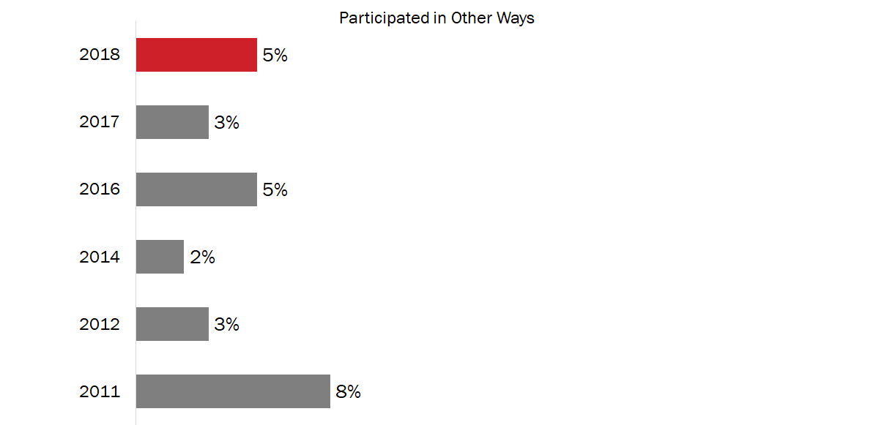

Q3C. And why didn't you or members of your immediate family participate in Veterans' Week? Base: Those who did not participate; 2018 n=517. (Up to 2 responses accepted)

Figure 19 illustrates the specific reasons Canadians gave for not participating in Veterans’ Week.

Figure 19: Reasons for Not Participating in Veterans’ Week [All Responses]

Practical Reasons
Too busy / no time to attend | 34%
Had to work / not available to participate | 10%
Can't participate due to health reasons / age | 11%
Lack of Knowledge / Awareness
Never heard of it / don't know about it | 22%
Don't know what activities there are for Veterans' Week | 2%
No Opportunity
There are no activities for Veterans' Week in the area | 5%
No occasion / opportunity / chance to participate | 3%
Lack of Personal Resonance
Don't have family members who are Veterans / don't know anyone in the military | 5%
Don't care / not important to me personally | 6%
I'm an immigrant | 1%
Participated in Other Ways
Remember by wearing a poppy | 3%
Participate in Remembrance Day events / observe Remembrance Day | 1%
Other
Don't have family nearby | 3%
We shouldn't celebrate war / we should focus on peace | 1%
Nothing / no reason | 6%
Note: Respondents could provide up to two reasons why they did not participate in Veterans’ Week. Therefore, the percentages in the table above for the full range of responses assigned to each theme (e.g., Practical Reasons) do not necessarily sum to the total percentage for that theme.

Majority participate by wearing a poppy, observing a moment of silence
The most popular way to commemorate Veterans was to wear a poppy. Just over four in five (82%) Canadians said they wore a poppy in 2018. Additionally, 72% said they observed a moment of silence. Following this, 46% watched Remembrance Day ceremonies on TV, with a further 38% saying they participated in a remembrance ceremony in their community. One in five (20%) Canadians said they participated in remembrance-related activities on social media.

Figure 20: Participation in Activities to Commemorate Veterans

Q4: Did you or members of your immediate family do any of the following during Veterans' Week this year? Base: All respondents; 2018 n=1,000. DK/NR: <1% - 1%. (Multiple responses accepted)
Q4B: Outside of Remembrance Day or Veterans’ Week, in the past year, have you or members of your immediate family made an effort to remember Canadian Veterans and those who died in service? Base: All respondents; 2018 n=1,000. DK/NR: 3%

Over time, participation in Veterans’ Week activities has remained fairly consistent.

Figure 21: Participation in Veterans’ Week Activities [Over Time]

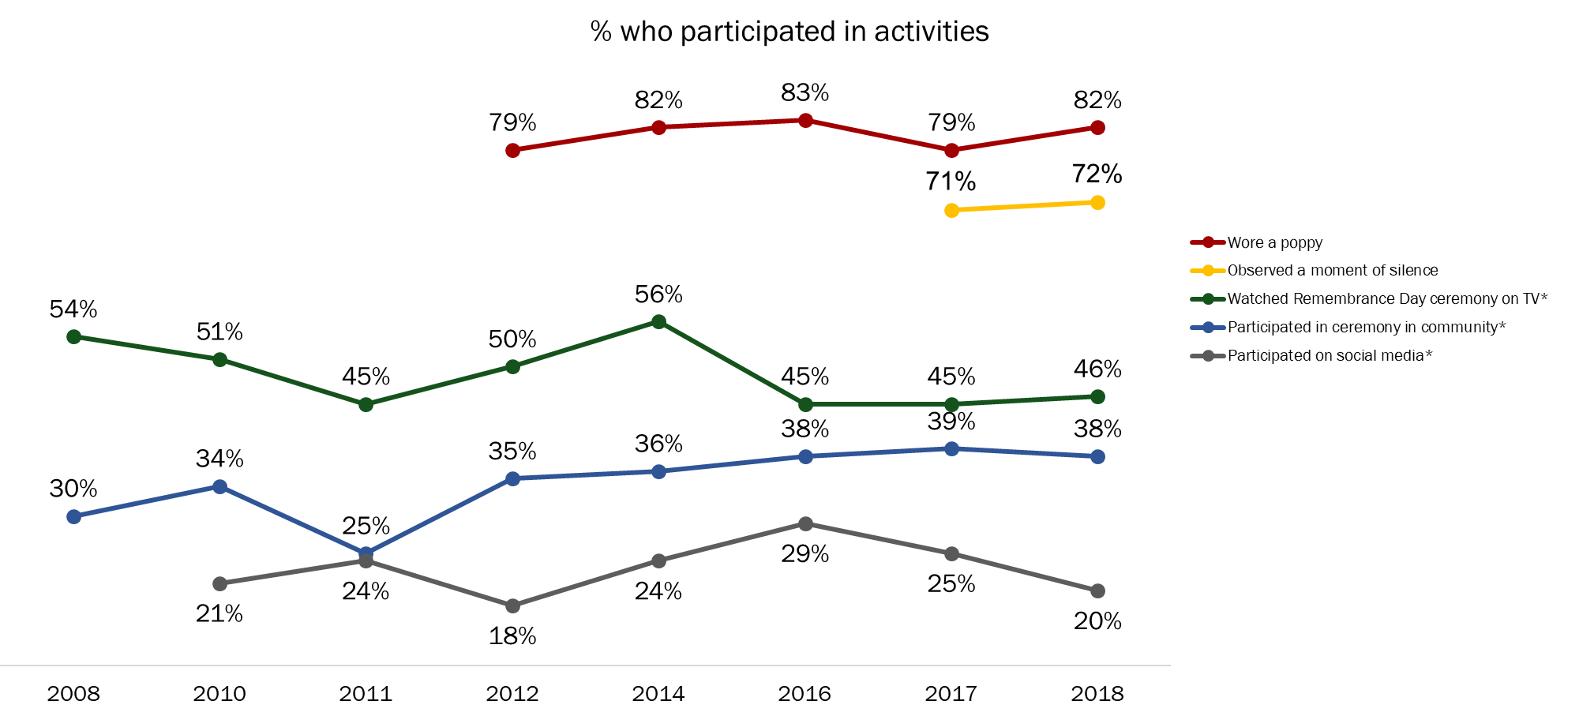

Q4: Did you or members of your immediate family do any of the following during Veterans' Week this year? Base: All respondents; 2018 n=1,000. DK/NR: <1% - 1%. (Multiple responses accepted) *Wording changed in 2012

Wearing a poppy to commemorate Veterans has increased three percentage points after declining five percentage points from 2016 to 2017. Additionally, participation through social media has decreased year over year, from 29% in 2016 to 25% in 2017 to 20% in 2018.

Half of Canadians participate outside of Veterans’ Week
Half (52%) of Canadians said they or members of their immediate family made an effort to remember Canadian Veterans and those who died in service outside of Remembrance Day or Veterans’ Week. This result shows a significant increase from the continued decline recorded since 2014.

Figure 22: Participation in Activities Outside of Veterans’ Week [Over Time]

Q4B: Outside of Remembrance Day or Veterans’ Week, in the past year, have you or members of your immediate family made an effort to remember Canadian Veterans and those who died in service? Base: All respondents; 2018 n=1,000. DK/NR: 3%

Prioritizing Veterans’ Week Activities
This section discusses Canadians’ perceptions about the importance of various Veterans’ Week initiatives.

Most Canadians attribute at least some importance to all remembrance initiatives
Most Canadians attributed at least some importance to all remembrance initiatives that recognize the achievements and sacrifices of Canadians during wartime and in peacetime operations. When asked to indicate what priority they feel the Government of Canada should place on various initiatives, at least two-thirds of Canadians assigned a moderate or high importance to each initiative.

More specifically, nine in 10 Canadians attributed importance to providing educational materials for schools, with 70% saying this is very important. Following this, 84% viewed as important supporting and leading commemorative events, with more than half (57%) saying it is very important. Majorities also placed importance on providing funding for commemorative projects (75%), posting remembrance-related content on social media (74%), and creating remembrance-related ads (72%). Finally, exactly two-thirds (66%) think it is important that the Government of Canada provide promotional materials, such as posters and pins.

Figure 23: Importance of Remembrance Initiatives

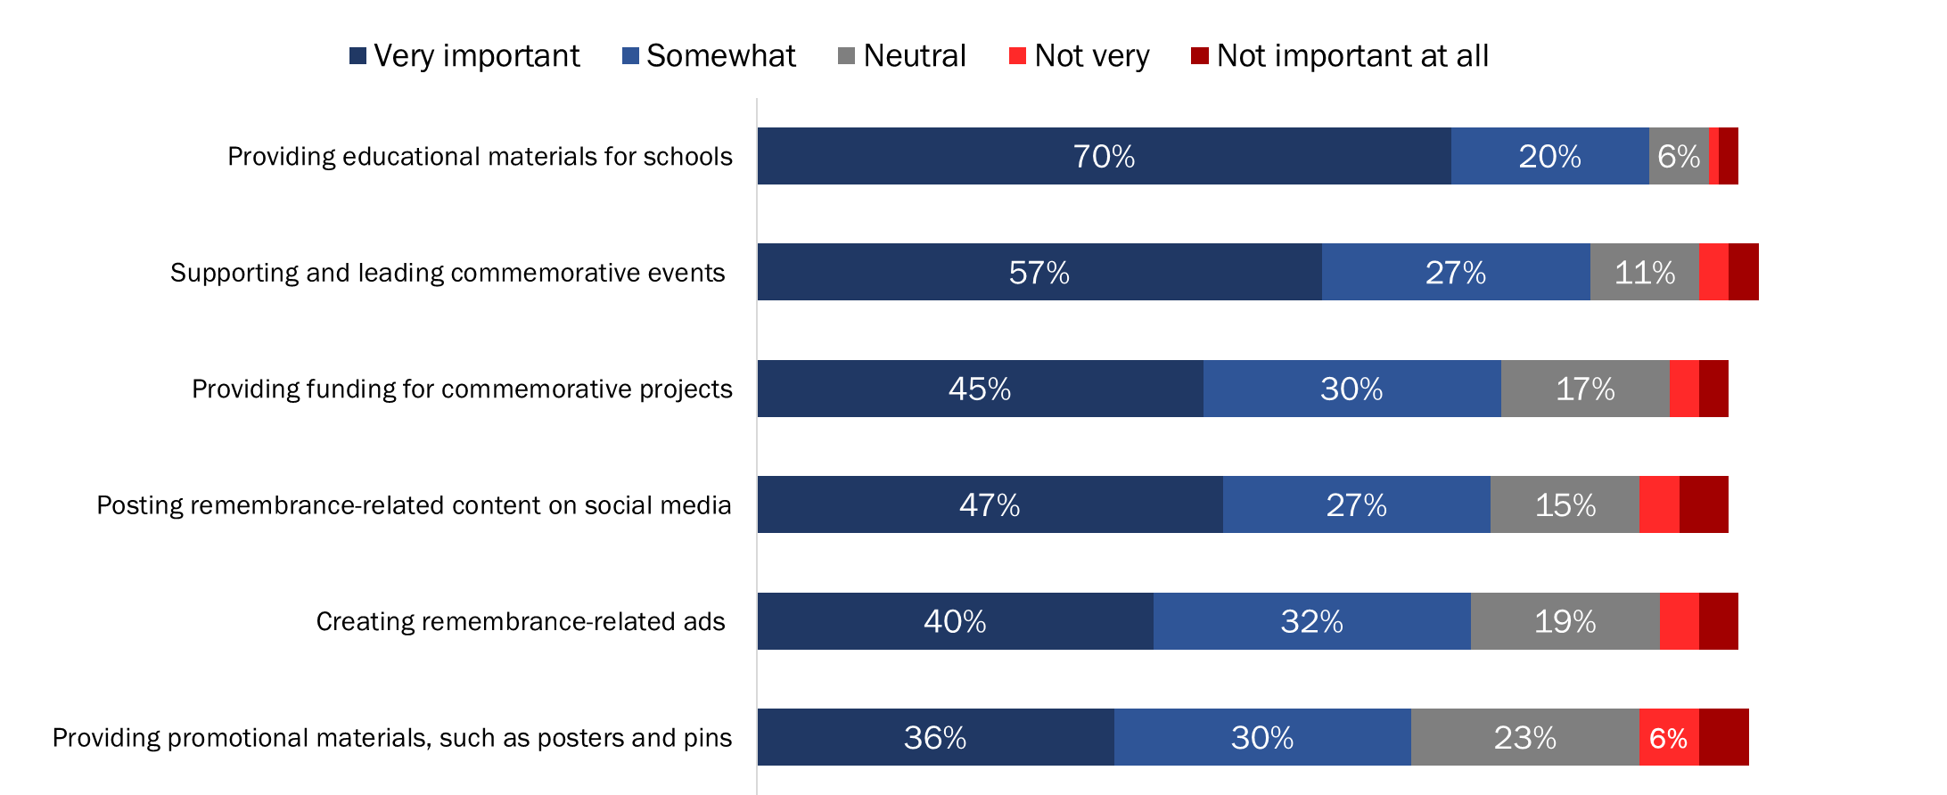

Q5: Now, thinking about ways of recognizing the achievements and sacrifices of Canadians during wartime and in peacetime operations, what priority should the Government of Canada place on each of the following remembrance initiatives? Base: All respondents; 2018 n=1,000. DK/NR: <1%-2%

The likelihood of attributing importance to remembrance initiatives was generally lower among respondents from Quebec. The one exception was posting remembrance-related content on social media. There were no significant regional differences when it came to the importance attributed to this activity.

Other noteworthy differences include the following:

- Canadians aged 65 and older were more likely than Canadians 30 to 44 years of age to attribute importance to providing funding for commemorative projects and to providing promotional materials, such as posters and pins.
- Canadians aged 65 and older were less likely than Canadians under 65 to attribute importance to posting remembrance-related content on social media.
- Women were more likely than men to attribute importance to providing educational materials for schools, creating remembrance-related ads, and posting remembrance content on social media.

Notable changes over time include the following:

- Support for providing educational materials is the highest it has been in a decade (90% in 2018 versus 85% in 2008).
- Support for creating remembrance-related ads continues to decline since it reached a high of 80% in 2016.
- Support for providing funding for commemorative projects is the highest it has been since this initiative was introduced in 2012: 75% in 2018 versus 66% in 2012.

Figure 24: Importance of Remembrance Initiatives [Over Time]

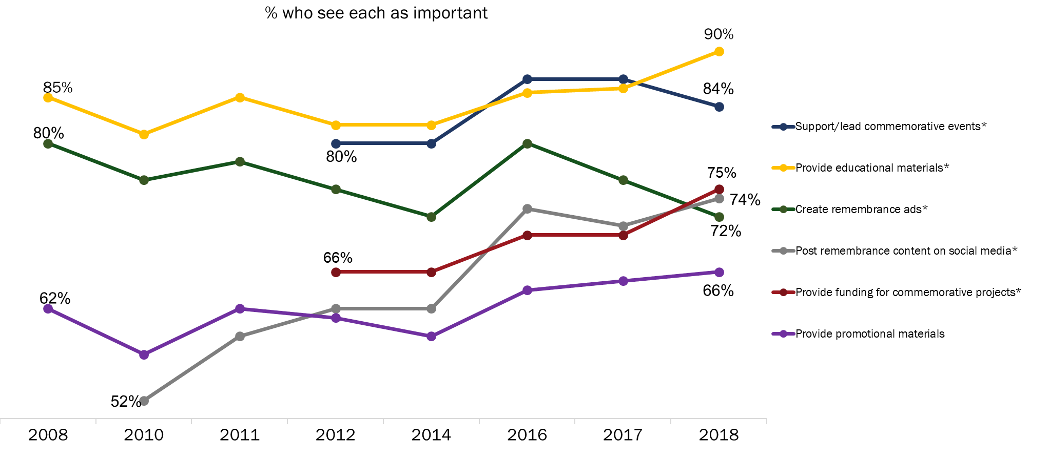

Q5: Now, thinking about ways of recognizing the achievements and sacrifices of Canadians during wartime and in peacetime operations, what priority should the Government of Canada place on each of the following remembrance initiatives? Base: All respondents; 2018 n=1,000. DK/NR: <1%-2%. *Wording changed in 2018

Attitudes Towards Veterans and Canada’s Military
This section provides an analysis of Canadians’ perceptions of Veterans’ contributions and sacrifices, the effectiveness of VAC’s remembrance program and honouring Veterans and those who died in service.

Canadians display positive attitudes towards Veterans
Respondents were asked to rate their level of agreement or disagreement with the following statements related to Canadian Veterans:
    - Canada’s Veterans and those who died in service have made major contributions to our country.
    - Canada’s Veterans and those who died in service should be recognized for their service to Canada.
    - I make an effort to demonstrate my appreciation to those who served our country.
    - Veterans Affairs Canada's remembrance program effectively honours Veterans and those who died in service, and preserves the memory of their achievements and sacrifices.
    - Participation in commemorative activities increases awareness of, and appreciation for, the contributions of Veterans and those who died in service.

Nearly all Canadians were in agreement that Canada’s Veterans and those who died in service should be recognized for their service to Canada (96%) and have made major contributions to our country (93%). Furthermore, the vast majority of Canadians (87% and 81%, respectively) completely agreed with these statements. Additionally, 86% agreed that participating in commemorative activities increases awareness, with 60% agreeing completely.

Figure 25: Attitudes Towards Veterans and Commemoration

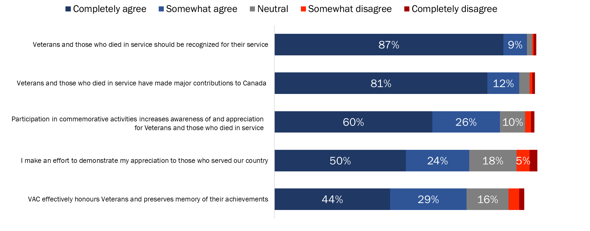

Q6: Please tell me how much you agree or disagree with each of the following statements, using a scale of 1 to 5, where 1 means completely disagree and 5 means completely agree. Base: All respondents; 2018 n=1,000. DK/NR: 1%-5%

Following this, nearly three-quarters agreed that they make an effort to demonstrate their appreciation to those who served our country and think that VAC’s remembrance program effectively honours Veterans and those who died in service and preserves the memory of their achievements and sacrifices (74% and 73% respectively).

The likelihood of agreeing with the following statements was generally lower among residents of Quebec compared to Canadians in other regions of the country:

- that Canada’s Veterans and those who died in service have made major contributions to our country;
- that Veterans and those who died in service should be recognized for their service to Canada;
- that they make an effort to demonstrate their appreciation to those who served;
- that VAC’s remembrance program effectively honours Veterans and those who died in service, and preserves the memory of their achievements and sacrifices; and
- that participation in commemorative activities increases awareness of, and appreciation for, the contributions of Veterans and those who died in service.

Over time, attitudes towards Veterans and commemoration have remained strong. Year-over-year there has been virtually no change.

Figure 26: Attitudes Towards Veterans and Commemoration [Over Time]

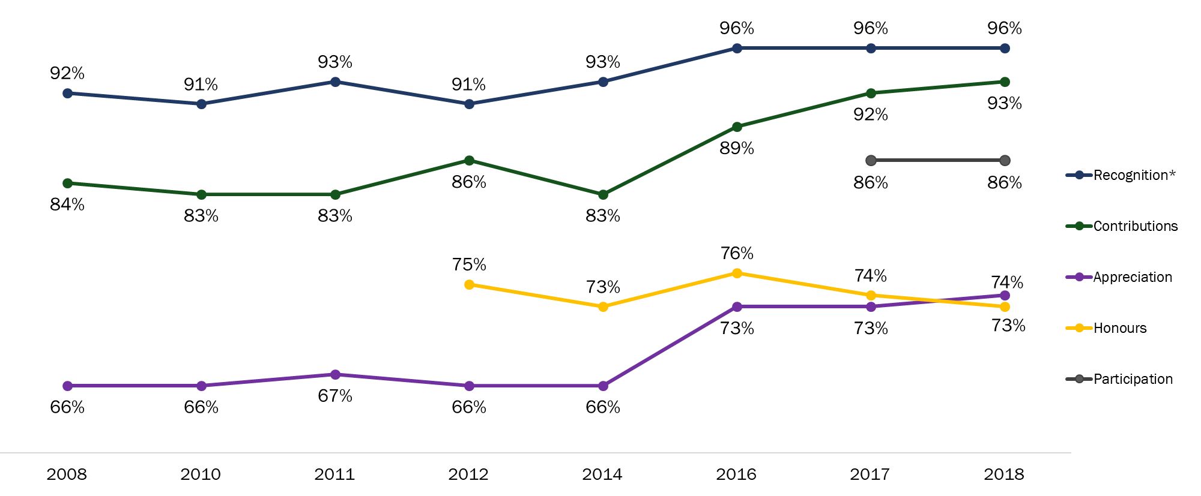

Q6: Please tell me how much you agree or disagree with each of the following statements, using a scale of 1 to 5, where 1 means completely disagree and 5 means completely agree. Base: All respondents; 2018 n=1,000. DK/NR: 1%-5%
*In 2012, the survey language changed when asking about recognition.

Canadians have a positive attitude towards Canada’s military role
Canadians were also asked to rate their level of agreement with statements relating to Canada’s military role. The statements were as follows:
    - I am knowledgeable about the role that Canada’s military has played in peacekeeping missions and conflicts like the World Wars, the Korean War, and the war in Afghanistan.
    - I am proud of the role that Canada’s military has played in peacekeeping missions and conflicts like the World Wars, the Korean War, and the war in Afghanistan.

As in previous years, Canadians were more likely to agree that they are proud of Canada’s military role than to think of themselves as knowledgeable about it. Over four in five (83%) Canadians agreed they are proud of the role that Canada’s military has played in peacekeeping missions and conflicts, while 71% agreed that they are knowledgeable about the role that Canada’s military has played.

Figure 27: Attitudes Towards Canada’s Military Role

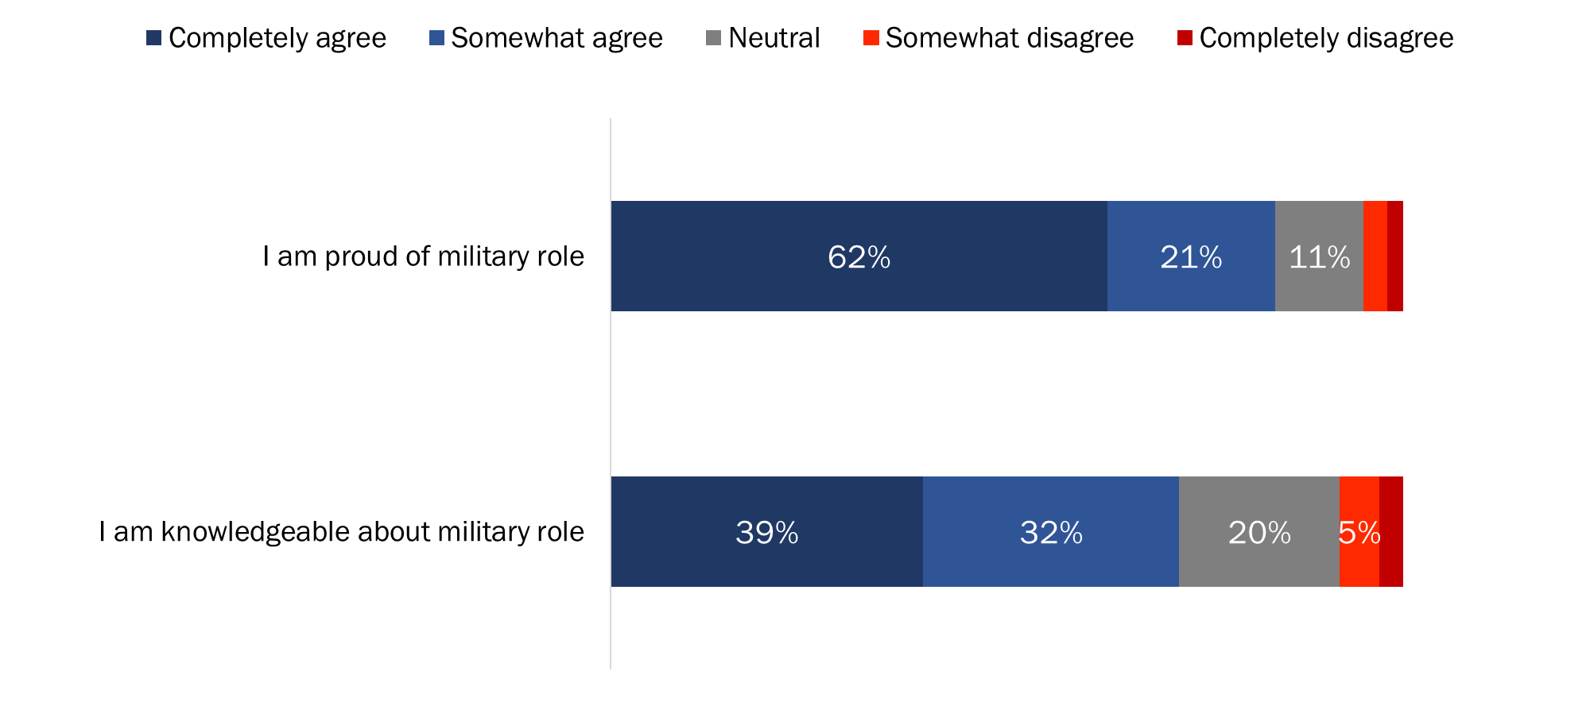

Q6: Please tell me how much you agree or disagree with each of the following statements, using a scale of 1 to 5, where 1 means completely disagree and 5 means completely agree. Base: All respondents; 2018 n=1,000. DK/NR: 1%

The likelihood of agreeing that they are knowledgeable about and proud of Canada’s military role was higher among Canadians aged 45 and older compared to Canadians under 45 years of age. In addition, residents of Quebec (64%) were less likely than Canadians residing in British Columbia (75%) and Ontario (74%) to agree they are knowledgeable about the role Canada’s military played in peacekeeping missions and conflicts and proud of Canada’s military role (76% of residents of Quebec versus at least 82% of respondents residing in other regions of the country).

Canadians’ attitudes towards Canada’s military role have been relatively stable over the last decade, fluctuating by no more than four percentage points.

Figure 28: Attitudes Towards Canada’s Military Role [Over Time]

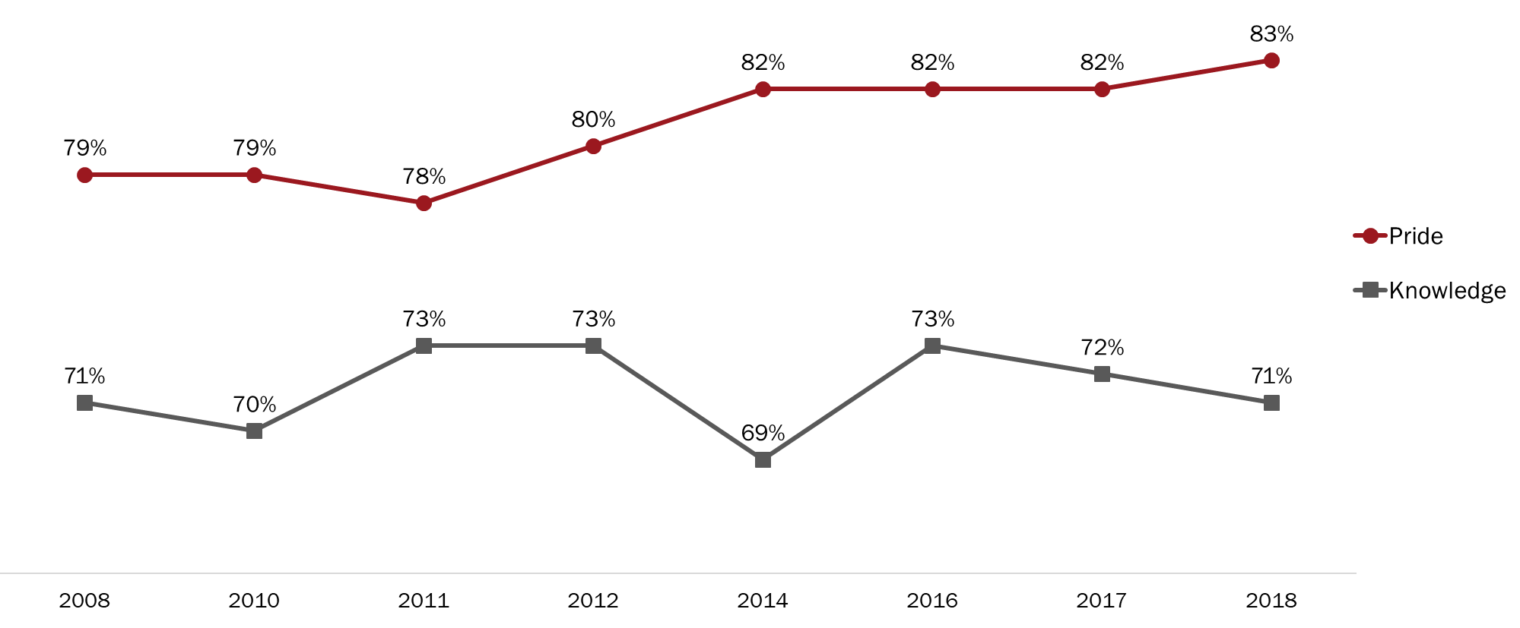

Q6: Please tell me how much you agree or disagree with each of the following statements, using a scale of 1 to 5, where 1 means completely disagree and 5 means completely agree. Base: All respondents; 2018 n=1,000. DK/NR: 1%

Recognizing Canadian Veterans and Those Who Died in Service
This section examines Canadians’ perceptions of the importance of, and levels of satisfaction with, VAC’s measures to recognize Veterans and those who died in service.

Widespread agreement on importance of recognition and many are satisfied with VAC’s performance in this area
More than nine in 10 (93%) Canadians agreed that it is important for Veterans Affairs Canada to recognize and honour Canadian Veterans and those who died in service through the presentation and care of memorials, cemeteries and grave markers. In addition, nearly six in 10 Canadians (59%) were satisfied with how Veterans Affairs Canada recognizes and honours Canadian Veterans and those who died in service through the presentation and care of these memorials, cemeteries and grave markers. Respondents who were not satisfied with VAC’s performance were more likely to be neutral (25%) than to express dissatisfaction (8%).

Figure 29: Attitudes Towards Actions to Recognize Veterans and Those Who Died in Service

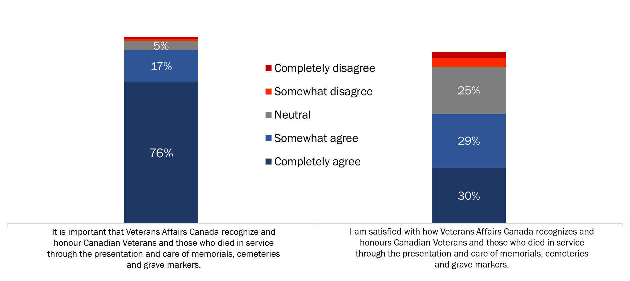

Q7A/B: Veterans Affairs Canada has a mandate to present and care for certain memorials, departmental cemeteries, and grave markers as well as to provide funeral and burial assistance for deceased Canadian Veterans. Please tell me how much you agree or disagree with each of the following statements… Base: All respondents; 2018 n=1,000. DK/NR: 1%-9%

The likelihood of completely agreeing that it is important for Veterans Affairs Canada to recognize and honour Canadian Veterans and those who died in service by presenting and caring for memorials, cemeteries and grave markers was highest among Canadians aged 65 and older (85% versus 76% of 45 to 64 year olds, 74% of those under 30 and 70% of 30 to 44 year olds) and was lower among residents of Quebec (68% versus at least 74% in other regions). Turning to VAC’s performance in this area, the likelihood of completely agreeing that they are satisfied with how VAC recognizes and honours Canadian Veterans and those who died in service increased as respondents’ level of education decreased, from 25% of university graduates to 36% of Canadians with a high school education or less.

Attitudes towards VAC’s recognition of Veterans remain stable over time
Agreement that it is important that VAC recognize and honour Canadian Veterans and those who died in service has been increasing since 2012, from 88% in 2012 to 93% in 2018 (there has been no change between 2017 and 2018). Conversely, satisfaction with VAC’s performance in this area has decreased since 2016, from 65% to 59% in 2018 (the same level of satisfaction recorded in 2010).

Figure 30: Attitudes Towards Actions to Recognize Veterans and Those Who Died in Service [Over Time]

Q7A/B: Veterans Affairs Canada has a mandate to present and care for certain memorials, departmental cemeteries, and grave markers as well as to provide funeral and burial assistance for deceased Canadian Veterans. Please tell me how much you agree or disagree with each of the following statements… Base: All respondents; 2018 n=1,000. DK/NR: 1%-9%

Widespread agreement on importance of providing funeral and burial assistance; majority satisfied with VAC’s provision of funeral and burial assistance
Ninety-one percent of Canadians agreed that it is important that Veterans Affairs Canada recognize and honour deceased Canadian Veterans by providing funeral and burial assistance. Three-quarters (74%) completely agreed that it is important for VAC to do so. Additionally, 52% of Canadians agreed they are satisfied with how Veterans Affairs Canada recognizes and honours deceased Veterans through the provision of funeral and burial assistance. Respondents who were not satisfied with VAC’s performance were more likely to be neutral (25%) than to express dissatisfaction (7%).

Figure 31: Attitudes Towards Provision of Funeral and Burial Assistance

Q7C/D: Veterans Affairs Canada has a mandate to present and care for certain memorials, departmental cemeteries, and grave markers as well as to provide funeral and burial assistance for deceased Canadian Veterans. Please tell me how much you agree or disagree with each of the following statements… Base: All respondents; 2018 n=1,000. DK/NR: 2%-16%

Residents of Quebec (66%) were less likely than residents of Atlantic Canada (83%) and Ontario (79%) to completely agree that it is important that VAC recognize and honour deceased Canadian Veterans by providing funeral and burial assistance. In addition, the likelihood of being satisfied with VAC’s performance in this area was higher among less educated Canadians: 57% of Canadians with a high school education or less and 55% of Canadians with some university or college versus 44% of university graduates.

Attitudes towards VAC’s provision of funeral and burial assistance relatively stable over time
Since tracking started in 2016, agreement that it is important that VAC recognize and honour deceased Canadian Veterans by providing funeral and burial assistance has been consistent, from 91% in 2016 to a high of 93% in 2017 and back to 91% in 2018. However, satisfaction with how VAC recognizes and honours deceased Canadian Veterans through the provision of funeral and burial assistance has been decreasing since 2016, from 65% to 52% in 2018.

Figure 32: Attitudes Towards Provision of Funeral and Burial Assistance [Over Time]

Q7C/D: Veterans Affairs Canada has a mandate to present and care for certain memorials, departmental cemeteries, and grave markers as well as to provide funeral and burial assistance for deceased Canadian Veterans. Please tell me how much you agree or disagree with each of the following statements… Base: All respondents; 2018 n=1,000. DK/NR: 2%-16%

Many aware of World War anniversaries; Majority believe it is important to commemorate World Wars
Canadians were asked if they are aware of anniversaries for the First and Second World Wars, as well as how important they think it is that these anniversaries be commemorated. Nearly two-thirds (64%) are at least vaguely aware of the 100th anniversary of the First World War, with 51% saying they are clearly aware. Fewer Canadians (46%) said they are aware of the 75th anniversary of the Second World War, with 29% saying they are clearly aware.

With respect to how Canadians feel about the importance of commemorating these military anniversaries, 89% said it is at least moderately important, with almost seven in ten (69%) saying it is very important.

Figure 33: Awareness and Importance of World War Commemorations

Q8: During the period 2014 to 2020, Canada is marking significant anniversaries of the two World Wars. Are you aware that Canada is commemorating… Base: All respondents; 2018 n=1,000. DK/NR: 1%
Q9: In your view, how important is it for Canada and Canadians to mark these two military anniversaries? Base: All respondents; 2018 n=1,000. DK/NR: <1%

Residents of Quebec were least likely to be aware of either the 100th anniversary of the First World War or the 75th anniversary of the Second World War. Additionally, the likelihood of saying they are clearly aware that Canada is marking significant anniversaries of the two World Wars generally increased with age.

Compared to 2017, awareness of the First and Second World War anniversaries has increased among Canadians, although the proportion of Canadians attributing importance to commemorating these anniversaries remains virtually unchanged at 89%.

Figure 34: Awareness and Importance of World War Commemorations [Over Time]

Q8: During the period 2014 to 2020, Canada is marking significant anniversaries of the two World Wars. Are you aware that Canada is commemorating… Base: All respondents; 2018 n=1,000. DK/NR: 1%
Q9: In your view, how important is it for Canada and Canadians to mark these two military anniversaries? Base: All respondents; 2018 n=1,000. DK/NR: <1%

The likelihood of saying it is important to mark these anniversaries was lower among Quebec residents (84%) than among residents of Ontario (91%) and Atlantic Canada (93%). Older Canadians were more likely than Canadians under 45 years of age to attribute importance to these anniversaries.

Appendix

1: Methodological Notes

The following specifications applied to this survey:

- An 11-minute random digit dialling (RDD) telephone survey was administered to 1,000 Canadian residents, 18 years of age or older, between November 12 and 22, 2018.
- Probability sampling was used: a total of 201 interviews were completed with cell phone only (CPO) households from the cell phone sample and 799 interviews with households from the landline sample. Of the 799 interviews completed with households from the landline sample, 161 were landline only households and 638 were households with both a landline and cell phone.
- The sample frame was geographically disproportionate to improve the accuracy of regional results. The distribution of completed surveys was as follows:

Strata | Completed Interviews
Atlantic | 100
Quebec | 300
Ontario | 350
Prairies (and Nunavut and the Northwest Territories) | 150
British Columbia (and the Yukon Territory) | 100
Total | 1,000

- Based on a sample of this size, the overall results can be considered to be accurate within ±3.3%, 19 times out of 20 (adjusted to reflect the geographically disproportionate sampling).
- The survey data have been weighted by region, age and gender using population figures from Statistics Canada’s 2016 census data.
- The overall response rate was 6% (8% for the landline sample and 5% for the cell phone sample).
- The table below presents information about the final call dispositions for this survey.
 | Total | Landline | Cell
Total Numbers Attempted | 40,866 | 14,003 | 26,863
Out-of-scope - Invalid | 23,552 | 5,656 | 17,896
Unresolved (U) | 10,294 | 4,063 | 6,231
No answer/Answering machine | 10,294 | 4,063 | 6,231
In-scope - Non-responding (IS) | 5,975 | 3,650 | 2,325
Language barrier | 240 | 129 | 111
Incapable of completing (ill/deceased) | 87 | 67 | 20
Callback (Respondent not available) | 383 | 272 | 111
Refusal | 5,149 | 3,126 | 2,023
Termination | 116 | 56 | 60
In-scope - Responding units (R) | 1,045 | 634 | 411
Completed Interview | 1,000 | 620 | 380
Not Qualified – Employment exclusions | 38 | 14 | 24
Not Qualified – Age | 7 | 0 | 7
- The potential for non-response bias was assessed by comparing the characteristics of respondents through unweighted and weighted data. As is typically the case for general population telephone surveys, older Canadians (those aged 65 and older) were overrepresented in the final survey sample and younger Canadians (those under 30 years of age) were underrepresented. This was corrected with weighting.

2: Tabulated Data

A full set of tabulated data has been provided under separate cover.

3: Questionnaire
Veterans Affairs Canada
Attitudes Towards Remembrance and Veterans’ Week 2018 Survey

Hello, my name is . I’m calling on behalf of Phoenix, a public opinion research firm. We’re conducting a survey for the Government of Canada to explore issues of interest to Canadians. Would you prefer to continue in English or French? / Préférez-vous continuer en français ou en anglais?

This survey should take no more than ten minutes to complete. Participation is voluntary and completely confidential, and your answers will remain anonymous. If you indicate that you no longer wish to participate, any survey responses already provided will be deleted.

CELL SAMPLE SKIP A, GO TO CS1.
- I’d like to speak to someone in your household who is 18 years of age or older. Is that you?

Yes |  | CONTINUE
No |  | ASK TO SPEAK TO ELIGIBLE PERSON.  REPEAT INTRO
Refused (Volunteered) |  | THANK/DISCONTINUE

CELL SAMPLE ONLY:
CS1. Have I reached you on your cell phone?

Yes | CONTINUE
No | GO TO B

CS2. Are you 18 years of age or older?

Yes | CONTINUE
No | THANK/DISCONTINUE

CS3. Are you in a place where you can safely talk on the phone and answer my questions?

Yes | GO TO B
No | CONTINUE

CS4. When would be a convenient time for me to call back?

Schedule call-back if possible (time/day): _______________

ASK EVERYONE:
- Do you, or does anyone in your family or household, work in any of the following areas? [READ LIST]

Advertising or Market Research | THANK/DISCONTINUE
The media (i.e. TV, radio, newspapers) | THANK/DISCONTINUE
An elected official | THANK/DISCONTINUE
* THOSE WHO ARE NOT ELIGIBLE: Thank you for your willingness to take part in this survey, but you do not meet the eligibility requirements of this study.

- In what year were you born?

Record year: ____________

INTERVIEWER AND PROGRAMMING NOTES:

IF RESPONDENT QUESTIONS THE LEGITIMACY OF THE SURVEY, INVITE RESPONDENT TO CALL VETERANS AFFAIRS CANADA, TOLL-FREE, AT 1-866-522-2122.

IF THE RESPONDENT EXPRESSES CONCERNS ABOUT PRIVACY, REITERATE THAT PARTICIPATION IN THE SURVEY IS VOLUNTARY AND COMPLETELY CONFIDENTIAL, AND THAT ALL ANSWERS WILL REMAIN ANONYMOUS. ALSO REITERATE THAT IF THE RESPONDENT INDICATES THEY NO LONGER WISH TO PARTICIPATE, ANY SURVEY RESPONSES ALREADY PROVIDED WILL BE DELETED.

IF ASKED ABOUT THE NATIONAL DO NOT CALL LIST, SAY:

Calls made for the purpose of market research, polls or surveys are not considered telemarketing calls. Organizations making these types of calls are not required to register with the National Do Not Call List. The National Do Not Call List toll-free telephone number is 1-866-580-3625.

REVEAL THE NAME OF THE CLIENT DEPARTMENT THAT COMMISSIONED THE SURVEY AT THE END OF THE SURVEY ONLY, IF ASKED - VETERANS AFFAIRS CANADA [VAC].

UNLESS OTHERWISE SPECIFIED, ALL QUESTIONS IN THE SURVEY WILL ALLOW FOR ‘DON’T KNOW/NO RESPONSE’ OPTION.

TRACKING QUESTIONS ARE IDENTIFIED AS FOLLOWS: T17 = 2017 IS MOST RECENT TRACKING.

IF ASKED WHERE AND HOW THE RESPONDENT CAN ACCESS THE RESULTS, INFORM HIM OR HER THAT THE REPORT WILL BE DEPOSITED WITH LIBRARY AND ARCHIVES CANADA (LAC) WITHIN SIX MONTHS AFTER THE DATA COLLECTION HAS BEEN COMPLETED. LAC’S WEBSITE IS www.lac-bac.gc.ca.

VAC IS CONDUCTING TWO DIFFERENT SURVEYS DURING NOVEMBER. THE OTHER SURVEY GAUGES RECALL OF A RECENT GOVERNMENT OF CANADA REMEMBRANCE ADVERTISING CAMPAIGN. IF, AT SOME POINT DURING THE INTERVIEW, A RESPONDENT INDICATES THAT S/HE HAS ALREADY COMPLETED A SURVEY ON REMEMBRANCE, ASSURE HIM/HER THAT THERE ARE TWO SURVEYS UNDERWAY RIGHT NOW, BOTH OF WHICH ARE RELATED TO REMEMBRANCE. APOLOGIZE FOR THE INCONVENIENCE, THANK THEM FOR THEIR WILLINGNESS TO RESPOND, AND CONFIRM THAT THEY WILL CONTINUE WITH THIS INTERVIEW.

ASK EVERYONE:
- Have you ever heard of Veterans' Week? T17

Yes
No

READ THIS DESCRIPTION TO EVERYONE:
Veterans’ Week takes place November 5-11 each year. During this week, commemorative ceremonies and events take place across the country to recognize the achievements of our Veterans and those who died in service. People also take part through things like social media, wearing a poppy, and having discussions with Veterans or military personnel.

- On a scale of 1 to 5, where 1 means not important at all and 5 means very important, with 3 being neither unimportant nor important, in your opinion, how important is it that Veterans' Week be held each year? T17

Not important at all
Not very important
Neither important nor unimportant
Moderately important
Very important

ASK IF “VERY/MODERATELY IMPORTANT”:
2b. And why do you say it is important that Veterans’ Week be held each year? [DO NOT READ LIST; ACCEPT UP TO TWO RESPONSES; DO NOT PROBE BEYOND FIRST RESPONSE] T17

To honour/ to respect the Veterans/ those who died in service
So people will remember their sacrifices
To recognize their contribution to our freedom/ security/ peace
Veterans fought for our country/ they served our country
To recognize their service/ accomplishments
Family member is a Veteran/ I am a Veteran
Canada wouldn't be the country it is today/ I wouldn't be here if it weren't for Veterans
So children can understand/ learn the importance of it
Good idea/ good to remember
We owe them/ they deserve recognition
Part of our heritage/ our history
Many soldiers died in past wars
So we don't repeat past mistakes
Should not/ cannot forget
There are fewer Veterans/ their story should be told
Believe in it/ it's important to do it
To show support for our troops (past and/ or present)
Forces us to examine war
Other. Specify: __________________________
Nothing/ no reason

ASK IF “NOT VERY/NOT AT ALL IMPORTANT”:
2c. And why do you say it is unimportant that Veterans’ Week be held each year? [DO NOT READ LIST; ACCEPT UP TO TWO RESPONSES; DO NOT PROBE BEYOND FIRST RESPONSE] T17

Never heard of it/ don't know about it
Don't care/ not important to me personally
We already have Remembrance Day/ a week is too long
It is important/ necessary that we have it
Happened in the past/ we should focus on the present
We shouldn't celebrate war/ we should focus on peace
Don't have family members who are Veterans/ don't know anyone in the military
Too expensive/ waste of money
Re-opens old wounds/ sad memories
There are other issues/ concerns that are more important
Most Veterans have died/ very few Veterans left
Don't know what activities there are for Veterans' Week
Other. Specify: __________________________
Nothing/ no reason

ASK IF “NEITHER IMPORTANT NOR UNIMPORTANT”:
2d. And why do you say it is neither important nor unimportant that Veterans’ Week be held each year? [DO NOT READ LIST; ACCEPT UP TO TWO RESPONSES; DO NOT PROBE BEYOND FIRST RESPONSE] T17

Never heard of it/ don't know about it
Don't care/ not important to me personally
It is important/ necessary that we have it
We already have Remembrance Day/ a week is too long
Don't have family members who are Veterans/ don't know anyone in the military
We shouldn't celebrate war/ we should focus on peace
Happened in the past/ we should focus on the present
Don't know what activities there are for Veterans' Week
There are other issues/ concerns that are more important
Most Veterans have died/ very few Veterans left
Should be a more private ceremony/ held less often (so it's not overdone)
Other. Specify: __________________________
Nothing/ no reason

ASK EVERYONE:
- Did you or members of your immediate family participate in Veterans' Week this year? T17

Yes
No
Don’t know

ASK IF “YES”:
3b. And why did you or members of your immediate family participate in Veterans' Week? [DO NOT READ LIST; ACCEPT UP TO TWO RESPONSES; DO NOT PROBE BEYOND FIRST RESPONSE] T17

Family member is a Veteran/ I am a Veteran
To honour/ to respect the Veterans/ those who died in service
Know/ am related to someone/ I am currently in the military
So people will remember their sacrifices
Believe in it/ it's important to do it
So children can understand/ learn the importance of it
To recognize their contribution to our freedom/ security/ peace
I/ someone I know participate(s) in events
To recognize their service/ accomplishments
Veterans fought for our country/ they served our country
Canada wouldn't be the country it is today/ I wouldn't be here if it weren't for Veterans
To show support for our troops (past and/ or present)
Good idea/ good to remember
Show some (national) pride
Other. Specify: __________________________
Nothing/ no reason

ASK IF “NO”:
3c. And why didn't you or members of your immediate family participate in Veterans' Week? [DO NOT READ LIST; ACCEPT UP TO TWO RESPONSES; DO NOT PROBE BEYOND FIRST RESPONSE] T17

Never heard of it/ don't know about it
Too busy/ no time to attend
Don't have family members who are Veterans/ don't know anyone in the military
Had to work/ not available to participate
Don't care/ not important to me personally
There are no activities for Veterans' Week in the area
No occasion/ opportunity/ chance to participate
Don't know what activities there are for Veterans' Week
Participate in Remembrance Day events/ observe Remembrance Day
Can't participate due to health reasons/ elderly
Don't have family nearby
I'm an immigrant
We shouldn't celebrate war/ we should focus on peace
Remember by wearing a poppy
Other. Specify: __________________________
Nothing/ no reason

ASK EVERYONE:
4. Did you or members of your immediate family do any of the following during Veterans' Week this year? [READ LIST; ACCEPT YES/NO FOR EACH ITEM] T17; 4d MODIFIED

a. Wear a poppy.
b. Participate in a remembrance ceremony in your community. *
c. Watch a Remembrance Day 2018 ceremony on TV. *
d. Participate in any remembrance-related activity on social media. *
e. Observe a moment of silence. *

* RECODE “NO” TO “YES” AT Q3 IF RESPONDENT SAID “NO” BUT DID ONE OF THESE ACTIVITIES.

4b. Outside of Remembrance Day or Veterans’ Week, in the past year, have you or members of your immediate family made an effort to remember Canadian Veterans and those who died in service? T17MODIFIED

Yes
No

ASK EVERYONE:
5. Now, thinking about ways of recognizing the achievements and sacrifices of Canadians during wartime and in peacetime operations, what priority should the Government of Canada place on each of the following remembrance initiatives? Please respond using a scale of 1 to 5, where 1 means not important at all and 5 means very important, with 3 meaning neither unimportant nor important. [READ LIST; OBTAIN RATING FOR EACH ITEM] T17MODIFIED

- Providing educational materials for schools
- Supporting and leading commemorative events
- Creating remembrance-related ads
- Providing funding for commemorative projects
- Providing promotional materials, such as posters and pins
- Posting remembrance-related content on social media.

6. Please tell me how much you agree or disagree with each of the following statements, using a scale of 1 to 5, where 1 means completely disagree and 5 means completely agree. [READ LIST; OBTAIN RATING FOR EACH ITEM] T17

    - I am knowledgeable about the role that Canada’s military has played in peace-keeping missions and conflicts like the World Wars, the Korean War, and the war in Afghanistan.
    - I am proud of the role that Canada’s military has played in peacekeeping missions and conflicts like the World Wars, the Korean War, and the war in Afghanistan.
    - Canada’s Veterans and those who died in service have made major contributions to our country.
    - Canada’s Veterans and those who died in service should be recognized for their service to Canada.
    - I make an effort to demonstrate my appreciation to those who served our country.
    - Veterans Affairs Canada's remembrance program effectively honours Veterans and those who died in service, and preserves the memory of their achievements and sacrifices.
    - Participation in commemorative activities increases awareness of, and appreciation for, the contributions of Veterans and those who died in service.

ASK EVERYONE:
7. Veterans Affairs Canada has a mandate to present and care for certain memorials, departmental cemeteries, and grave markers as well as to provide funeral and burial assistance for deceased Canadian Veterans. Please tell me how much you agree or disagree with each of the following statements, using a scale of 1 to 5, where 1 means completely disagree and 5 means completely agree. T17

- It is important that Veterans Affairs Canada recognize and honour Canadian Veterans and those who died in service through the presentation and care of memorials, cemeteries and grave markers.
- I am satisfied with how Veterans Affairs Canada recognizes and honours Canadian Veterans and those who died in service through the presentation and care of memorials, cemeteries and grave markers.
- It is important that Veterans Affairs Canada recognize and honour deceased Canadian Veterans by providing funeral and burial assistance.
- I am satisfied with how Veterans Affairs Canada recognizes and honours deceased Canadian Veterans through the provision of funeral and burial assistance.

8. During the period 2014 to 2020, Canada is marking significant anniversaries of the two World Wars. Are you aware that Canada is commemorating the …T17

- …100th anniversary of the First World War?
- …75th anniversary of the Second World War?

RECORD:
Yes, clearly
Yes, vaguely
No

9. In your view, how important is it for Canada and Canadians to mark these two military anniversaries? Please respond using a scale of 1 to 5, where 1 means not important at all and 5 means very important, with 3 meaning neither unimportant nor important. T17

Not important at all
Not very important
Neither important nor unimportant
Moderately important
Very important

The last few questions are for classification purposes only.

10. What language do you speak most often at home? [READ LIST; ACCEPT ALL THAT APPLY]

English
French
Other
[DO NOT READ] Don't know/Refused

11. Were you born in Canada?

Yes
No
[DO NOT READ] Refused

12. How do you identify your gender? This may be different from the information noted on your birth certificate or other official documents. [READ LIST]

Female,
Male, or
Please specify: [TEXT]
[DO NOT READ] Prefer not to answer

13. What is the highest level of formal education that you have completed? [READ LIST]

Grade 8 or less*
Some high school**
High school diploma or equivalent
Registered Apprenticeship or other trades certificate or diploma
College, CEGEP or other non-university certificate or diploma
University certificate or diploma below bachelor's level
Bachelor's degree
Post graduate degree above bachelor's level
[DO NOT READ] Prefer not to answer

*IN QUEBEC, PLEASE REPLACE WITH: “Secondary II or less”
**IN QUEBEC, PLEASE REPLACE WITH: “Some secondary school”

14. Which of the following categories best describes your current employment status? Are you…? [READ LIST; ACCEPT ONE ANSWER ONLY]

Working full-time, that is, 35 or more hours per week
Working part-time, that is, less than 35 hours per week
Self-employed
Unemployed, but looking for work
A student attending school full-time
Retired
Not in the workforce (full-time homemaker, unemployed and not looking for work)
Other
[DO NOT READ] Refused

15. What was your total household income for 2017? That is, the total income of all persons in your household combined, before taxes. Please stop me when I get to the correct amount. Is it…? [READ LIST]

Under $20,000
$20,000 to just under $40,000
$40,000 to just under $60,000
$60,000 to just under $80,000
$80,000 to just under $100,000
$100,000 to just under $150,000
$150,000 and above
[DO NOT READ] Refused

ASK CELL SAMPLE:
In addition to your cellular telephone, does your household currently have a traditional telephone or landline? [ACCEPT ONE RESPONSE]

Yes
No

ASK LANDLINE SAMPLE:
In addition to your residential landline telephone, do you or someone else in your household also use one or more cell phone numbers? [ACCEPT ONE RESPONSE]

Yes
No

That concludes the survey. Thank you very much for your thoughtful feedback.
It is much appreciated.

RECORD BY OBSERVATION:
PROVINCE/REGION
GENDER
LANGUAGE OF INTERVIEW

This includes those who indicated that they, or members of their immediate family, participated in Veterans' Week this year and those who initially said they had not but later reported that they or their family had taken part in a remembrance activity, such as wearing a poppy.
The purpose of this description was to ensure that all respondents had a basis on which to rate the importance of Veterans’ Week.
These responses are more specific to the themes that respondents offered. The responses were then combined to create the graph above.
Given the very small sample size, a table of the full range of responses is not provided.
This includes those who indicated that they, or members of their immediate family, participated in Veterans' Week this year and those who initially said they had not but later reported that they or their family had taken part in a remembrance activity, such as wearing a poppy. This process of re-coding answers reflects a better measure of participation in Veterans’ Week. Recoding has been done since 2011.
The wording of this question was modified this year. Although the revision was limited (from “…are there any other ways that you or members of your immediate family have remembered Canadian Veterans and those who died in service?” to the wording used in the caption of Figure 22), it is possible that this contributed to the increase recorded this year.

